

quarterly report on
organizational performance excellence

SECOND state fiscal quarter 2014
October, November, December 2013

Mary Louise McEwen, RN, MBA
Superintendent
January 17, 2014

 Please consider the environment before printing this document. It is formatted for double-sided printing.
THIS PAGE INTENTIALLY LEFT BLANK

Table of Contents

GLOSSARY OF TERMS, ACRONYMS, AND ABBREVIATIONS i
INTRODUCTION iii

CONSENT DECREE

STANDARDS FOR DEFINING SUBSTANTIAL COMPLIANCE

CONSENT DECREE PLAN 1

CLIENT RIGHTS 1

ADMISSIONS 1

PEER SUPPORTS 7

TREATMENT PLANNING 7

MEDICATIONS 10

DISCHARGES 11

STAFFING AND STAFF TRAINING 14

USE OF SECLUSION AND RESTRAINTS 18

CLIENT ELOPEMENTS 31

CLIENT INJURIES 33

PATIENT ABUSE, NEGLECT, EXPLOITATION, INJURY OR DEATH 37

PERFORMANCE IMPROVEMENT AND QUALITY ASSURANCE 38

JOINT COMMISSION PERFORMANCE MEASURES

HOSPITAL-BASED INPATIENT PSYCHIATRIC SERVICES (HBIPS) 39

ADMISSION SCREENING (INITIAL ASSESSMENT) 40

HOURS OF RESTRAINT USE 41

HOURS OF SECLUSION USE 42

CLIENTS DISCHARGED ON MULTIPLE ANTIPSYCHOTIC MEDICATIONS 43

CLIENTS DISCHARGED ON MULTIPLE ANTIPSYCHOTIC MEDICATIONS

WITH JUSTIFICATION 45

POST DISCHARGE CONTINUING CARE PLAN CREATED 47

POST DISCHARGE CONTINUING CARE PLAN TRANSMITTED 48

JOINT COMMISSION PRIORITY FOCUS AREAS

ADVERSE REACTIONS TO SEDATION OR ANESTHESIA 49

HEALTHCARE ACQUIRED INFECTIONS MONITORING & MANAGEMENT 50

MEDICATION ERRORS AND ADVERSE DRUG REACTIONS 52

Table of Contents

INPATIENT CONSUMER SURVEY 58
PAIN MANAGEMENT 64
FALLS REDUCTION STRATEGIES 65

STRATEGIC PERFORMANCE EXCELLENCE

PROCESS IMPROVEMENT PLANS 66

ADMISSIONS 68

DIETARY SERVICES 69

ENVIRONMENT OF CARE 72
HARBOR TREATMENT MALL 75

HEALTH INFORMATION TECHNOLOGY/MEDICAL RECORDS 76

HUMAN RESOURCES 80

MEDICAL STAFF 83

NURSING 88

PEER SUPPORT 90

PHARMACY SERVICES 93

PROGRAM SERVICES 95

REHABILITATION THERAPY 100

Glossary of Terms, Acronyms & Abbreviations

ACT |  | Assertive Community Treatment
ADC |  | Automated Dispensing Cabinets (for medications)
ADON |  | Assistant Director of Nursing
AOC |  | Administrator on Call
CCM |  | Continuation of Care Management (Social Work Services)
CCP |  | Continuation of Care Plan
CMS |  | Centers for Medicare & Medicaid Services
CoP |  | Community of Practice or  Conditions of Participation (CMS)
CPI |  | Continuous Process (or Performance) Improvement
CPR |  | Cardio-Pulmonary Resuscitation
CSP |  | Comprehensive Service Plan
GAP |  | Goal, Assessment, Plan Documentation
HOC |  | Hand off communications.
IMD |  | Institute for Mental Disease
ICDCC |  | Involuntary Civil District Court Commitment
ICDCC-M |  | Involuntary Civil District Court Commitment, Court Ordered Medications
ICDCC-PTP |  | Involuntary Civil District Court Commitment, Progressive Treatment Plan
IC-PTP+M |  | Involuntary Commitment, Progressive Treatment Plan, Court Ordered Medications
ICRDCC |  | Involuntary Criminal District Court Commitment
INVOL CRIM |  | Involuntary Criminal Commitment
INVOL-CIV |  | Involuntary Civil Commitment
ISP |  | Individualized Service Plan
IST |  | Incompetent to Stand Trial
LCSW |  | Licensed Clinical Social Worker
LPN |  | License Practical Nurse
TJC |  | The Joint Commission (formerly JCAHO, Joint Commission on Accreditation of Healthcare Organizations)
MAR |  | Medication Administration Record
MRDO |  | Medication Resistant Disease Organism (MRSA, VRE, C-Dif)
NAPPI |  | Non Abusive Psychological and Physical Intervention
NASMHPD |  | National Association of State Mental Health Program Directors
NCR |  | Not Criminally Responsible
NOD |  | Nurse on Duty
NP |  | Nurse Practitioner
NPSG |  | National Patient Safety Goals (established by the Joint Commission)
NRI |  | NASMHPD Research Institute, Inc.
OT |  | Occupational Therapist
PA or PA-C |  | Physician’s Assistant (Certified)
PCHDCC |  | Pending Court Hearing
PCHDCC+M |  | Pending Court Hearing for Court Ordered Medications

i

Glossary of Terms, Acronyms & Abbreviations

PPR |  | Periodic Performance Review – a self-assessment based upon TJC standards that are conducted annually by each department head.
PSD |  | Program Services Director
PTP |  | Progressive Treatment Plan
R.A.C.E. |  | Rescue/Alarm/Confine/Extinguish
RN |  | Registered Nurse
RT |  | Recreation Therapist
SA |  | Substance Abuse
SAMHSA |  | Substance Abuse and Mental Health Services Administration (Federal)
SAMHS |  | Substance Abuse and Mental Health Services, Office of (Maine DHHS)
SBAR |  | Acronym for a model of concise communications first developed by the US Navy Submarine Command. S = Situation, B = Background, A = Assessment, R = Recommendation
SD |  | Standard Deviation – a measure of data variability.
Seclusion, Locked |  | Client is placed in a secured room with the door locked.
Seclusion, Open |  | Client is placed in a room and instructed not to leave the room.
SRC |  | Single Room Care (seclusion)
URI |  | Upper respiratory infection
UTI |  | Urinary tract infection
VOL |  | Voluntary – Self
VOL-OTHER |  | Voluntary – Others (Guardian)
MHW |  | Mental Health Worker

ii

INTRODUCTION

The Riverview Psychiatric Center Quarterly Report on Organizational Performance Excellence has been created to highlight the efforts of the hospital and its staffs to provide evidence of a commitment to client recovery, safety in culture and practices and fiscal accountability. The report is structure to reflect a philosophy and contemporary practices in addressing overall organizational performance in a systems improvement approach instead of a purely compliance approach. The structure of the report also reflects a focus on meaningful measures of organizational process improvement while maintaining measures of compliance that are mandated though regulatory and legal standards.
The methods of reporting are driven by a national accepted focused approach that seeks out areas for improvement that were clearly identified as performance priorities. The American Society for Quality, National Quality Forum, Baldrige National Quality Program and the National Patient Safety Foundation all recommend a systems-based approach where organizational improvement activities are focused on strategic priorities rather than compliance standards.
There are three major sections that make up this report:
The first section reflects compliance factors related to the Consent Decree and includes those performance measure described in the Order Adopting Compliance Standards dated October 29, 2007. Comparison data is not always available for the last month in the quarter and is included in the next report.
The second section describes the hospital’s performance with regard to Joint Commission performance measures that are derived from the Hospital-Based Inpatient Psychiatric Services (HBIPS) that are reflected in the Joint Commissions quarterly ORYX Report and priority focus areas that are referenced in the Joint Commission standards;
I. Data Collection (PI.01.01.01)
II. Data Analysis (PI.02.01.01, PI.02.01.03)
III. Performance Improvement (PI.03.01.01)
The third section encompasses those departmental process improvement projects that are designed to improve the overall effectiveness and efficiency of the hospital’s operations and contribute to the system’s overall strategic performance excellence. Several departments and work areas have made significant progress in developing the concepts of this new methodology.
As with any change in how organizations operate, there are early adopters and those whose adoption of system changes is delayed. It is anticipated that over the next year, further contributors to this section of strategic performance excellence will be added as opportunities for improvement and methods of improving operational functions are defined.

iii
. THIS PAGE INTENTIALLY LEFT BLANK

(Glossary of Terms, Acronyms & Abbreviations) (Back to Table of Contents)
CONSENT DECREE

Consent Decree Plan

V1) The Consent Decree Plan, established pursuant to paragraphs 36, 37, 38, and 39 of the Settlement Agreement in Bates v. DHHS defines the role of Riverview Psychiatric Center in providing consumer-centered inpatient psychiatric care to Maine citizens with serious mental illness that meets constitutional, statutory, and regulatory standards.
The following elements outline the hospital’s processes for ensuring substantial compliance with the provisions of the Settlement Agreement as stipulated in an Order Adopting Compliance Standards dated October 29, 2007.
Client Rights

V2) Riverview produces documentation that clients are routinely informed of their rights upon admission in accordance with ¶ 150 of the Settlement Agreement;

Indicators | 3Q2013 | 4Q2013 | 1Q2014 | 2Q2014
- Clients are routinely informed of their rights upon admission | 91%  42/46 | 100%  19/20  1 refusal | 98%  52/55  2 refused | 100%  45/45  (15/15 for decertified unit)

This measure has shown improvement in the past two quarters. 98% this quarter and 100% last quarter. Clients are informed of their rights and asked to sign that information has been provided to them. If they refuse, the staff documents the refusal and sign, date & time the refusal.

V3) Grievance tracking data shows that the hospital responds to 90% of Level II grievances within five working days of the date of receipt or within a five-day extension.

Indicators | 3Q2013 | 4Q2013 | 1Q2014 | 2Q2014
- Level II grievances responded to by RPC on time. | 100%  1/1 | 0/0 | 50%  3/6 | 100%  1/1
- Level I grievances responded to by RPC on time. | 95%  96/101 | 98%  58/59 | 98%  59/60 | 100%  61/61

Admissions

V4) Quarterly performance data shows that in 4 consecutive quarters, 95% of admissions to Riverview meet legal criteria;

Legal Status on Admission | 3Q2013 | 4Q2013 | 1Q2014 | 2Q2014
ICDCC | 20 | 17 | 30 | 15
ICRDCC
INVOL CRIM | 21
INVOL CRIM – Forensic Evaluation |  | 16 | 24 | 18
INVOL CRIM – IST |  | 3 | 5 | 12
INVOL CRIM – NCR |  |  | 3 | 8
INVOL CRIM – Jail Transfer
INVOL-CIV | 1 |  | 1 | 3
PCHDCC |  | 3
PCHDCC+M | 1
PCHDSS-PTP-R |  | 1
VOL | 7 | 3 |  | 1
(Glossary of Terms, Acronyms & Abbreviations) (Back to Table of Contents)
CONSENT DECREE

V5) Quarterly performance data shows that in 3 out of 4 consecutive quarters, the % of readmissions within 30 days of discharge does not exceed one standard deviation from the national mean as reported by NASMHPD

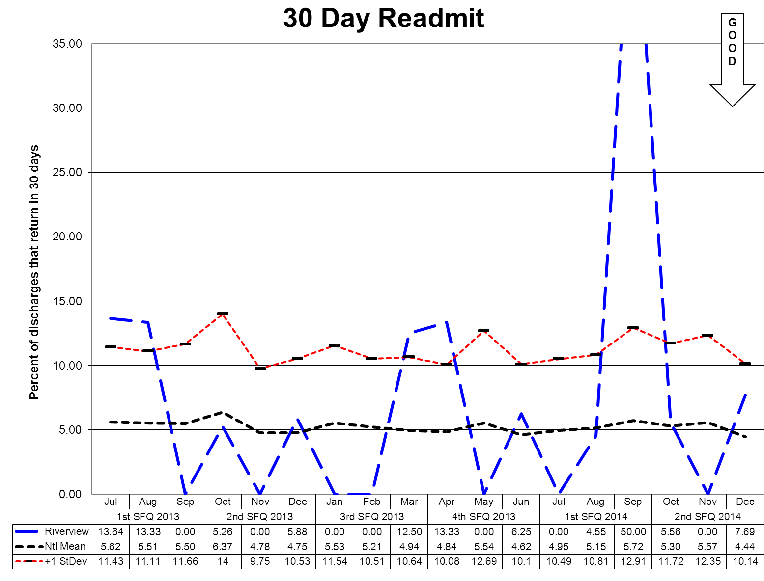

This graph depicts the percent of discharges from the facility that returned within 30 days of a discharge of the same client from the same facility. For example, a rate of 10.0 means that 10% of all discharges were readmitted within 30 days.
The graphs shown on the next page depict the percent of discharges from the facility that returned within 30 days of a discharge of the same client from the same facility stratified by forensic or civil classifications. For example, a rate of 10.0 means that 10% of all discharges were readmitted within 30 days. The hospital-wide results from the Dorothea Dix facility are compared to the civil population results at the Riverview facility due to the homogeneous nature of these two sample groups.
Reasons for client readmission are varied and may include decompensating or lack of compliance with a PTP to name a few. Specific causes for readmission are reviewed with each client upon their return. These graphs are intended to provide an overview of the readmission picture and do not provide sufficient granularity in data elements to determine trends for causes of readmission.
(Glossary of Terms, Acronyms & Abbreviations) (Back to Table of Contents)
CONSENT DECREE

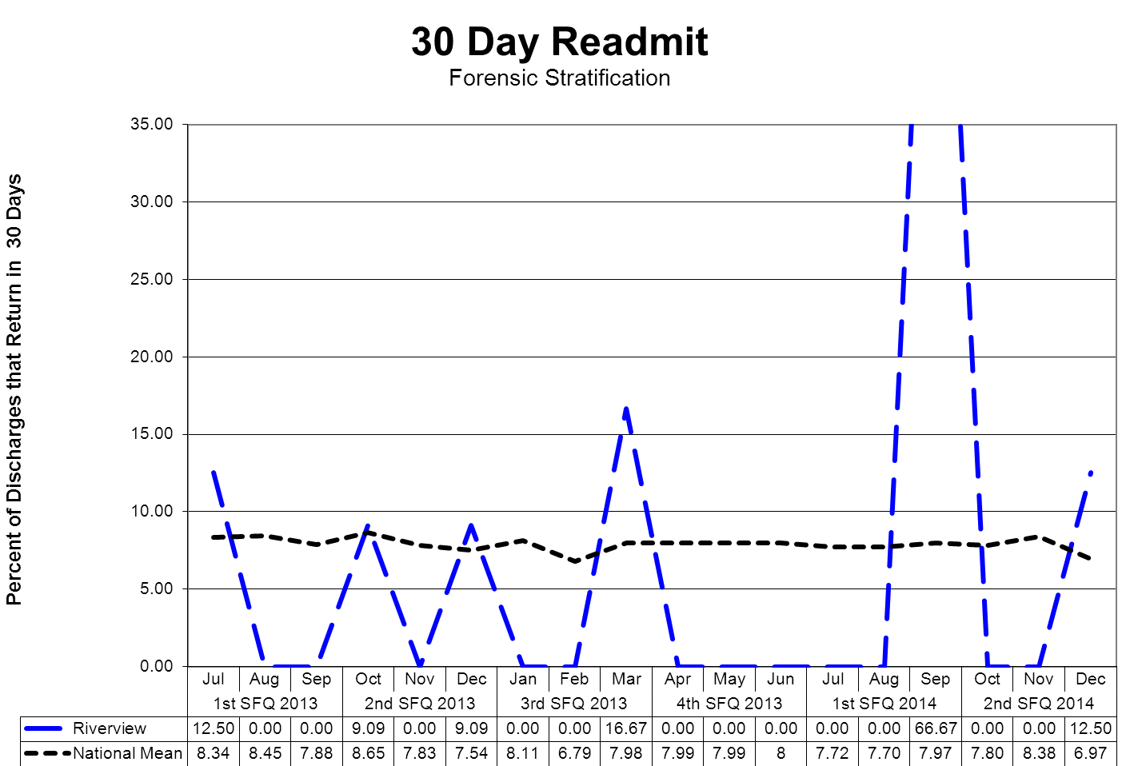

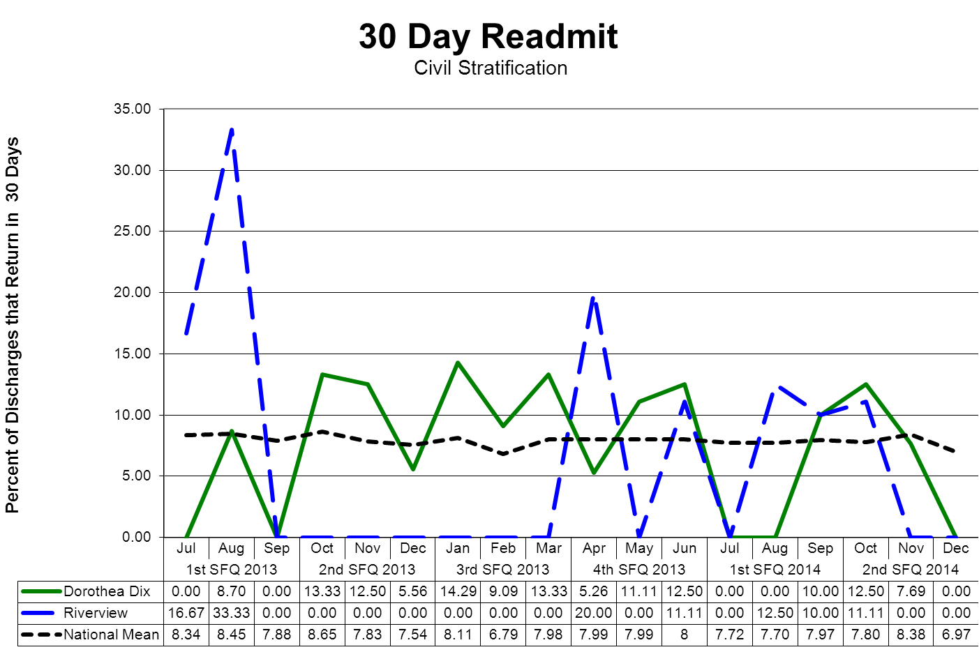
(Glossary of Terms, Acronyms & Abbreviations) (Back to Table of Contents)
CONSENT DECREE

V6) Riverview documents, as part of the Performance Improvement & Quality Assurance process, that the Director of Social Work reviews all readmissions occurring within 60 days of the last discharge; and for each client who spent fewer than 30 days in the community, evaluated the circumstances to determine whether the readmission indicated a need for resources or a change in treatment and discharge planning or a need for different resources and, where such a need or change was indicated, that corrective action was taken;

REVIEW OF READMISSION OCCURRING WITHIN 60 DAYS

Indicators | 3Q2013 | 4Q2013 | 1Q2014 | 2Q2014
Director of Social Services reviews all readmissions occurring within 60 days of the last discharge and for each client who spent fewer than 30 days in the community, evaluated the circumstances of the readmission to determine an indicated need for resources or a change in treatment and discharge planning or the need for alternative resources. In cases where such a need or change was indicated that corrective action was taken. | 100%  2/2 | 100%  3/3 | 100%  2/2 | 100%  1/1

In this aspect area one of the clients that returned is on the Progressive Treatment program with the Riverview ACT team and as part of his court ordered treatment plan was returned to the hospital after displaying increased symptoms in his current group home. Client will remain on PTP and return to placement once stable. The second client is under Progressive Treatment with a provider in Portland he eloped from his group home placement and was re-admitted to Riverview as part of his court ordered treatment plan for increased symptomology. Client will also return to his placement under the PTP. The third client was discharged at his request to the Oxford St Shelter after refusing all placement offerings from his team. Client was assigned to a case manager and psychiatric providers. Client left the shelter and was re-admitted to Riverview after he was found wandering in the community exhibiting aggressive behaviors and psychotic symptoms. Team will work with client to identify needs and wants and set up a discharge plan if client will accept that provides him with a more stable living environment that can provide a compliment of mental health services.

(Glossary of Terms, Acronyms & Abbreviations) (Back to Table of Contents)
CONSENT DECREE

Reduction of re-hospitalization for ACT Team clients

Indicators | 3Q2013 | 4Q2013 | 1Q2014 | 2Q2014
- The ACT Team Director will review all client cases of re-hospitalization from the community for patterns and trends of the contributing factors leading to re-hospitalization each quarter. The following elements are considered during the review:  - Length of stay in community  - Type of residence (i.e.: group home, apartment, etc)  - Geographic location of residence  - Community support network  - Client demographics (age, gender, financial)  - Behavior pattern/mental status  - Medication adherence  - Level of communication with ACT Team | 100%  3 clients were returned to RPC; two for substance use and 1 for psychiatric decompensating. | 100%  5 clients were returned to RPC; 4 for psychiatric symptoms, one for relapse while in supervised apartment. | 100%  2 clients were returned to RPC for psychiatric instability, | 100%  1 client was returned to RPC for psychiatric instability due to substance abuse relapse
- ACT Team will work closely with inpatient treatment team to create and apply discharge plan incorporating additional supports determined by review noted in #1. | 100% | 100% |  | 100%

Current Quarter Summary

- Readmission was male, age 25; client readmitted is socioeconomically disadvantaged, had been living in his group home for one year, has family support and uses resources that are available such as transportation, educational opportunities, leisure activities. Client was medication adherent, was experiencing medical issues related to lower GI, and had been attending appointments as scheduled with the ACT Team.
2. The ACT Team and the inpatient unit of RPC (Upper Saco) worked collaboratively to minimize the time spent in Riverview while maximizing the opportunity for success upon return to community placements.
(Glossary of Terms, Acronyms & Abbreviations) (Back to Table of Contents)
CONSENT DECREE

V7) Riverview certifies that no more than 5% of patients admitted in any year have a primary diagnosis of mental retardation, traumatic brain injury, dementia, substance abuse or dependence.

Client Admission Diagnoses | 2Q13 | 3Q13 | 1Q14 | 2Q14 | TOT
ADJUSTMENT DISORDER WITH DEPRESSED MOOD | 1 |  |  |  | 1
ADJUSTMENT DISORDER WITH ANXIETY |  | 1 |  |  | 1
ADJUST DISORDER WITH MIXED ANXIETY & DEPRESSED MOOD | 3 | 1 | 2 | 1 | 7
ADJUSTMENT REACTION NOS | 1 | 1 | 1 |  | 3
ALCOHOL ABUSE-IN REMISS | 1 |  |  |  | 1
ANXIETY STATE NOS |  | 1 |  |  | 1
ATTN DEFICIT W HYPERACT |  | 1 | 1 | 2 | 4
BIPOL I, MOST RECENT EPISODE (OR CURRENT) MIXED, UNSPEC |  |  |  | 3 | 3
BIPOLAR DISORDER, UNSPECIFIED | 5 | 5 | 9 | 4 | 23
DELUSIONAL DISORDER | 1 | 2 |  |  | 3
DEPRESS DISORDER-UNSPEC |  |  |  | 3 | 3
DEPRESSIVE DISORDER NEC | 2 | 2 | 6 |  | 10
DRUG ABUSE NEC-IN REMISS | 1 |  |  |  | 1
FACTITIOUS DIS W PREDOMINANTLY PSYCHOLOGICAL SIGNS & SYMPTOM |  |  |  | 1 | 1
FACTITIOUS ILL NEC/NOS |  |  |  | 1 | 1
HEBEPHRENIA-UNSPEC |  |  |  | 1 | 1
IMPULSE CONTROL DIS NOS | 1 | 2 |  | 1 | 4
INTERMITT EXPLOSIVE DIS | 1 | 1 | 2 |  | 4
MOOD DISORDER IN CONDITIONS CLASSIFIED ELSEWHERE | 1 |  |  |  | 1
OTH PERSISTENT MENTAL DIS DUE TO COND CLASS ELSEWHERE | 1 |  |  |  | 1
PARANOID SCHIZO-CHRONIC | 5 | 8 | 10 | 3 | 26
PARANOID SCHIZO-UNSPEC |  | 1 | 2 | 1 | 4
PERSON FEIGNING ILLNESS | 1 |  | 1 | 1 | 3
POSTTRAUMATIC STRESS DISORDER | 3 | 3 | 4 |  | 10
PSYCHOSIS NOS | 4 | 4 | 5 | 10 | 23
SCHIZOAFFECTIVE DISORDER, UNSPECIFIED | 6 | 9 | 12 | 13 | 40
SCHIZOPHRENIA NOS-CHR |  | 1 |  | 1 | 2
SCHIZOPHRENIA NOS-UNSPEC |  | 2 |  |  | 2
SCHIZOPHRENIFORM DISORDER, UNSPECIFIED |  | 1 |  | 1 | 2
UNSPECIFIED EPISODIC MOOD DISORDER | 6 | 4 | 8 | 6 | 24
UNSPECIFIED NONPSYCHOTIC MENTAL DISORDER |  |  |  | 3 | 3
Total Admissions | 44 | 50 | 63 | 56 | 213
Admitted with primary diagnosis of mental retardation, traumatic brain injury,  dementia, substance abuse or dependence. | 4.55% | 0.00% | 0.00% | 0.00% | 1%

(Glossary of Terms, Acronyms & Abbreviations) (Back to Table of Contents)
CONSENT DECREE

Peer Supports

Quarterly performance data shows that in 3 out of 4 consecutive quarters:

V8) 100% of all clients have documented contact with a peer specialist during hospitalization;

V9) 80% of all treatment meetings involve a peer specialist.

Indicators | 3Q2013 | 4Q2013 | 1Q2014 | 2Q2014
- Attendance at Comprehensive Treatment Team meetings. (v9) | 87%  354/406 | 87%  362/418 | 84%  408/488 | 86%  352/411
- Attendance at Service Integration meetings. (v8) | 98%  48/49 | 79%  26/33 | 95%  53/56 | 100%  41/41
- Contact during admission. (v8) | 100%  50/50 | 100%  46/46 | 100%  56/56 | 100%  57/57

Treatment Planning

V10) 95% of clients have a preliminary treatment and transition plan developed within 3 working days of admission;

Indicators | 3Q2013 | 4Q2013 | 1Q2014 | 2Q2014
1. Preliminary Continuity of Care meeting completed by end of 3rd day | 100%  30/30 | 100%  30/30 | 100%  30/30 | 100%  30/30
2. Service Integration form completed by the end of the 3rd day | 100%  30/30 | 100%  30/30 | 100%  30/30 | 100%  30/30
3a. Client Participation in Preliminary Continuity of Care meeting. | 96%  29/30 | 100%  30/30 | 100%  30/30 | 100%  30/30
3b. CCM Participation in Preliminary Continuity of Care meeting. | 100%  30/30 | 100%  30/30 | 100%  30/30 | 100%  30/30
3c. Client’s Family Member and/or Natural Support (e.g., peer support, advocacy, attorney) Participation in Preliminary Continuity of Care meeting. | 100%  30/30 | 100%  30/30 | 93%  28/30 | 90%  27/30
4a.Initial Comprehensive Psychosocial Assessments completed within 7 days of admission. | 93%  28/30 | 90%  27/30 | 96%  29/30 | 93%  28/30
4b. Initial Comprehensive Assessment contains summary narrative with conclusion and recommendations for discharge and social worker role | 100%  30/30 | 100%  30/30 | 96%  29/30 | 100%  30/30
4c. Annual Psychosocial Assessment completed and current in chart | N/A | N/A | 100%  15/15 | 100%  15/15

Summary: For area 4A we had two psych-social assignments that were started but not completed within the 7 day timeframe required. Both staff were addressed in individual supervision.
(Glossary of Terms, Acronyms & Abbreviations) (Back to Table of Contents)
CONSENT DECREE

V11) 95% of clients also have individualized treatment plans in their records within 7 days thereafter;

Indicators | 3Q2013 | 4Q2013 | 1Q2014 | 2Q2014
- Progress notes in GAP/Incidental/Contact format will indicate at minimum weekly 1:1 meeting with all clients on assigned CCM caseload. | 93%  43/45 | 96%  44/45 | 96%  29/30 | 93%  28/30
- On Upper Saco progress notes in GAP/Incidental format will indicate at minimum weekly 1:1 meeting with all clients on assigned CCM caseload | 95%  14/15 | 100%  15/15 | N/A | N/A
- Treatment plans will have measurable goals and interventions listing client strengths and areas of need related to transition to the community or transition back to a correctional facility. | 96%  58/60 | 91%  55/60 | 100%  30/30 | 100%  30/30

Data is no longer being collected for #2 as all information is not lumped together into #1.

V12) Riverview certifies that all treatment modalities required by ¶155 are available.

The treatment modalities listed below as listed in ¶155 are offered to all clients according to the individual client’s ability to participate in a safe and productive manner as determined by the treatment team and established in collaboration with the client during the formulation of the individualized treatment plan.

Treatment Modality | Provision of Services Normally by….
Treatment Modality | Medical Staff  Psychology | Nursing | Social  Services | Rehabilitation Services/  Treatment Mall
Group and Individual Psychotherapy | X
Psychopharmacological Therapy | X
Social Services |  |  | X
Physical Therapy |  |  |  | X
Occupational Therapy |  |  |  | X
ADL Skills Training |  | X |  | X
Recreational Therapy |  |  |  | X
Vocational/Educational Programs |  |  |  | X
Family Support Services and Education |  | X | X | X
Substance Abuse Services | X
Sexual/Physical Abuse Counseling | X
Intro to Basic Principles of Health, Hygiene, and Nutrition |  | X |  | X

(Glossary of Terms, Acronyms & Abbreviations) (Back to Table of Contents)
CONSENT DECREE

An evaluation of treatment planning and implementation, performed in accordance with Attachment D, demonstrates that, for 90% of the cases reviewed:

V13) The treatment plans reflect

- Screening of the patient’s needs in all the domains listed in ¶61;
- Consideration of the patient’s need for the services listed in ¶155;
- Treatment goals for each area of need identified, unless the patient chooses not, or is not yet ready, to address that treatment goal;
- Appropriate interventions to address treatment goals;
- Provision of services listed in ¶155 for which the patient has an assessed need;
- Treatment goals necessary to meet discharge criteria; and
- Assessments of whether the patient is clinically safe for discharge;

V14) The treatment provided is consistent with the individual treatment plans;

V15) If the record reflects limitations on a patient’s rights listed in ¶159, those limitations were imposed consistent with the Rights of Recipients of Mental Health Services

An abstraction of pertinent elements of a random selection of charts is periodically conducted to determine compliance with the compliance standards of the consent decree outlined in parts V13, V14, and V15.

This review of randomly selected charts revealed substantial compliance with the consent decree elements. Individual charts can be reviewed by authorized to validate this chart review.

(Glossary of Terms, Acronyms & Abbreviations) (Back to Table of Contents)
CONSENT DECREE

Medications

V16) Riverview certifies that the pharmacy computer database system for monitoring the use of psychoactive medications is in place and in use, and that the system as used meets the objectives of ¶168.
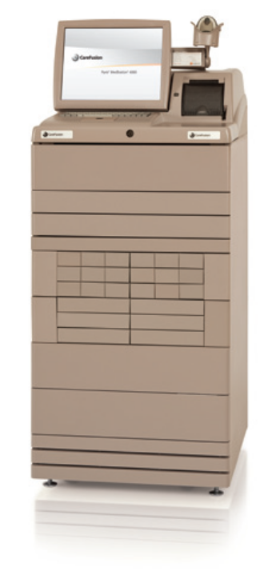
Riverview utilizes a Pyxis Medstation 4000 System for the dispensing of medications on each client care unit. A total of six devices, one on each of the four main units and in each of the two special care units, provide access to all medications used for client care, the pharmacy medication record, and allow review of dispensing and administration of pharmaceuticals.
A database program, HCS Medics, contains records of medication use for each client and allows access by an after-hours remote pharmacy service to these records, to the Pyxis Medstation 4000 System. The purpose of this after-hours service is to maintain 24 hour coverage and pharmacy validation and verification services for prescribers.
Records of transactions are evaluated by the Director of Pharmacy and the Medical Director to validate the appropriate utilization of all medication classes dispensed by the hospital. The Pharmacy and Therapeutics Committee, a multidisciplinary group of physicians, pharmacists, and other clinical staff evaluate issues related to the prescribing, dispensing, and administration of all pharmaceuticals.
The system as described is capable of providing information to process reviewers on the status of medications management in the hospital and to ensure the appropriate use of psychoactive and other medications.
The effectiveness and accuracy of the Pyxis Medstation 4000 System is analyzed regularly through the conduct of process improvement and functional efficiency studies. These studies can be found in the Medication Management and Pharmacy Services sections of this report.

(Glossary of Terms, Acronyms & Abbreviations) (Back to Table of Contents)
CONSENT DECREE

Discharges

Quarterly performance data shows that in 3 consecutive quarters:

V17) 70% of clients who remained ready for discharge were transitioned out of the hospital within 7 days of a determination that they had received maximum benefit from inpatient care;

V18) 80 % of clients who remained ready for discharge were transitioned out of the hospital within 30 days of a determination that they had received maximum benefit from inpatient care;

V19) 90% of clients who remained ready for discharge were transitioned out of the hospital within 45 days of a determination that they had received maximum benefit from inpatient care (with certain clients excepted, by agreement of the parties and court master).

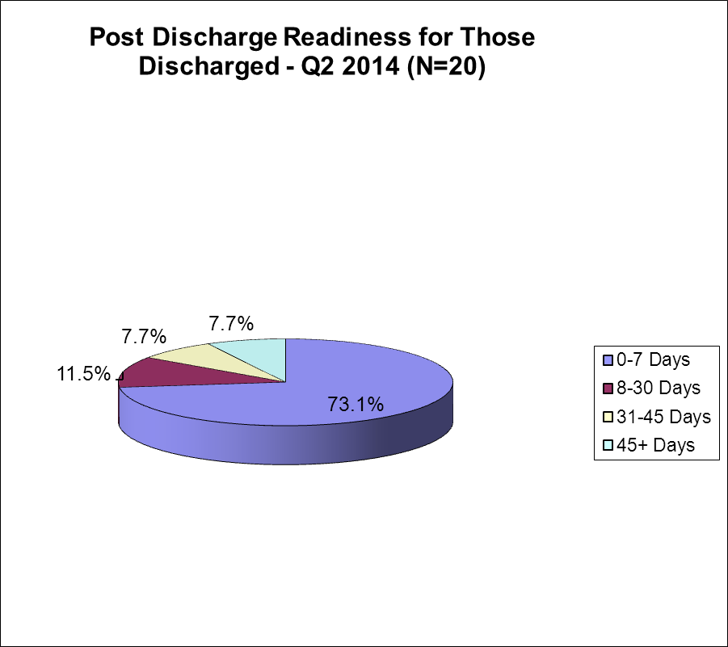 | Cumulative percentages & targets are as follows:  Within 7 days = (15) 73.1% (target 70%)  Within 30 days = (17) 84.6% (target 80%)  Within 45 days = (18) 92.3% (target 90%)  Post 45 days = (2) 7.7% (target 0%)
Barriers to Discharge Following Clinical Readiness
Residential Supports (1%)  1 client discharged 41 days post clinical readiness |  | Housing (10%)  1 client discharged 34 days post clinical readiness  1 client discharged 111 days post clinical readiness
Treatment Services (0)
No barriers in this area

The previous four quarters are displayed in the table below

Target >> |  | Within 7 days | Within 30days | Within 45 days | 45 +days
 |  | 70% | 80% | 90% | < 10%
1Q2014 | N=26 | 73.1% | 84.6% | 92.3% | 7.7%
4Q2013 | N=30 | 70% | 86.7% | 93.3% | 6.7%
3Q2013 | N=22 | 77.3% | 86.4% | 90.0% | 9.1%
2Q2013 | N-24 | 54.2% | 70.9% | 87.6% | 12.5%
(Glossary of Terms, Acronyms & Abbreviations) (Back to Table of Contents)
CONSENT DECREE

An evaluation of treatment and discharge planning, performed in accordance with Attachment D, demonstrates that, for 90% of the cases reviewed:

V20) Treatment and discharge plans reflect interventions appropriate to address discharge and transition goals;

V21a) For patients who have been found not criminally responsible or not guilty by reason of insanity, appropriate interventions include timely reviews of progress toward the maximum levels allowed by court order; and the record reflects timely reviews of progress toward the maximum levels allowed by court order;

V21) Interventions to address discharge and transition planning goals are in fact being implemented;

V21a) For patients who have been found not criminally responsible or not guilty by reason of insanity, this means that, if the treatment team determines that the patient is ready for an increase in levels beyond those allowed by the current court order, Riverview is taking reasonable steps to support a court petition for an increase in levels.

Indicators | 3Q2013 | 4Q2013 | 1Q2014 | 2Q2014
- The Client Discharge Plan Report will be updated/reviewed by each Social Worker minimally one time per week. | 100%  12/12 | 100%  13/13 | 100%  12/12 | 100%  11/11
- The Client Discharge Plan Report will be reviewed/updated minimally one time per week by the Director of Social Services. | 100%  12/12 | 100%  13/13 | 100%  12/12 | 100%  11/11
2a. The Client Discharge Plan Report will be sent out weekly as indicated in the approved court plan. | 100%  12/12 | 100%  13/13 | 91%  11/12 | 100%  11/11
- Each week the Social Work team and Director will meet and discuss current housing options provided by the respective regions and prioritize referrals. | 100%  12/12 | 100%  13/13 | 91%  11/12 | 100%  11/11

Meeting was cancelled once for the Christmas holiday but a report encompassing two weeks was distributed.

(Glossary of Terms, Acronyms & Abbreviations) (Back to Table of Contents)
CONSENT DECREE

V22) The Department demonstrates that 95% of the annual reports for forensic patients are submitted to the Commissioner and forwarded to the court on time.

Indicators | 3Q2013 | 4Q2013 | 1Q2014 | 2Q2014
- Institutional Reports will be completed, reviewed internally, and delivered to the court within 10 business days of request. | 87%  7/8 | 80%  8/10 | 12%  1/8 | 0%  0/4
- The assigned CCM will review the new court order with the client and document the meeting in a progress note or treatment team note. | 100$  9/9 | 100%  4/4 | 100%  2/2 | 100%  4/4
- Annual Reports (due Dec) to the commissioner for all inpatient NCR clients are submitted annually |  |  |  | 100%  92/92

Summary: Area 1, to address this area of continued challenge Social Work Director and Program Service Director will investigate why this area continues to not meet compliance, identify the barriers in the system, and create a system of tracking to ensure that this indicator comes into compliance going forward.
(Glossary of Terms, Acronyms & Abbreviations) (Back to Table of Contents)
CONSENT DECREE

Staffing and Staff Training

V23) Riverview performance data shows that 95% of direct care staff have received 90% of their annual training.
Indicators | 1Q2014 | 2Q2014 | 3Q2014 | 4Q2014 | 2014 Total
1. Riverview and Contract staff will attend CPR training bi-annually. | *40/46 | *64/67 |  |  | 93%
2. Riverview and Contract staff will attend NAPPI training annually. | *101/120 | *137/157 |  |  | 85%
3. Riverview and Contract staff will attend Annual training. | *11/25 | *78/81 |  |  | 83%

1Q 2014
1. *Of the six employees who are not in compliance, two staff are on Workers Compensation status, two staff are on Family Medical Leave, one transferred and missed training due to family emergency. All are scheduled for next available training. One staff is out of the country,
2. *Of the nineteen employees who are not in compliance two are on Workers Compensation leave, one is on LOA. Those remaining are scheduled for the next available training.
3. *Of the eleven staff who are not in compliance; two staff are on Workers Compensation, one is out of the country, one has transferred to another department. Supervisors of remaining staff have been informed they are in non-compliance and corrective actions have been taken.

2Q 2014
1. Three employees who are out of compliance are on leave status.
2. Eight of the employees are on leave status. The remaining twelve will be attending the next offered behavior management /physical intervention training.
3. The three the individuals who are not in compliance are on leave status.

Goal: SD will provide opportunities for employees to gain, develop and renew skills knowledge and aptitudes.
Objective: 100% of employees will be provided with an opportunity both formal and informal training and/or learning experiences that contribute to individual growth and improved performance in current position.
SD will survey staff annually and develop trainings to address training needs as identified by staff.
Current Status: 1Q SFY 13-14
Employee Education needs survey distributed to employees in March of 2013.
As a result of identified needs, the training entitled Personality Disorder Characteristics and Effective Interventions was developed and presented in August 2013.
August 19 & 26 2013, Susan C. Righthand, Ph.D, a nationally recognized speaker and consultant in the field of psychological assessment and treatment of sex offenders, conducted a two part training entitled: Working Effectively with Adult Sexual Offenders: Characteristics, Assessment, and Interventions available to all Riverview Psychiatric Center Employees.

August 20, 2013 Dr. Kenneth Beattie provided an in-service entitled: The Psychology of Working with Emotionally Challenging and Emotionally Challenged Clients. This training was developed in response to the Employee Education needs survey distributed to employees in March of 2013 and made available to all Riverview Psychiatric Center employees.
August 5, 2013, Single Wrist Restraint Application training was held to provide an opportunity to practice skills taught in the Initial NAPPI course provided to New Employees and NAPPI Recertification Class provided on a monthly basis through-out the year to Riverview Psychiatric Center employees. Over sixty unit staff attended.

(Glossary of Terms, Acronyms & Abbreviations) (Back to Table of Contents)
CONSENT DECREE

2Q SFY 13-14
Patricia Deegan Ph D. provided Recovery Oriented Care training which included lessons from her own recovery from schizophrenia while teaching practical strategies for:
- Balancing the Dignity of Risk with the Duty to Care when supporting individual involvement in decision making.
- Navigating the Neglect/Overprotect Continuum, especially when folks appear to be making self-defeating choices.
- Practicing leadership-for-recovery in the workplace.
On January 18th, James Claiborn, Ph. D, provided training entitled Understanding Behavior and Treatment Planning in which participants learned :
How to identify, define and describe behavior.
How to develop interventions that reinforce behavior we want to increase and extinguish behavior we want to decrease.

STAT Drills were offered throughout the month of November and December to provide staff with the opportunity to develop and enhance behavior intervention techniques and improve overall skill level when dealing with clients having difficulty maintaining positive behavior.

Goal: SD will develop and implement a comprehensive mentoring program to assist new employees in gaining the skills necessary to do their job.
Objective: 100% of new Mental Health Workers will be paired with a mentor and will satisfactorily complete 12 competency areas on the unit orientation prior to being assigned regular duties requiring direct care of patients.
Current Status: 1Q SFY 13-14
100% of new Mental Health Workers were paired with a mentor and satisfactorily completed competency areas in the Unit Orientation.
2Q SFY 13-14
100% of new Mental Health Workers were paired with a mentor and satisfactorily completed competency areas in the Unit Orientation.
(Glossary of Terms, Acronyms & Abbreviations) (Back to Table of Contents)
CONSENT DECREE

V24) Riverview certifies that 95% of professional staff have maintained professionally-required continuing education credits and have received the ten hours of annual cross-training required by ¶216;

DATE | HRS | TITLE | PRESENTER
3Q2012 | 14 | Jan- March 2012 | Winter Semester  (see1Q13 Quarterly Report)
4Q2012 | 11 | Apr – June 2012 | Spring Semester  (see1Q13 Quarterly Report)
1Q2013 | 3 | Jul – Sep 2012 | Summer Hiatus  (see1Q13 Quarterly Report)
2Q2013 | 9 | Oct – Dec 2012 | Fall Semester  (see2Q13 Quarterly Report)
3Q2013 | 11 | Jan – Mar 2013 | Winter Semester  (see 3Q13 Quarterly Report)
4Q2013 | 12 | Apr – June 2013 | Spring Semester  (see 4Q13 Quarterly Report)
1Q2014 | 5.5 | July - September 2013 | Summer Semester  (see 1Q14 Quarterly Report)
10/15/13 | 1 | Peer Review Committee: Case Review | William Nelson, MD
10/17/13 | 1 | Epigenetics – The Future of Medicine: A Primer and References to Major Mental Illness | George Davis, MD
10/24/13 | 1 | Overview of Changes in DSM-5 Psychotic Disorders | Douglas Noordsy, MD
10/31/13 | 1 | Differences Between ODT and SL Tablet Formulations | Miranda Cole, PharmD  Patrick Cote, RN  Renee Dufresne, Pharmacy Student
11/7/13 | 1 | Recovery, Treatment Resistance, and Recidivism: Three Case Reviews | David Dettmann, DO
11/2013 | 1 | Peer Review Committee: Case Review | William Nelson, MD
11/21/13 | 1 | Mass Shootings: Is Prevention Possible/ A Forum For Discussion | Mitch Manin, MD

(Glossary of Terms, Acronyms & Abbreviations) (Back to Table of Contents)
CONSENT DECREE

V25) Riverview certifies that staffing ratios required by ¶202 are met, and makes available documentation that shows actual staffing for up to one recent month;

Staff Type | Consent Decree Ratio
General Medicine Physicians | 1:75
Psychiatrists | 1:25
Psychologists | 1:25
Nursing | 1:20
Social Workers | 1:15
Mental Health Workers | 1:6
Recreational/Occupational Therapists/Aides | 1:8

With 92 beds, Riverview regularly meets or exceeds the staffing ratio requirements of the consent decree.

Staffing levels are most often determined by an analysis of unit acuity, individual monitoring needs of the clients who residing on specific units, and unit census.

V26) The evaluation of treatment and discharge planning, performed in accordance with Attachment D, demonstrates that staffing was sufficient to provide patients access to activities necessary to achieve the patients’ treatment goals, and to enable patients to exercise daily and to recreate outdoors consistent with their treatment plans.

Treatment teams regularly monitor the needs of individual clients and make recommendations for ongoing treatment modalities. Staffing levels are carefully monitored to ensure that all treatment goals, exercise needs, and outdoor activities are achievable. Staffing does not present a barrier to the fulfillment of client needs. Staffing deficiencies that may periodically be present are rectified through utilization of overtime or mandated staff members.

(Glossary of Terms, Acronyms & Abbreviations) (Back to Table of Contents)
CONSENT DECREE

Use of Seclusion and Restraints

V27) Quarterly performance data shows that, in 5 out of 6 quarters, total seclusion and restraint hours do not exceed one standard deviation from the national mean as reported by NASMHPD;

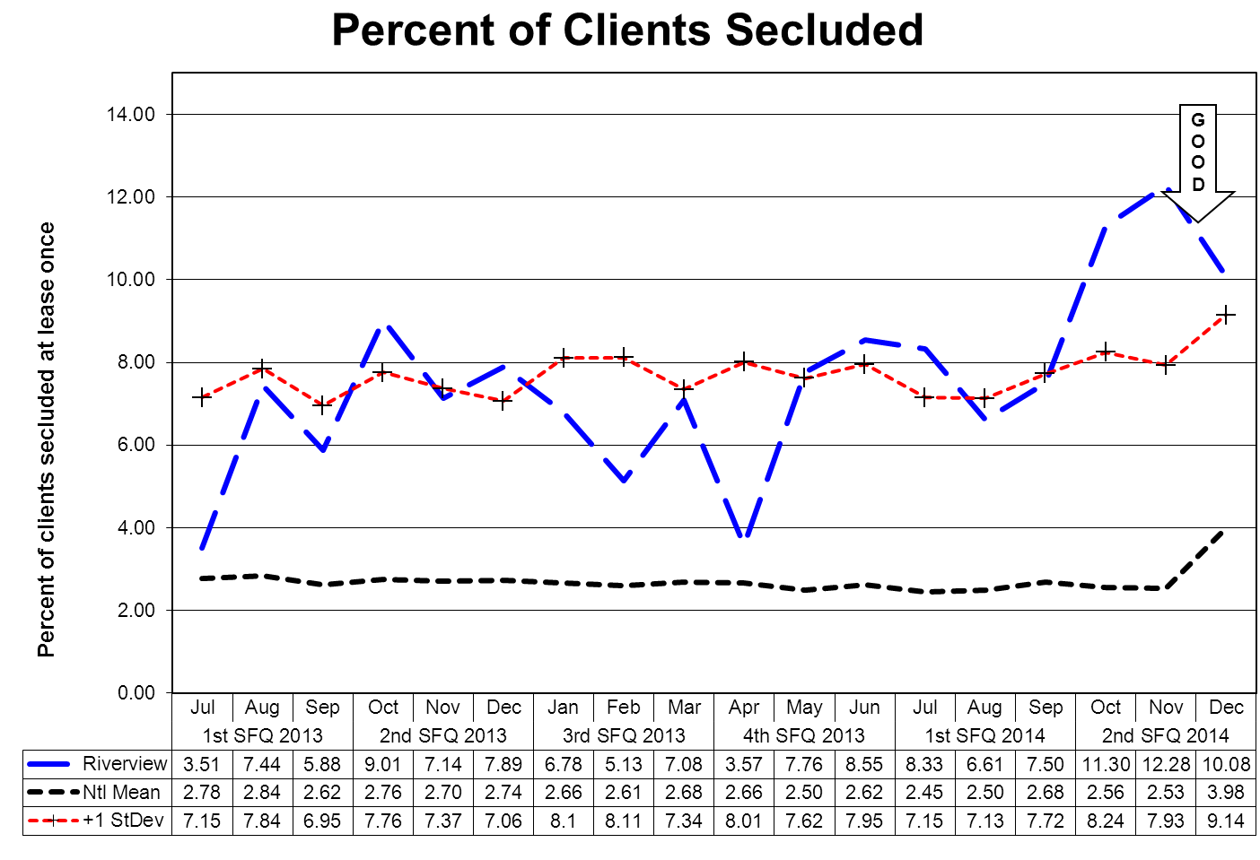

This graph depicts the percent of unique clients who were secluded at least once. For example, a rate of 3.0 means that 3% of the unique clients served were secluded at least once.
The following graphs depict the percent of unique clients who were secluded at least once stratified by forensic or civil classifications. For example, a rate of 3.0 means that 3% of the unique clients served were secluded at least once.
The hospital-wide results from the Dorothea Dix facility are compared to the civil population results at the Riverview facility due to the homogeneous nature of these two sample groups.
(Glossary of Terms, Acronyms & Abbreviations) (Back to Table of Contents)
CONSENT DECREE

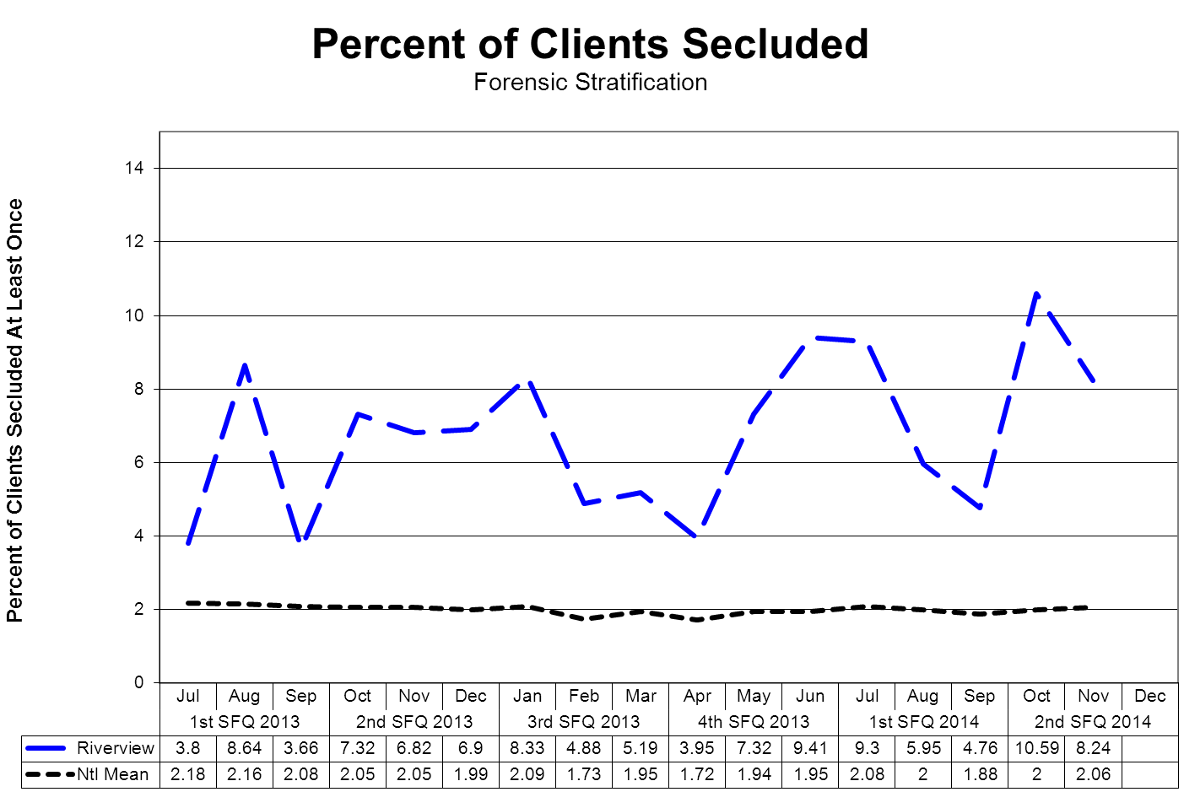

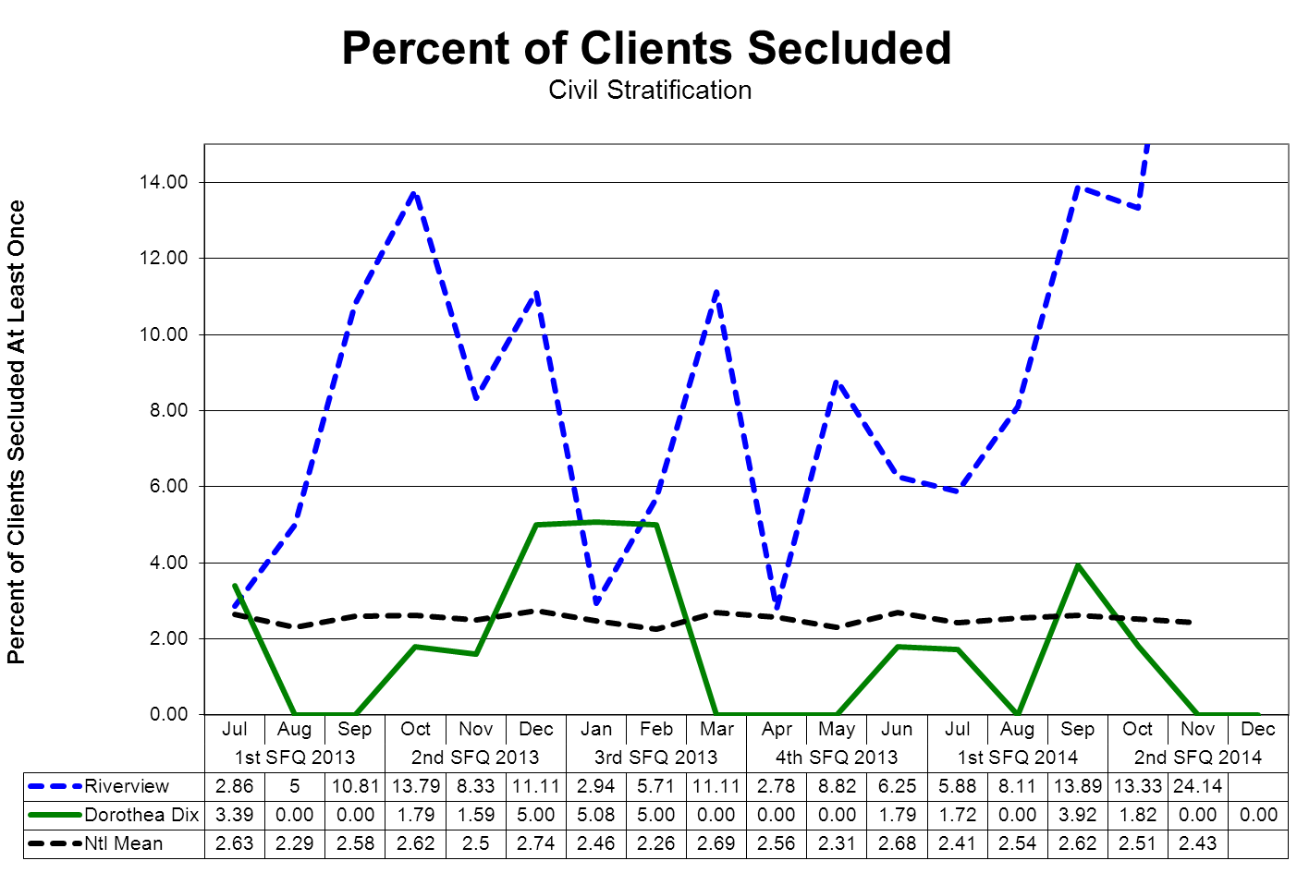
(Glossary of Terms, Acronyms & Abbreviations) (Back to Table of Contents)
CONSENT DECREE

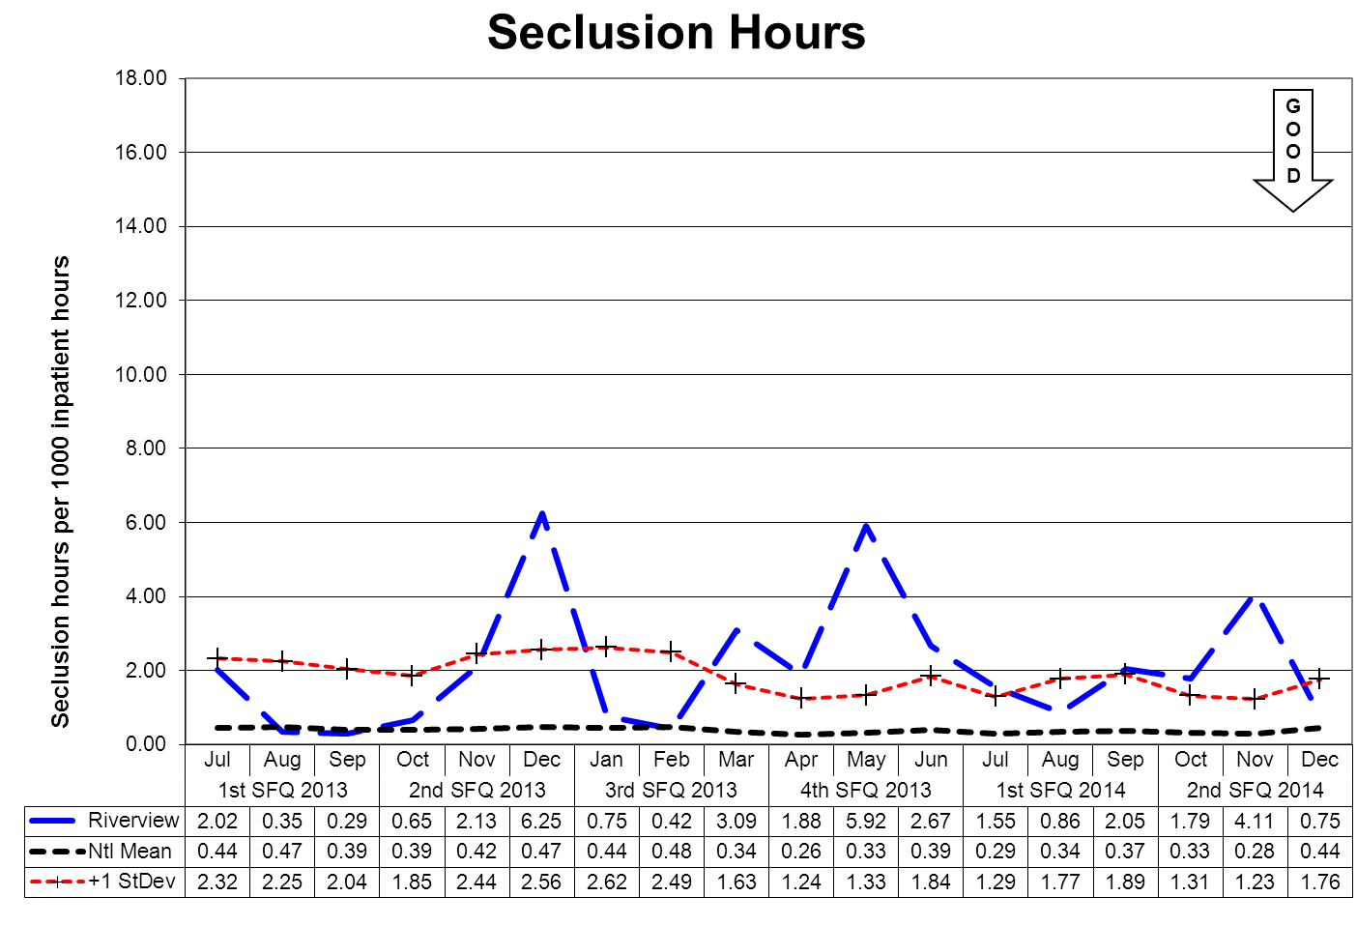

This graph depicts the number of hours clients spent in seclusion for every 1000 inpatient hours. For example, a rate of 0.8 means that 1 hour was spent in seclusion for each 1250 inpatient hours.

The outlier values shown in May and June reflect the events related to a single individual during this period. This individual was in seclusion for extended periods of time due to extremely aggressive behaviors that are focused on staff. It was determined that the only way to effectively manage this client and create a safe environment for both the staff and other clients was to segregate him in an area away from other clients and to provide frequent support and interaction with staff in a manner that ensured the safety of the staff so engaged.
The following graphs depict the number of hours clients spent in seclusion for every 1000 inpatient hours stratified by forensic or civil classifications. For example, a rate of 0.8 means that 1 hour was spent in seclusion for each 1250 inpatient hours.
The hospital-wide results from the Dorothea Dix facility are compared to the civil population results at the Riverview facility due to the homogeneous nature of these two sample groups.

(Glossary of Terms, Acronyms & Abbreviations) (Back to Table of Contents)
CONSENT DECREE

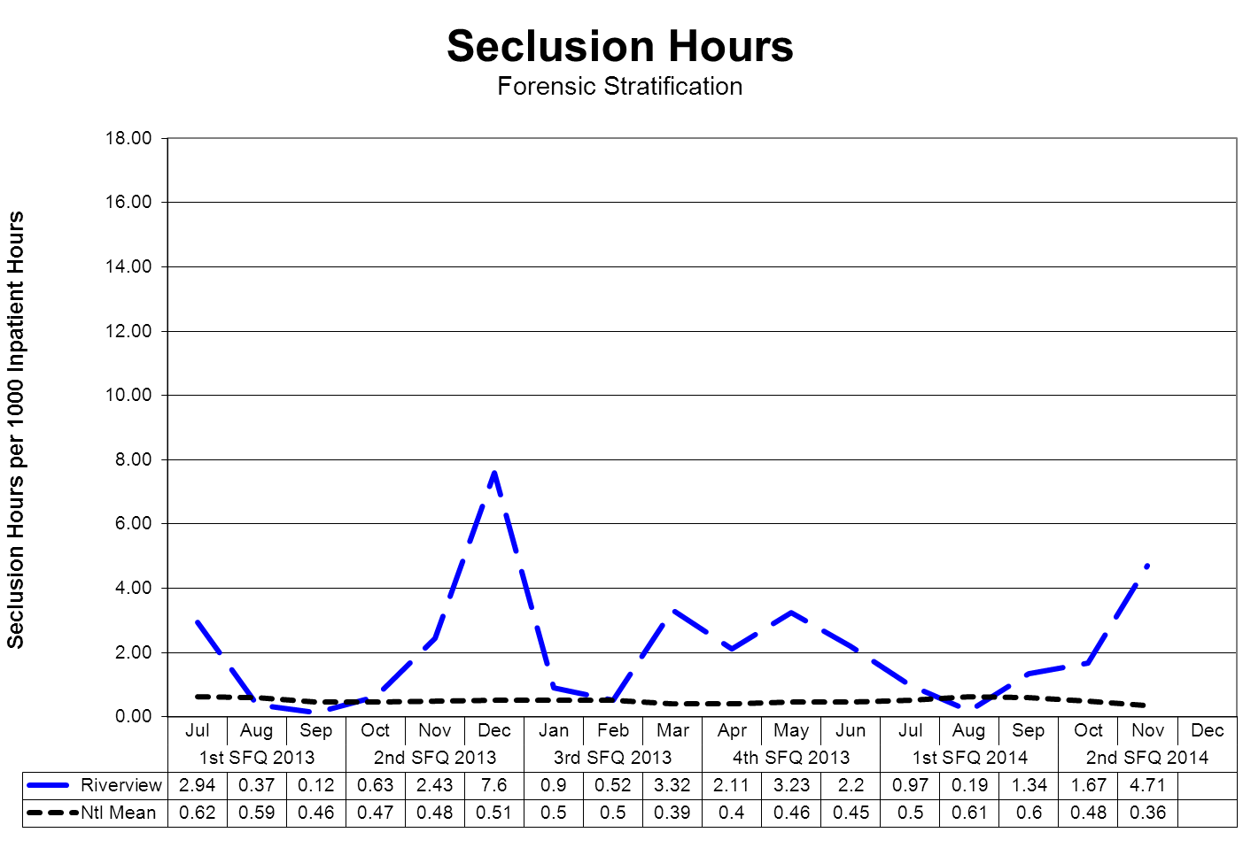
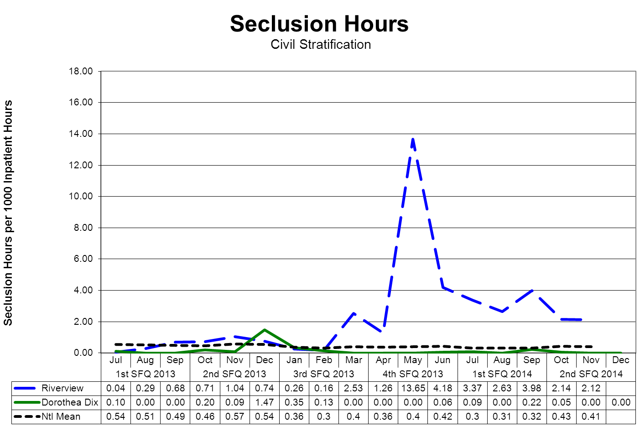
(Glossary of Terms, Acronyms & Abbreviations) (Back to Table of Contents)
CONSENT DECREE

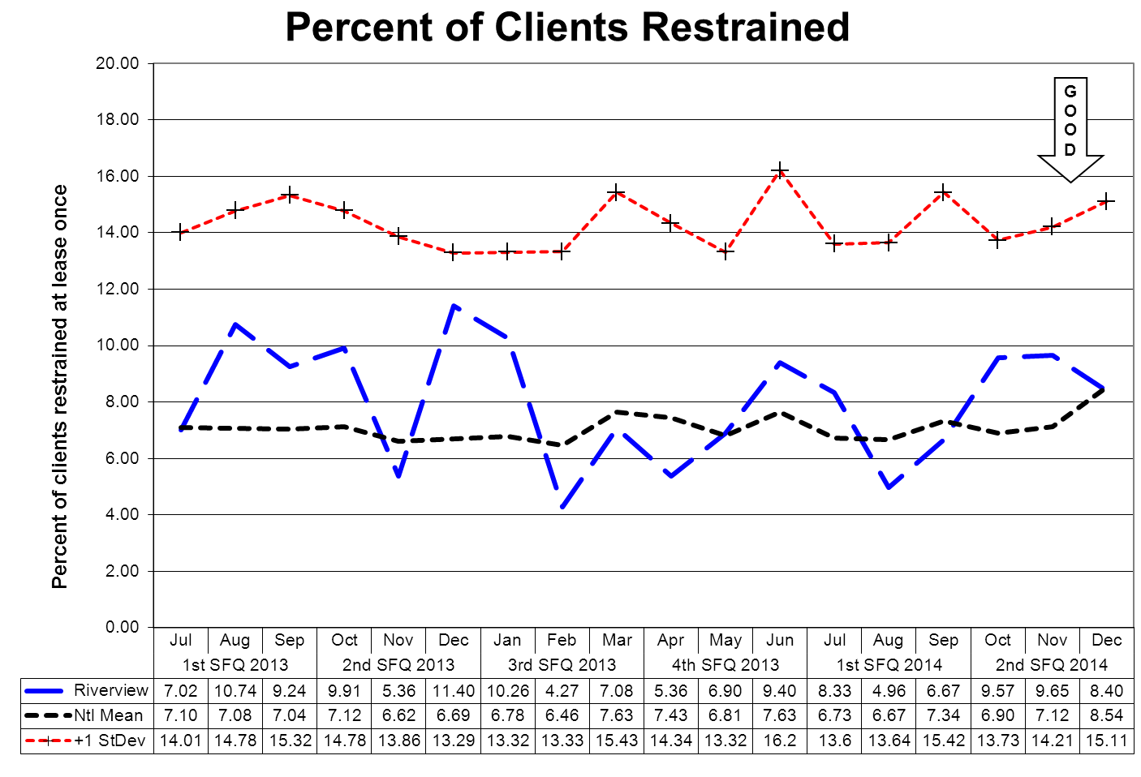

This graph depicts the percent of unique clients who were restrained at least once – includes all forms of restraint of any duration. For example, a rate of 4.0 means that 4% of the unique clients served were restrained at least once.
The following graphs depict the percent of unique clients who were restrained at least once stratified by forensic or civil classifications – includes all forms of restraint of any duration. For example, a rate of 4.0 means that 4% of the unique clients served were restrained at least once.
The hospital-wide results from the Dorothea Dix facility are compared to the civil population results at the Riverview facility due to the homogeneous nature of these two sample groups.
(Glossary of Terms, Acronyms & Abbreviations) (Back to Table of Contents)
CONSENT DECREE

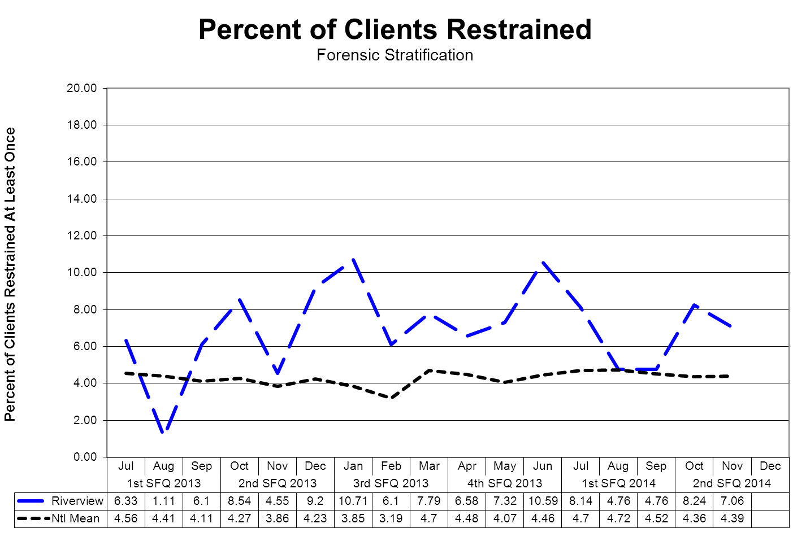
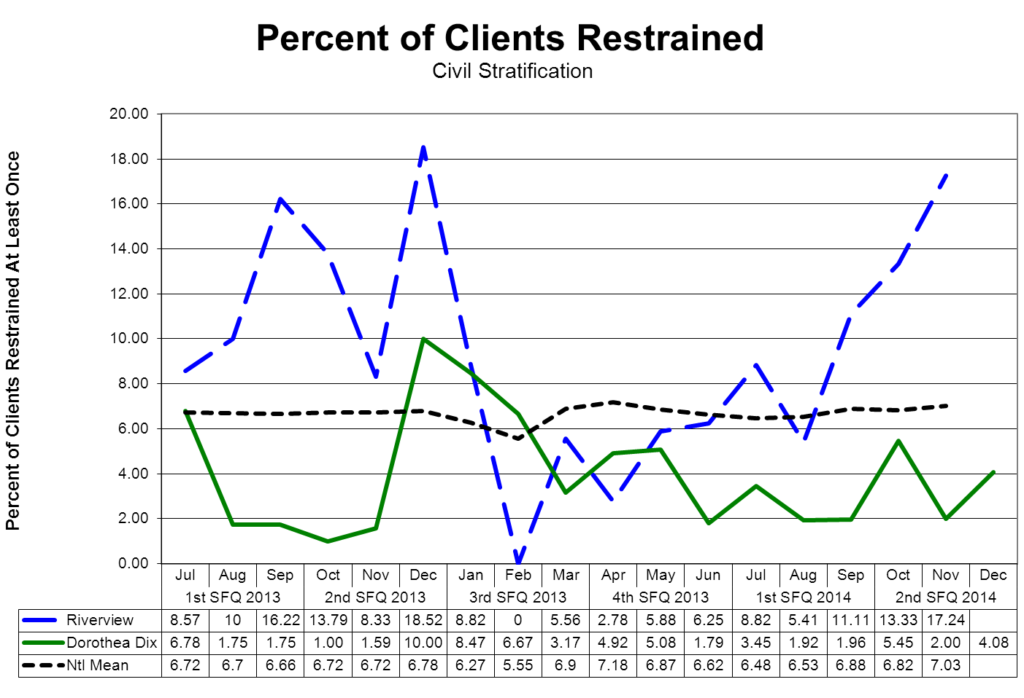
(Glossary of Terms, Acronyms & Abbreviations) (Back to Table of Contents)
CONSENT DECREE

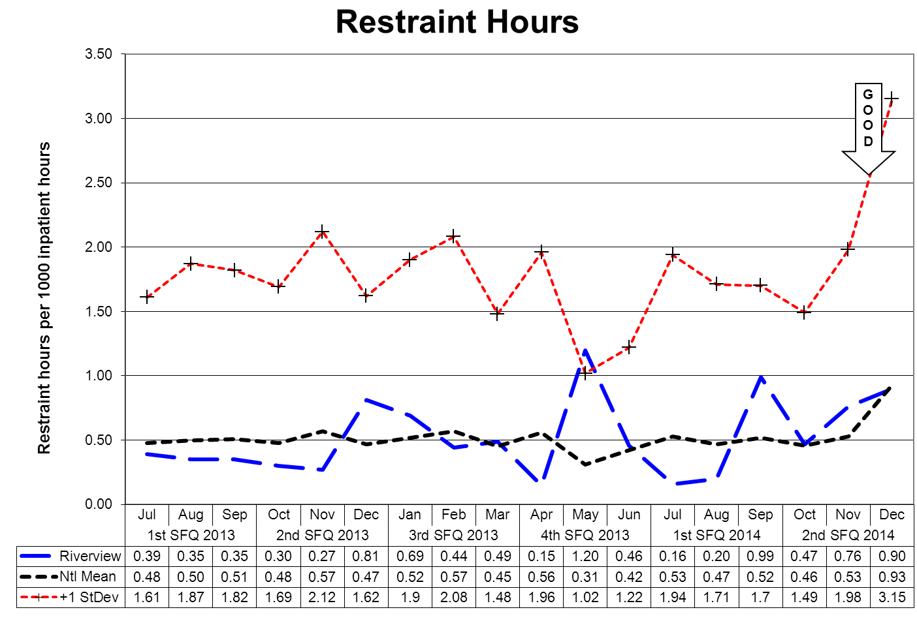
This graph depicts the number of hours clients spent in restraint for every 1000 inpatient hours - includes all forms of restraint of any duration. For example, a rate of 1.6 means that 2 hours were spent in restraint for each 1250 inpatient hours.
The following graphs depict the number of hours clients spent in restraint for every 1000 inpatient hours stratified by forensic or civil classifications - includes all forms of restraint of any duration. For example, a rate of 1.6 means that 2 hours were spent in restraint for each 1250 inpatient hours.
The hospital-wide results from the Dorothea Dix facility are compared to the civil population results at the Riverview facility due to the homogeneous nature of these two sample groups.
(Glossary of Terms, Acronyms & Abbreviations) (Back to Table of Contents)
CONSENT DECREE

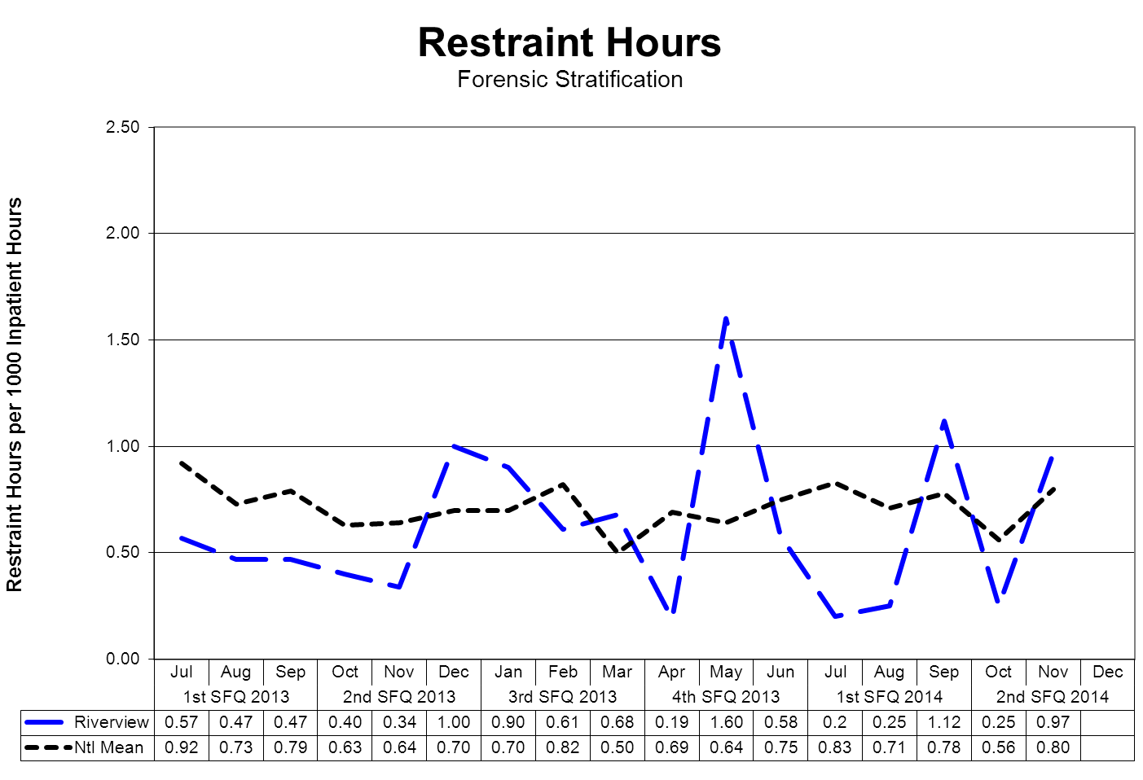
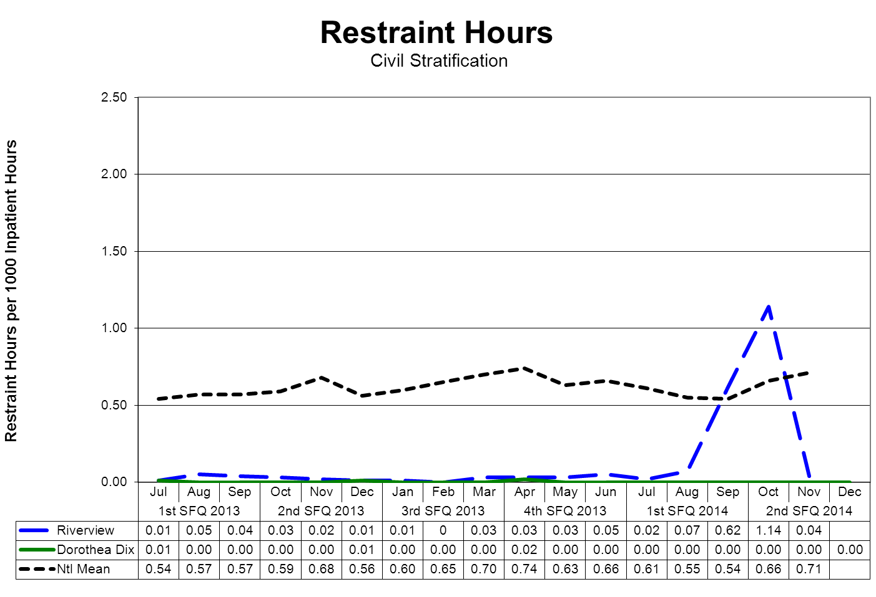
(Glossary of Terms, Acronyms & Abbreviations) (Back to Table of Contents)
CONSENT DECREE

Confinement Event Detail
2nd Quarter 2014

 | Manual Hold | Mechanical Restraint | Locked Seclusion | Grand Total | % of Total | Cumulative %
MR00000657 | 26 | 36 | 11 | 73 | 31.6% | 31.6%
MR00007411 | 31 | 11 | 3 | 45 | 19.5% | 51.1%
MR00006963 | 6 |  | 13 | 19 | 8.2% | 59.3%
MR00003374 | 5 |  | 7 | 12 | 5.2% | 64.5%
MR00006330 | 2 |  | 9 | 11 | 4.8% | 69.3%
MR00000814 |  | 2 | 6 | 8 | 3.5% | 72.7%
MR00007419 | 3 |  | 4 | 7 | 3.0% | 75.8%
MR00004814 | 2 |  | 3 | 5 | 2.2% | 77.9%
MR00007431 |  |  | 4 | 4 | 1.7% | 79.7%
MR00006955 |  |  | 4 | 4 | 1.7% | 81.4%
MR00003726 | 1 |  | 2 | 3 | 1.3% | 82.7%
MR00004271 |  | 1 | 2 | 3 | 1.3% | 84.0%
MR00004637 | 1 |  | 2 | 3 | 1.3% | 85.3%
MR00005267 | 1 |  | 2 | 3 | 1.3% | 86.6%
MR00000029 | 1 | 1 | 1 | 3 | 1.3% | 87.9%
MR00007394 | 1 |  | 2 | 3 | 1.3% | 89.2%
MR00007340 | 1 |  | 2 | 3 | 1.3% | 90.5%
MR00006799 | 1 |  | 2 | 3 | 1.3% | 91.8%
MR00007359 | 2 |  |  | 2 | 0.9% | 92.6%
MR00007127 | 1 |  | 1 | 2 | 0.9% | 93.5%
MR00007189 | 1 |  | 1 | 2 | 0.9% | 94.4%
MR00007291 | 1 |  | 1 | 2 | 0.9% | 95.2%
MR00007455 | 1 |  | 1 | 2 | 0.9% | 96.1%
MR00006314 |  |  | 2 | 2 | 0.9% | 97.0%
MR00007458 | 1 |  | 1 | 2 | 0.9% | 97.8%
MR00000091 | 1 |  | 1 | 2 | 0.9% | 98.7%
MR00007314 | 1 |  |  | 1 | 0.4% | 99.1%
MR00002313 | 1 |  |  | 1 | 0.4% | 99.6%
MR00007457 |  |  | 1 | 1 | 0.4% | 100.0%
 | 92 | 51 | 88 | 231

39% (29/74) of average hospital population experienced some form of confinement event during the 2nd fiscal quarter 2014. Five of these clients (7% of the average hospital population) accounted for 69% of the containment events.

The trend in frequency of confinement event, specifically the increase in the trend related to mechanical restraints is due to a few high acute clients requiring special management to ensure the safety of the milieu.
(Glossary of Terms, Acronyms & Abbreviations) (Back to Table of Contents)
CONSENT DECREE

.
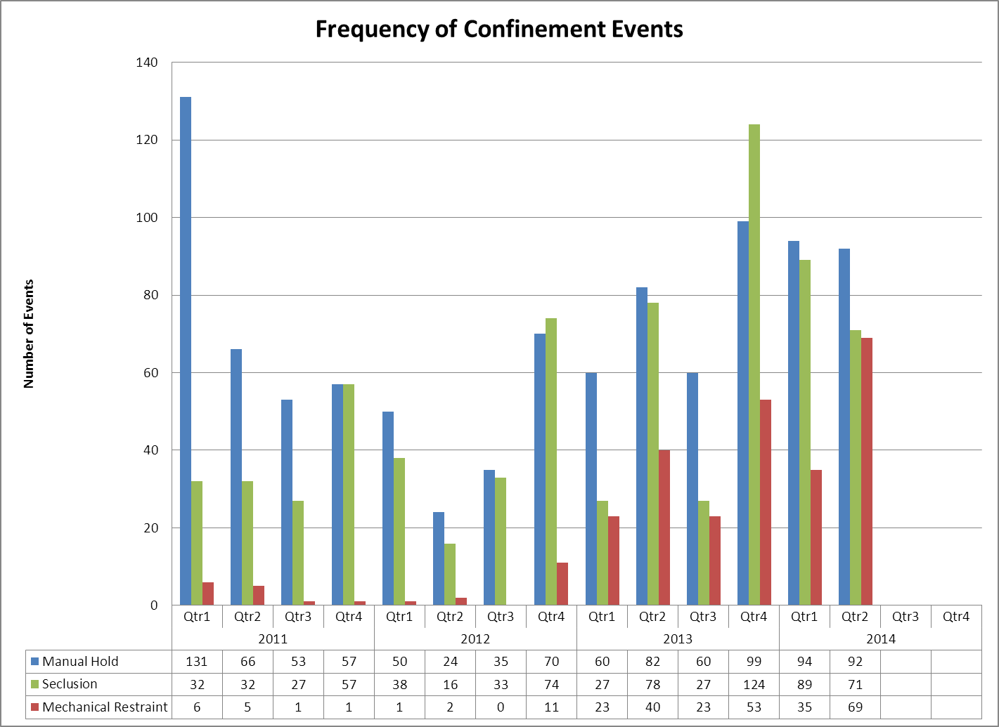

Since December 2012, Riverview has been admitting an increasing number of forensic clients that are extremely violent and difficult to manage. This increase in high acutiy clients has required the use of specialized management techniques that ensure the safety of these clients, other clients, and staff while attempting to maintain a therapeutic mileau.

Best practices from other forensic facilities and recommendations from experts in forensic client management from other State of Maine departments have been considered in the management of these clients.
(Glossary of Terms, Acronyms & Abbreviations) (Back to Table of Contents)
CONSENT DECREE

V28) Riverview demonstrates that, based on a review of two quarters of data, for 95% of seclusion events, seclusion was employed only when absolutely necessary to protect the patient from causing physical harm to self or others or for the management of violent behavior;

Factors of Causation Related to Seclusion Events
 | 2Q13 | 3Q13 | 4Q13 | 1Q14 | 2Q14
Danger to Others/Self | 78 | 50 | 124 | 71 | 88
Danger to Others
Danger to Self |  | 1
% Dangerous Precipitation | 100% | 100% | 100% | 100% | 100%
Total Events | 78 | 51 | 124 | 71 | 88

V29) Riverview demonstrates that, based on a review of two quarters of data, for 95% of restraint events involving mechanical restraints, the restraint was used only when absolutely necessary to protect the patient from serious physical injury to self or others;

Factors of Causation Related to Mechanical Restraint Events
 | 2Q13 | 3Q13 | 4Q13 | 1Q14 | 2Q14
Danger to Others/Self | 40 | 40 | 53 | 29 | 51
Danger to Others
Danger to Self |  |  |  |  | 1
% Dangerous Precipitation | 100% | 100% | 100% | 100% | 100%
Total Events | 40 | 40 | 53 | 29 | 52

V30) Riverview demonstrates that, based on a review of two quarters of data, for 95% of seclusion and restraint events, the hospital achieved an acceptable rating for meeting the requirements of paragraphs 182 and 184 of the Settlement Agreement, in accordance with a methodology defined in Attachments E-1 and E-2.

See Pages 29 & 30

(Glossary of Terms, Acronyms & Abbreviations) (Back to Table of Contents)
CONSENT DECREE

Confinement Events Management
Seclusion Events (88) Events
  Standard | Threshold | Compliance
  The record reflects that seclusion was absolutely necessary to protect the patient from causing physical harm to self or others, or if the patient was examined by a physician or physician extender prior to implementation of seclusion, to prevent further serious disruption that significantly interferes with other patients’ treatment. | 95% | 100%
  The record reflects that lesser restrictive alternatives were inappropriate or ineffective. This can be reflected anywhere in record. | 90% | 100%
  The record reflects that the decision to place the patient in seclusion was made by a physician or physician extender. | 90% | 100%
  The decision to place the patient in seclusion was entered in the patient’s records as a medical order. | 90% | 100%
  The record reflects that, if the physician or physician extender was not immediately available to examine the patient, the patient was placed in seclusion following an examination by a nurse. | 90% | 100%
  The record reflects that the physician or physician extender personally evaluated the patient within 30 minutes after the patient has been placed in seclusion, and if there is a delay, the reasons for the delay. | 90% | 100%
  The record reflects that the patient was monitored every 15 minutes. (Compliance will be deemed if the patient was monitored at least 3 times per hour.) | 90% | 100%
  Individuals implementing seclusion have been trained in techniques and alternatives. | 90% | 100%
  The record reflects that reasonable efforts were taken to notify guardian or designated representative as soon as possible that patient was placed in seclusion. | 75% | 100%
  Standard | Threshold | Compliance
  The medical order states time of entry of order and that number of hours in seclusion shall not exceed 4. | 85% | 100%
  The medical order states the conditions under which the patient may be sooner released. | 85% | 100%
  The record reflects that the need for seclusion is re-evaluated at least every 2 hours by a nurse. | 90% | 100%
  The record reflects that the 2 hour re-evaluation was conducted while the patient was out of seclusion room unless clinically contraindicated. | 70% | 100%
  The record includes a special check sheet that has been filled out to document reason for seclusion, description of behavior and the lesser restrictive alternatives considered. | 85% | 100%
  The record reflects that the patient was released, unless clinically contraindicated, at least every 2 hours or as necessary for eating, drinking, bathing, toileting or special medical orders. | 85% | 100%
  Reports of seclusion events were forwarded to medical director and advocate. | 90% | 100%
  The record reflects that, for persons with mental retardation, the regulations governing seclusion of clients with mental retardation were met. | 85% | 100%
  The medical order for seclusion was not entered as a PRN order. | 90% | 100%
  Where there was a PRN order, there is evidence that physician was counseled. | 95% | N/A
(Glossary of Terms, Acronyms & Abbreviations) (Back to Table of Contents)
CONSENT DECREE

Confinement Events Management
Mechanical Restraint Events (52) Events
  Standard | Threshold | Compliance
  The record reflects that restraint was absolutely necessary to protect the patient from causing serious physical injury to self or others. | 95% | 100%
  The record reflects that lesser restrictive alternatives were inappropriate or ineffective. | 90% | 100%
  The record reflects that the decision to place the patient in restraint was made by a physician or physician extender | 90% | 100%
  The decision to place the patient in restraint was entered in the patient’s records as a medical order. | 90% | 100%
  The record reflects that, if a physician or physician extended was not immediately available to examine the patient, the patient was placed in restraint following an examination by a nurse. | 90% | 100%
  The record reflects that the physician or physician extender personally evaluated the patient within 30 minutes after the patient has been placed in restraint, or, if there was a delay, the reasons for the delay. | 90% | 100%
  The record reflects that the patient was kept under constant observation during restraint. | 95% | 100%
  Individuals implementing restraint have been trained in techniques and alternatives. | 90% | 100%
  The record reflects that reasonable efforts taken to notify guardian or designated representative as soon as possible that patient was placed in restraint. | 75% | 100%
  The medical order states time of entry of order and that number of hours shall not exceed four. | 90% | 100%
  The medical order shall state the conditions under which the patient may be sooner released. | 85% | 100%
  Standard | Threshold | Compliance
  The record reflects that the need for restraint was re-evaluated every 2 hours by a nurse. | 90% | 100%
  The record reflects that re-evaluation was conducted while the patient was free of restraints unless clinically contraindicated. | 70% | 100%
  The record includes a special check sheet that has been filled out to document the reason for the restraint, description of behavior and the lesser restrictive alternatives considered. | 85% | 100%
  The record reflects that the patient was released as necessary for eating, drinking, bathing, toileting or special medical orders. | 90% | 100%
  The record reflects that the patient’s extremities were released sequentially, with one released at least every fifteen minutes. | 90% | 100%
  Copies of events were forwarded to medical director and advocate. | 90% | 100%
  For persons with mental retardation, the applicable regulations were met. | 85% | 100%
  The record reflects that the order was not entered as a PRN order. | 90% | 100%
  Where there was a PRN order, there is evidence that physician was counseled. | 95% | N/A
  A restraint event that exceeds 24 hours will be reviewed against the following requirement: If total consecutive hours in restraint, with renewals, exceeded 24 hours, the record reflects that the patient was medically assessed and treated for any injuries; that the order extending restraint beyond 24 hours was entered by Medical Director (or if the Medical Director is out of the hospital, by the individual acting in the Medical Director’s stead) following examination of the patient; and that the patient’s guardian or representative has been notified. | 90% | 100%

(Glossary of Terms, Acronyms & Abbreviations) (Back to Table of Contents)
CONSENT DECREE

Client Elopements

V31) Quarterly performance data shows that, in 5 out of 6 quarters, the number of client elopements do not exceed one standard deviation from the national mean as reported by NASMHPD
.
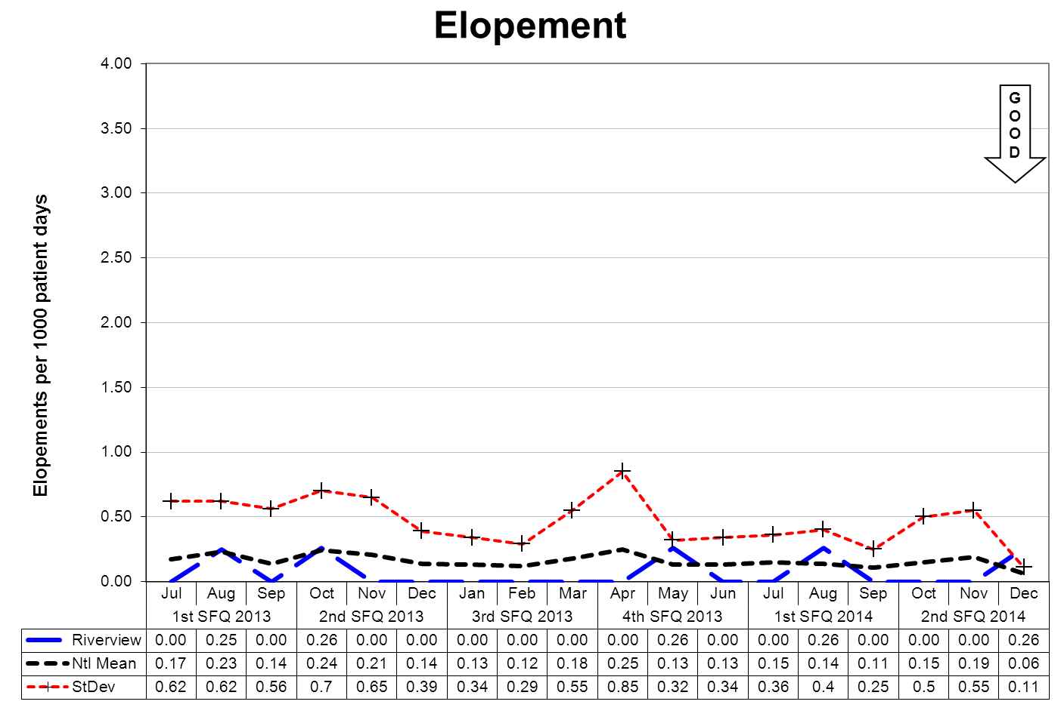

This graph depicts the number of elopements that occurred for every 1000 inpatient days. For example, a rate of 0.25 means that 1 elopement occurred for each 4000 inpatient days.
An elopement is defined as any time a client is “absent from a location defined by the client’s privilege status regardless of the client’s leave or legal status.”
The following graphs depict the number of elopements stratified by forensic or civil classifications that occurred for every 1000 inpatient days. For example, a rate of 0.25 means that 1 elopement occurred for each 4000 inpatient days.
The hospital-wide results from the Dorothea Dix facility are compared to the civil population results at the Riverview facility due to the homogeneous nature of these two sample groups.
(Glossary of Terms, Acronyms & Abbreviations) (Back to Table of Contents)
CONSENT DECREE

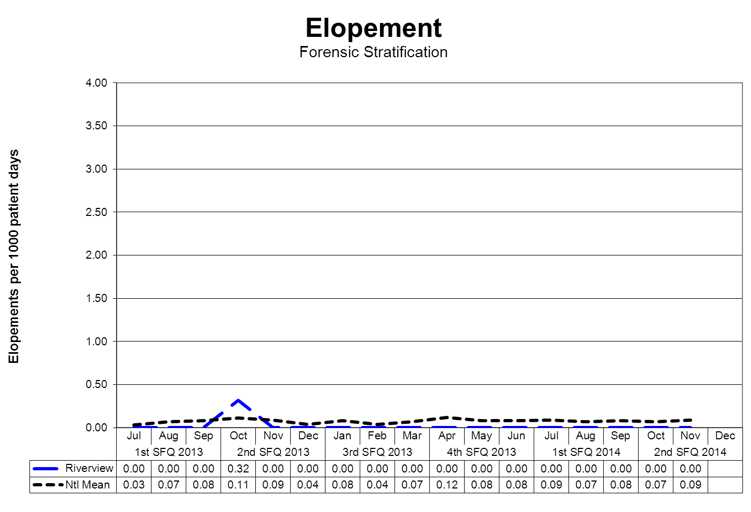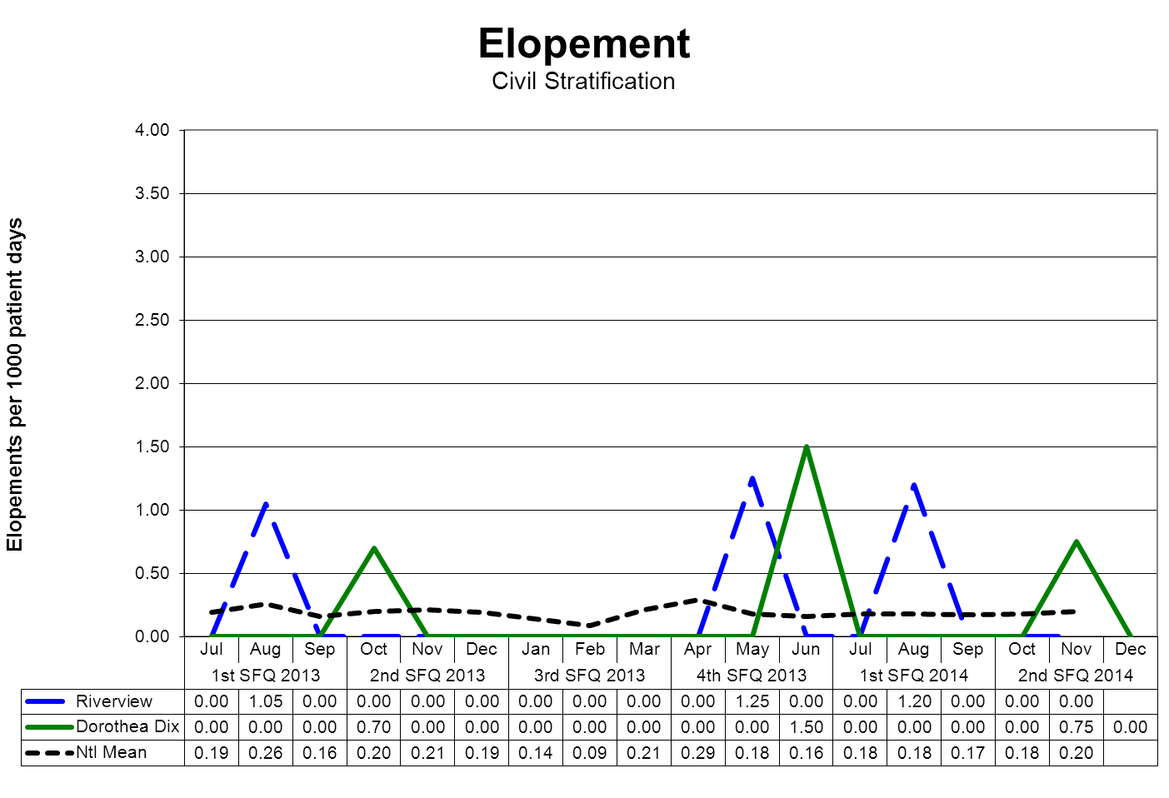
(Glossary of Terms, Acronyms & Abbreviations) (Back to Table of Contents)
CONSENT DECREE

Client Injuries

V32) Quarterly performance data shows that, in 5 out of 6 quarters, the number of client injuries does not exceed one standard deviation from the national mean as reported by NASMHPD.
The NASMHPD standards for measuring client injuries differentiate between injuries that are considered reportable to the Joint Commission as a performance measure and those injuries that are of a less severe nature. While all injuries are currently reported internally, only certain types of injuries are documented and reported to NRI for inclusion in the performance measure analysis process.
“Non-reportable” injuries include those that require: 1) No Treatment, or 2) Minor First Aid
Reportable injuries include those that require: 3) Medical Intervention, 4) Hospitalization or where, 5) Death Occurred.
- No Treatment – The injury received by a client may be examined by a clinician but no treatment is applied to the injury.
- Minor First Aid – The injury received is of minor severity and requires the administration of minor first aid.
- Medical Intervention Needed – The injury received is severe enough to require the treatment of the client by a licensed practitioner, but does not require hospitalization.
- Hospitalization Required – The injury is so severe that it requires medical intervention and treatment as well as care of the injured client at a general acute care medical ward within the facility or at a general acute care hospital outside the facility.
- Death Occurred – The injury received was so severe that if resulted in, or complications of the injury lead to, the termination of the life of the injured client.
The comparative statistics graph only includes those events that are considered “Reportable” by NASMHPD.

(Glossary of Terms, Acronyms & Abbreviations) (Back to Table of Contents)
CONSENT DECREE

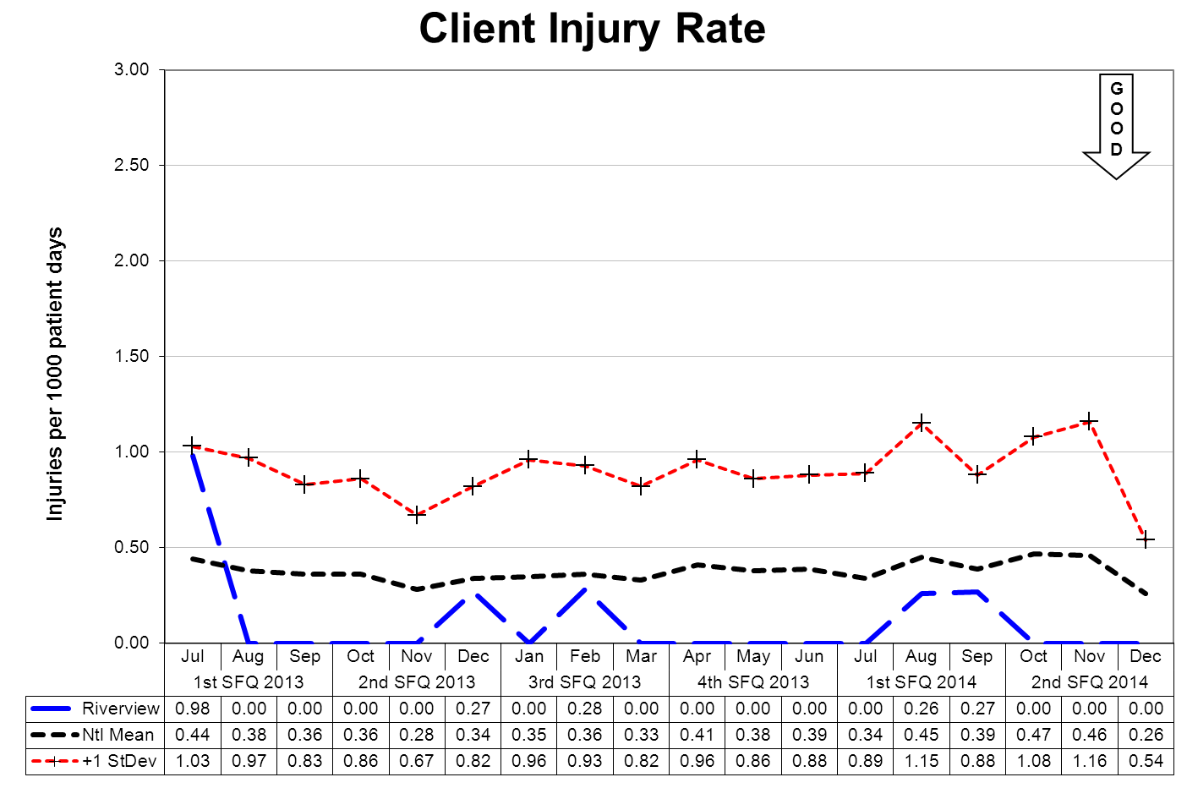

This graph depicts the number of client injury events that occurred for every 1000 inpatient days. For example, a rate of 0.5 means that 1 injury occurred for each 2000 inpatient days.
The following graphs depict the number of client injury events stratified by forensic or civil classifications that occurred for every 1000 inpatient days. For example, a rate of 0.5 means that 1 injury occurred for each 2000 inpatient days.
The hospital-wide results from the Dorothea Dix facility are compared to the civil population results at the Riverview facility due to the homogeneous nature of these two sample groups.
(Glossary of Terms, Acronyms & Abbreviations) (Back to Table of Contents)
CONSENT DECREE
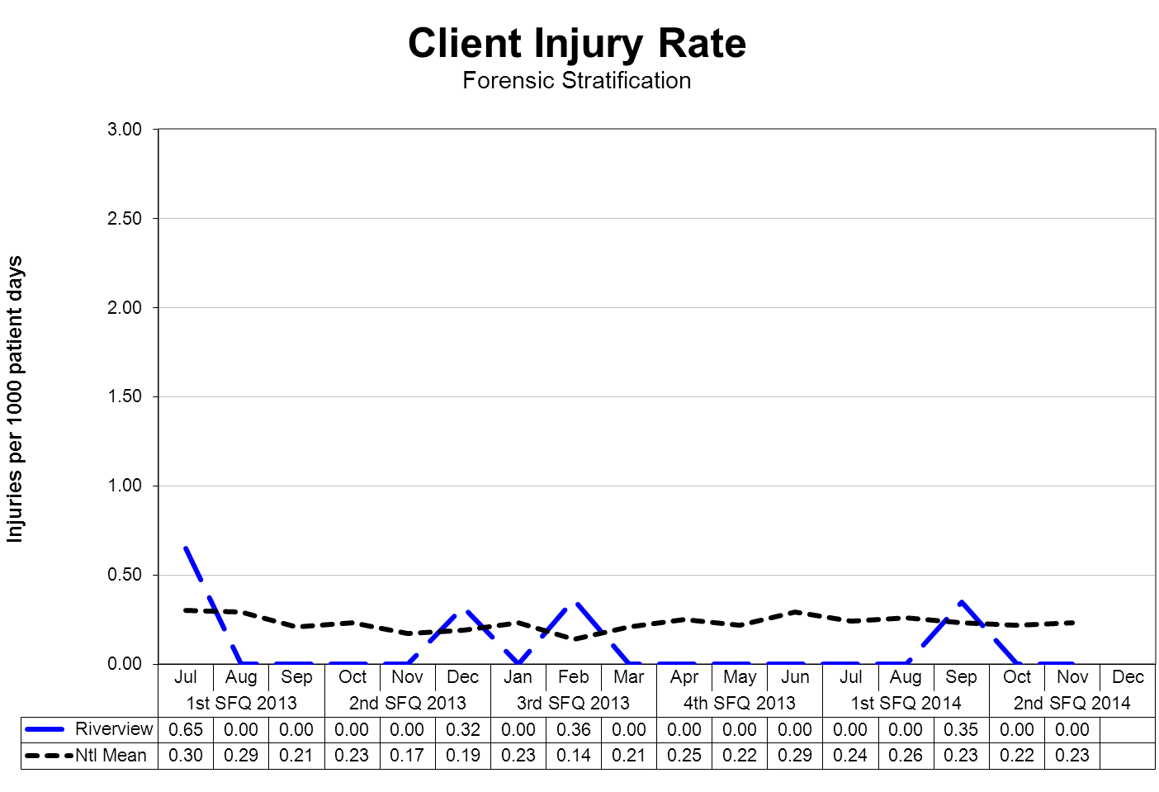
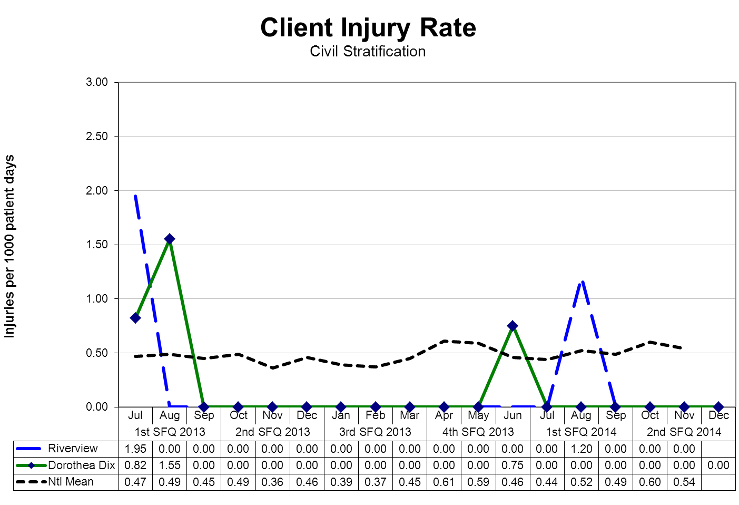
(Glossary of Terms, Acronyms & Abbreviations) (Back to Table of Contents)
CONSENT DECREE

Severity of injury by Month

Severity | OCT | NOV | DEC | 2Q2014
No Treatment | 58 | 31 | 27 | 116
Minor First Aid
Medical Intervention Required
Hospitalization Required
Death Occurred
Total | 58 | 31 | 27 | 116

Type and Cause of Injury by Month

Type - Cause | OCT | NOV | DEC | 2Q2014
Accident – Fall Unwitnessed | 4 | 1 | 2 | 7
Accident – Fall Witnessed | 9 | 2 | 7 | 18
Accident – Other |  | 1 | 1 | 2
Assault – Client to Client | 21 | 16 | 3 | 40
Self-Injurious Behavior | 24 | 11 | 14 | 49
Total | 58 | 31 | 27 | 116

Changes in reporting standards related to “criminal” events as defined by the “State of Maine Rules for Reporting Sentinel Events”, effective February 1, 2013 as defined the by “National Quality Forum 2011 List of Serious Reportable Events” the number of reportable “assaults” that occur as the result of client interactions increased significantly. This change is due primarily as a result of the methods and rules related to data collection and abstraction.
Falls continues to be the predominant cause of potentially injurious events not related to the assaults discussed previously. Fall incidents remain a focus of the hospital. None of the fall incidents required treatment of any kind but are address as to causation during the Falls Process Review Team Meeting held each month.
Further information on Fall Reduction Strategies can be found under the Joint Commission Priority Focus Areas section of this report.

(Glossary of Terms, Acronyms & Abbreviations) (Back to Table of Contents)
CONSENT DECREE

Patient Abuse, Neglect, Exploitation, Injury or Death

V33) Riverview certifies that it is reporting and responding to instances of patient abuse, neglect, exploitation, injury or death consistent with the requirements of ¶¶ 192-201 of the Settlement Agreement.

Type of Allegation | 3Q2013 | 4Q2013 | 1Q2014 | 2Q2014
Abuse Physical | 2 | 3 | 3 | 4
Abuse Sexual | 2 | 5 | 4 | 2
Abuse Verbal |  |  | 1 | 1
Coercion/Exploitation |  | 1
Neglect

Riverview utilizes several vehicles to communicate concerns or allegations related to abuse, neglect or exploitation.
- Staff members complete an incident report upon becoming aware of an incident or an allegation of any form of abuse, neglect, or exploitation.
- Clients have the option to complete a grievance or communicate allegations of abuse, neglect, or exploitation during any interaction with staff at all levels, peer support personnel, or the client advocates.
- Any allegation of abuse, neglect, or exploitation is reported both internally and externally to appropriate stakeholders, include:
- Superintendent and/or AOC
- Adult Protective Services
- Guardian
- Client Advocate
- Allegations are reported to the Risk Manager through the incident reporting system and fact-finding or investigations occur at multiple levels. The purpose of this investigation is to evaluate the event to determine if the allegations can be substantiated or not and to refer the incident to the client’s treatment team, hospital administration, or outside entities.
- When appropriate to the allegation and circumstances, investigations involving law enforcement, family members, or human resources may be conducted.
- The Human Rights Committee, a group consisting of consumers, family members, providers, and interested community members, and the Medical Executive Committee receive a report on the incidence of alleged abuse, neglect, and exploitation monthly.

(Glossary of Terms, Acronyms & Abbreviations) (Back to Table of Contents)
CONSENT DECREE

Performance Improvement and Quality Assurance

V34) Riverview maintains Joint Commission accreditation;

Riverview successfully completed an accreditation survey with The Joint Commission on
November 11-13, 2013. A triennial accreditation survey is expected to occur in November 2016 or earlier.

The surveyors identified five areas of direct impact that required a review and revision of hospital processes within 45 days

The surveyors identified four BHC and sixteen HAP areas of indirect impact that required a review and revision of hospital processes within 60 days. Three of the HAP areas were clarified within the ten days and were accepted.

V35) Riverview maintains its hospital license;

Riverview maintains licensing status as required through the Department of Health and Human Services Division of Licensing and Regulatory Services Centers for Medicare and Medicaid Services.

V36) The hospital does not lose its CMS certification (for the entire hospital excluding Lower Saco SCU so long as Lower Saco SCU is a distinct part of the hospital for purposes of CMS certification) as a result of patient care issues;

The hospital was terminated from the Medicare Provider Agreement on September 2, 2013 for failing to show evidence of substantial compliance by August 27, 2013. A revisit by CMS occurred on September 16th and 17th, 2013. The Medicare Provider Agreement will not be accepted unless CMS finds that the reason for termination of the previous agreement has been removed and there is reasonable assurance that it will not recur; and that the hospital has fulfilled, or has made satisfactory arrangements to fulfill, all of its statutory and regulatory responsibilities of its previous agreement. See Section 1866(c) of the Social Security Act and 42 C.F.R.§489.57. Riverview is currently in the process of applying for recertification.

V37) Riverview conducts quarterly monitoring of performance indicators in key areas of hospital administration, in accordance with the Consent Decree Plan, the accreditation standards of the Joint Commission, and according to a QAPI plan reviewed and approved by the Advisory Board each biennium, and demonstrates through quarterly reports that management uses that data to improve institutional performance, prioritize resources and evaluate strategic operations.

Riverview complies with this element of substantial compliance as evidenced by the current Integrated Plan for Performance Excellence, the data and reports presented in this document, the work of the Integrated Performance Excellence Committee and sub-groups of this committee that are engaged in a transition to an improvement orientated methodology that is support by the Joint Commission and is consistent with modern principles of process management and strategic methods of promoting organizational performance excellence.

(Glossary of Terms, Acronyms & Abbreviations) (Back to Table of Contents)
JOINT COMMISSION

Hospital-Based Inpatient Psychiatric Services (ORYX Data Elements)

The Joint Commission Quality Initiatives
In 1987, The Joint Commission announced its Agenda for Change, which outlined a series of major steps designed to modernize the accreditation process. A key component of the Agenda for Change was the eventual introduction of standardized core performance measures into the accreditation process. As the vision to integrate performance measurement into accreditation became more focused, the name ORYX® was chosen for the entire initiative. The ORYX initiative became operational in March of 1999, when performance measurement systems began transmitting data to The Joint Commission on behalf of accredited hospitals and long term care organizations. Since that time, home care and behavioral healthcare organizations have been included in the ORYX initiative.
The initial phase of the ORYX initiative provided healthcare organizations a great degree of flexibility, offering greater than 100 measurement systems capable of meeting an accredited organization’s internal measurement goals and the Joint Commission’s ORYX requirements. This flexibility, however, also presented certain challenges. The most significant challenge was the lack of standardization of measure specifications across systems. Although many ORYX measures appeared to be similar, valid comparisons could only be made between healthcare organizations using the same measures that were designed and collected based on standard specifications. The availability of over 8,000 disparate ORYX measures also limited the size of some comparison groups and hindered statistically valid data analyses. To address these challenges, standardized sets of valid, reliable, and evidence-based quality measures have been implemented by The Joint Commission for use within the ORYX initiative.
Hospital-Based Inpatient Psychiatric Services (HBIPS) Core Measure Set
Driven by an overwhelming request from the field, The Joint Commission was approached in late 2003 by the National Association of Psychiatric Health Systems (NAPHS), the National Association of State Mental Health Program Directors (NASMHPD) and the NASMHPD Research Institute, Inc. (NRI) to work together to identify and implement a set of core performance measures for hospital-based inpatient psychiatric services. Project activities were launched in March 2004. At this time, a diverse panel of stakeholders convened to discuss and recommend an overarching initial framework for the identification of HBIPS core performance measures. The Technical Advisory Panel (TAP) was established in March 2005 consisting of many prominent experts in the field.
The first meeting of the TAP was held May 2005 and a framework and priorities for performance measures was established for an initial set of core measures. The framework consisted of seven domains:
Assessment
Treatment Planning and Implementation
Hope and Empowerment
Patient Driven Care
Patient Safety
Continuity and Transition of Care
Outcomes
The current HIBIPS standards reflected in this report a designed to reflect these core domains in the delivery of psychiatric care.
(Glossary of Terms, Acronyms & Abbreviations) (Back to Table of Contents)
JOINT COMMISSION

Admissions Screening (HBIPS 1)
For Violence Risk, Substance Use, Psychological Trauma History, and Patient Strengths
Description
Patients admitted to a hospital-based inpatient psychiatric setting who are screened within the first three days of admission for all of the following: risk of violence to self or others, substance use, psychological trauma history and patient strengths
Rationale
Substantial evidence exists that there is a high prevalence of co-occurring substance use disorders as well as history of trauma among persons admitted to acute psychiatric settings. Professional literature suggests that these factors are under-identified yet integral to current psychiatric status and should be assessed in order to develop appropriate treatment (Ziedonis, 2004; NASMHPD, 2005). Similarly, persons admitted to inpatient settings require a careful assessment of risk for violence and the use of seclusion and restraint. Careful assessment of risk is critical to safety and treatment. Effective, individualized treatment relies on assessments that explicitly recognize patients’ strengths. These strengths may be characteristics of the individuals themselves, supports provided by families and others, or contributions made by the individuals’ community or cultural environment (Rapp, 1998). In the same way, inpatient environments require assessment for factors that lead to conflict or less than optimal outcomes.

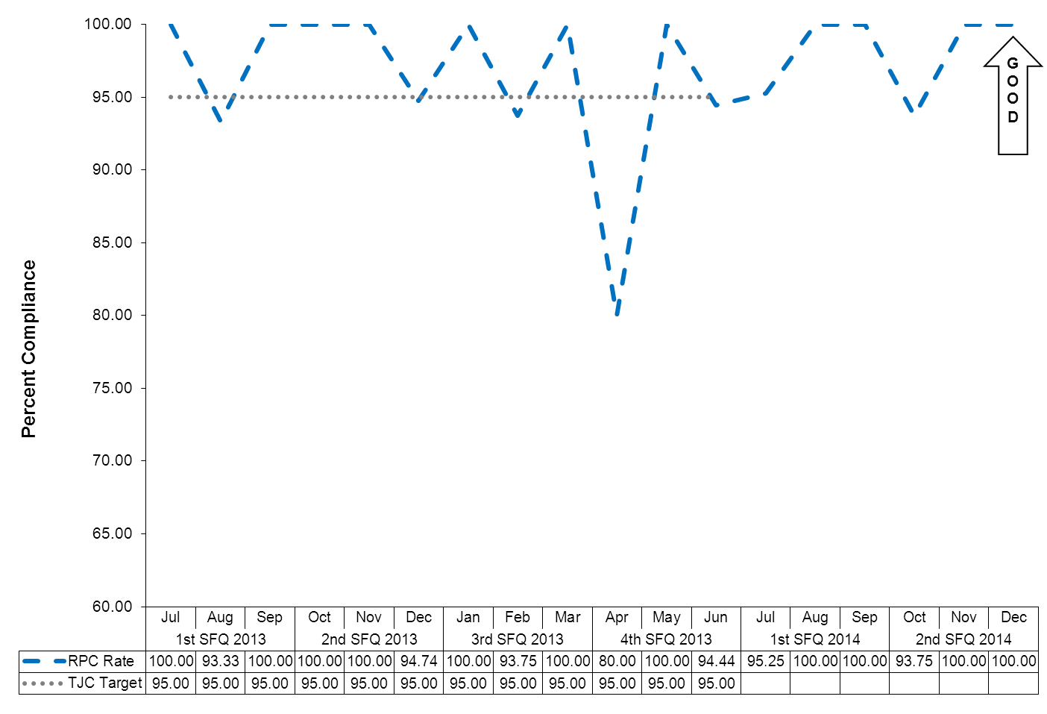

(Glossary of Terms, Acronyms & Abbreviations) (Back to Table of Contents)
JOINT COMMISSION

Physical Restraint (HBIPS 2)
Hours of Use
Description
The total number of hours that all patients admitted to a hospital-based inpatient psychiatric setting were maintained in physical restraint
Rationale
Mental health providers that value and respect an individual’s autonomy, independence and safety seek to avoid the use of dangerous or restrictive interventions at all times (Donat, 2003). The use of seclusion and restraint is limited to situations deemed to meet the threshold of imminent danger and when restraint and seclusion are used; such use is rigorously monitored and analyzed to prevent future use. Providers also seek to prevent violence or aggression from occurring in their treatment environments by focusing their attention on prevention activities that have a growing evidence base (Donat, 2003.

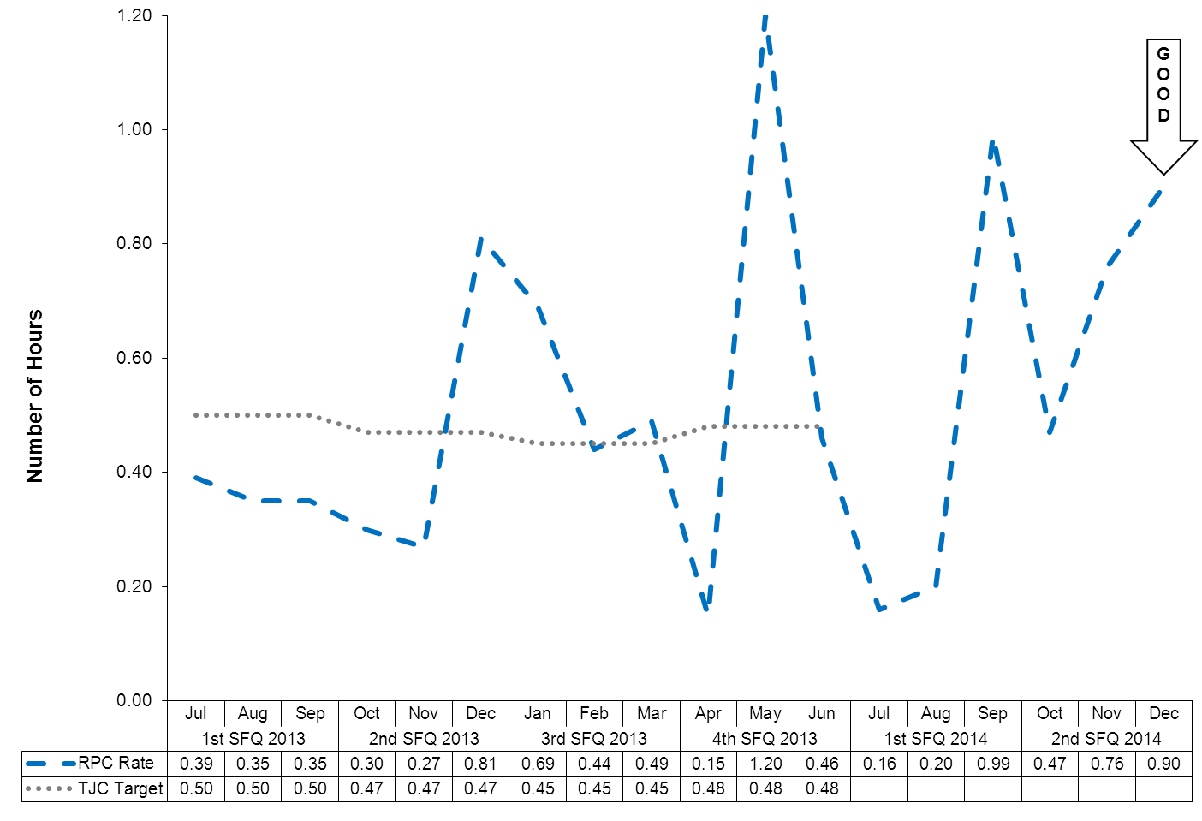

(Glossary of Terms, Acronyms & Abbreviations) (Back to Table of Contents)
JOINT COMMISSION

Seclusion (HBIPS 3)
Hours of Use
Description
The total number of hours that all patients admitted to a hospital-based inpatient psychiatric setting were held in seclusion
Rationale
Mental health providers that value and respect an individual’s autonomy, independence and safety seek to avoid the use of dangerous or restrictive interventions at all times (Donat, 2003). The use of seclusion and restraint is limited to situations deemed to meet the threshold of imminent danger and when restraint or seclusion are used; such use is rigorously monitored and analyzed to prevent future use. Providers also seek to prevent violence or aggression from occurring in their treatment environments by focusing their attention on prevention activities that have a growing evidence base (Donat, 2003).

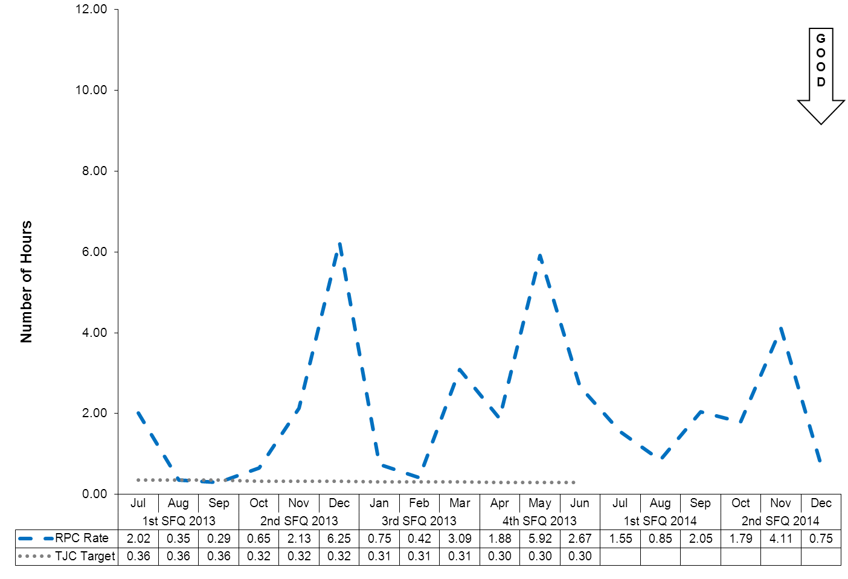
(Glossary of Terms, Acronyms & Abbreviations) (Back to Table of Contents)
JOINT COMMISSION

Multiple Antipsychotic Medications on Discharge (HBIPS 4)
Description
Patients discharged from a hospital-based inpatient psychiatric setting on two or more antipsychotic medications
Rationale
Research studies have found that 4-35% of outpatients and 30-50% of inpatients treated with an antipsychotic medication concurrently received 2 or more antipsychotics (Covell, Jackson, Evans, & Essock, 2002; Ganguly, Kotzan, Miller, Kennedy, & Martin, 2004; Gilmer, Dolder, Folsom, Mastin, & Jeste, 2007; Kreyenbuhl, Valenstein, McCarthy, Ganocyz, & Blow, 2006; Stahl & Grady, 2004). One study reported 4.6% of patients concurrently received 3 or more antipsychotics (Jaffe & Levine, 2003). These findings are seen across diverse sectors: state mental health authorities, the Veterans Health System and Medicaid-financed care. Antipsychotic polypharmacy can lead to greater side effects, often without improving clinical outcomes (Ananth, Parameswaran, & Gunatilake, 2004; Stahl & Grady, 2004). As a result, a range of stakeholders have called for efforts to reduce unnecessary use of multiple antipsychotics (Centorrino, Gören, Hennen, Salvatore, Kelleher, & Baldessarini, 2004; Gilmer, Dolder, Folsom, Mastin, & Jeste, 2007; National Association of State Mental Health Program Directors, 2001; University HealthSystem Consortium, 2006). Practice guidelines recommend the use of a second antipsychotic only after multiple trials of a single antipsychotic have proven inadequate (American Psychiatric Association [APA] Practice Guidelines, 2004). Randomized controlled trials (RCTs) provide some evidence to support augmentation with a second antipsychotic in treatment resistant patients. Most of these studies were limited to augmentation of clozapine with another second-generation antipsychotic (Tranulis, Skalli, Lalonde, & Nicole, 2008). Among patients without a documented history of previous treatment failures of antipsychotic monotherapy, multiple RCTs and other controlled trials failed to show a benefit of antipsychotic polypharmacy over monotherapy (Ananth, Parameswaran, & Gunatilake, 2004; Centorrino, Gören, Hennen, Salvatore, Kelleher, & Baldessarini, 2004; Potkin, Thyrum, Alva, Bera, Yeh, & Arvanitis, 2002; Shim et al., 2007; Stahl,& Grady, 2004). Clinical circumstances, such as shorter inpatient stays, may require hospitals to discharge a patient on multiple antipsychotics with an aftercare plan to transition to monotherapy. In such cases, effective communication between the inpatient and aftercare clinician is an essential element of care.

(Glossary of Terms, Acronyms & Abbreviations) (Back to Table of Contents)
JOINT COMMISSION

Multiple Antipsychotic Medications on Discharge (HBIPS 4)
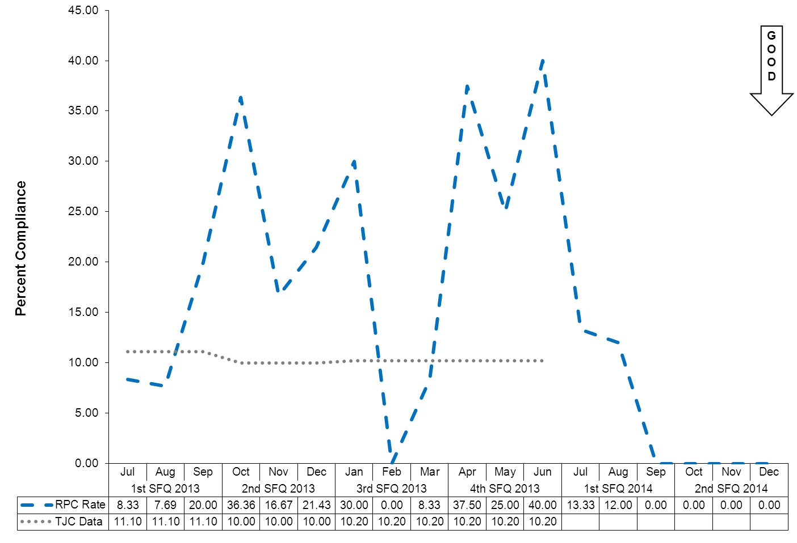

(Glossary of Terms, Acronyms & Abbreviations) (Back to Table of Contents)
JOINT COMMISSION

Multiple Antipsychotic Medications at Discharge with Justification (HBIPS 5)
Description
Patients discharged from a hospital-based inpatient psychiatric setting on two or more antipsychotic medications with appropriate justification
Rationale
Research studies have found that 4-35% of outpatients and 30-50% of inpatients treated with an antipsychotic medication concurrently received 2 or more antipsychotics (Covell, Jackson, Evans, & Essock, 2002; Ganguly, Kotzan, Miller, Kennedy, & Martin, 2004; Gilmer, Dolder, Folsom, Mastin, & Jeste, 2007; Kreyenbuhl, Valenstein, McCarthy, Ganocyz, & Blow, 2006; Stahl & Grady, 2004). One study reported 4.6% of patients concurrently received 3 or more antipsychotics (Jaffe & Levine, 2003). These findings are seen across diverse sectors: state mental health authorities, the Veterans Health System and Medicaid-financed care. Antipsychotic polypharmacy can lead to greater side effects, often without improving clinical outcomes (Ananth, Parameswaran, & Gunatilake, 2004; Stahl & Grady, 2004). As a result, a range of stakeholders have called for efforts to reduce unnecessary use of multiple antipsychotics (Centorrino, Gören, Hennen, Salvatore, Kelleher, & Baldessarini, 2004; Gilmer, Dolder, Folsom, Mastin, & Jeste, 2007; National Association of State Mental Health Program Directors, 2001; University HealthSystem Consortium, 2006).
Practice guidelines recommend the use of a second antipsychotic only after multiple trials of a single antipsychotic have proven inadequate (American Psychiatric Association [APA] Practice Guidelines, 2004). Randomized controlled trials (RCTs) provide some evidence to support augmentation with a second antipsychotic in treatment resistant patients. Most of these studies were limited to augmentation of clozapine with another second-generation antipsychotic (Tranulis, Skalli, Lalonde, & Nicole, 2008). Among patients without a documented history of previous treatment failures of antipsychotic monotherapy, multiple RCTs and other controlled trials failed to show a benefit of antipsychotic polypharmacy over monotherapy (Ananth, Parameswaran, & Gunatilake, 2004; Centorrino, Gören, Hennen, Salvatore, Kelleher, & Baldessarini, 2004; Potkin, Thyrum, Alva, Bera, Yeh, & Arvanitis, 2002; Shim et al., 2007; Stahl,& Grady, 2004). Clinical circumstances, such as shorter inpatient stays, may require hospitals to discharge a patient on multiple antipsychotics with an aftercare plan to transition to monotherapy. In such cases, effective communication between the inpatient and aftercare clinician is an essential element of care.
(Glossary of Terms, Acronyms & Abbreviations) (Back to Table of Contents)
JOINT COMMISSION

Multiple Antipsychotic Medications at Discharge with Justification (HBIPS 5)

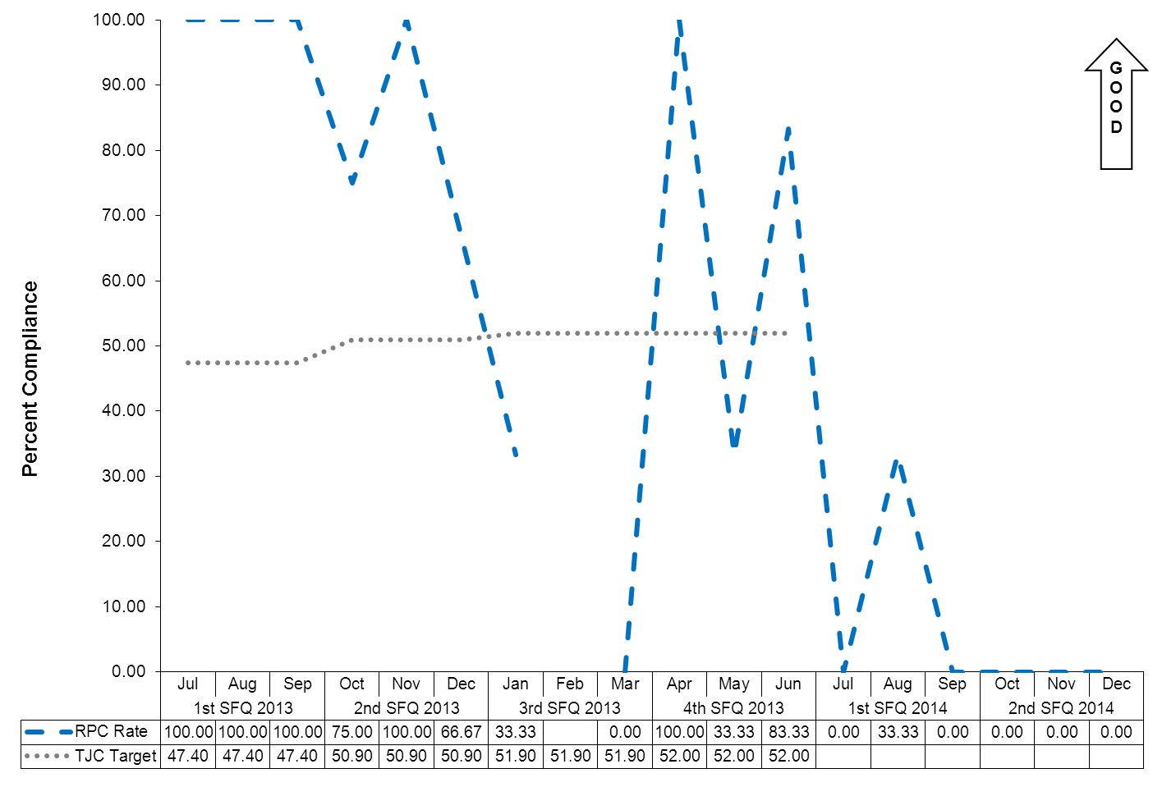
(Glossary of Terms, Acronyms & Abbreviations) (Back to Table of Contents)
JOINT COMMISSION

Post Discharge Continuing Care Plan (HBIPS 6)
Description
Patients discharged from a hospital-based inpatient psychiatric setting with a continuing care plan created
Rationale
Patients may not be able to fully report to their next level of care health-care provider their course of hospitalization or discharge treatment recommendations. The aftercare instructions given the patient may not be available to the next level of care provider at the patient’s initial intake or follow-up appointment. In order to provide optimum care, next level of care providers need to know details of precipitating events immediately preceding hospital admission, the patient’s treatment course during hospitalization, discharge medications and next level of care recommendations (American Association of Community Psychiatrists [AACP], 2001).
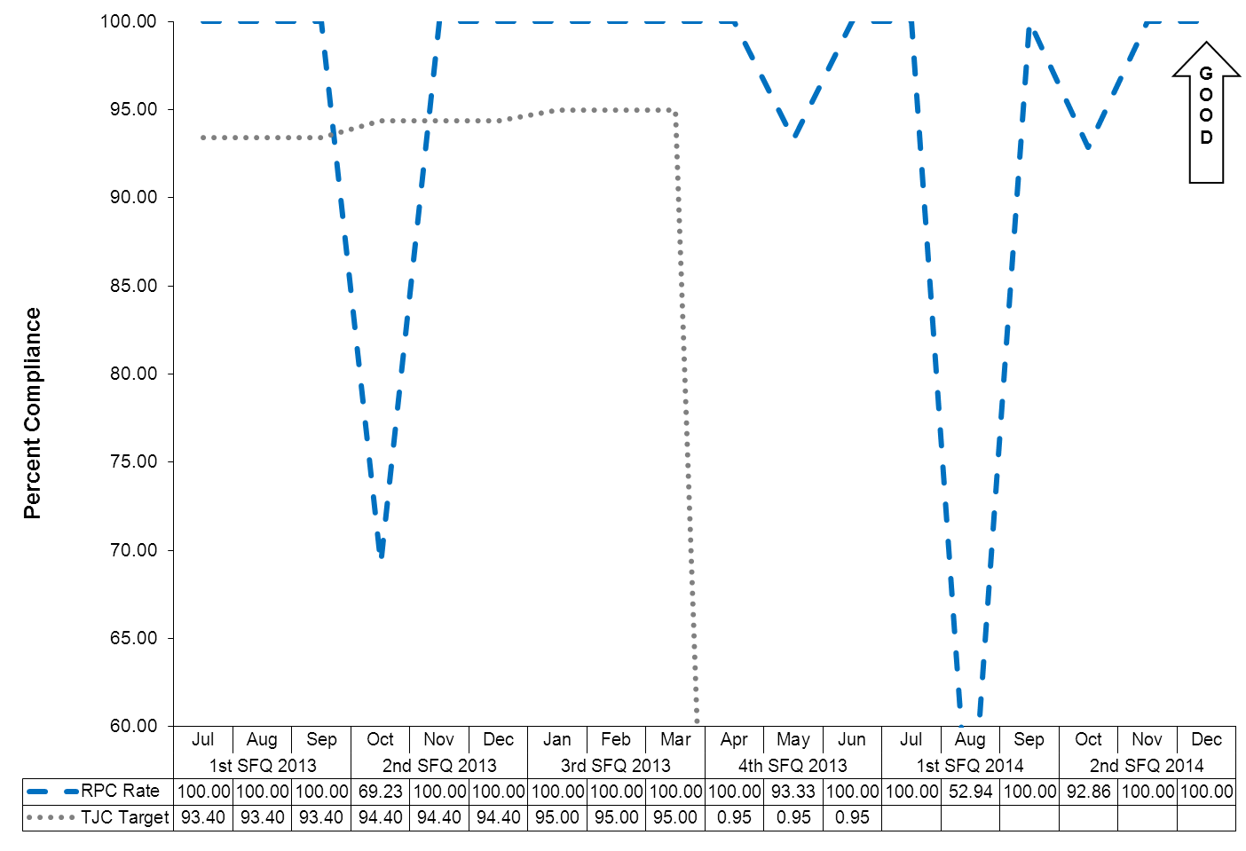

(Glossary of Terms, Acronyms & Abbreviations) (Back to Table of Contents)
JOINT COMMISSION

Post Discharge Continuing Care Plan Transmitted (HBIPS 7)
To Next Level of Care Provider on Discharge
Description
Patients discharged from a hospital-based inpatient psychiatric setting with a continuing care plan provided to the next level of care clinician or entity
Rationale
Patients may not be able to fully report to their next level of care health-care provider their course of hospitalization or discharge treatment recommendations. The aftercare instructions given the patient may not be available to the next level of care provider at the patient’s initial intake or follow-up appointment. In order to provide optimum care, next level of care providers need to know details of precipitating events immediately preceding hospital admission, the patient’s treatment course during hospitalization, discharge medications and next level of care recommendations (American Association of Community Psychiatrists [AACP], 2001).

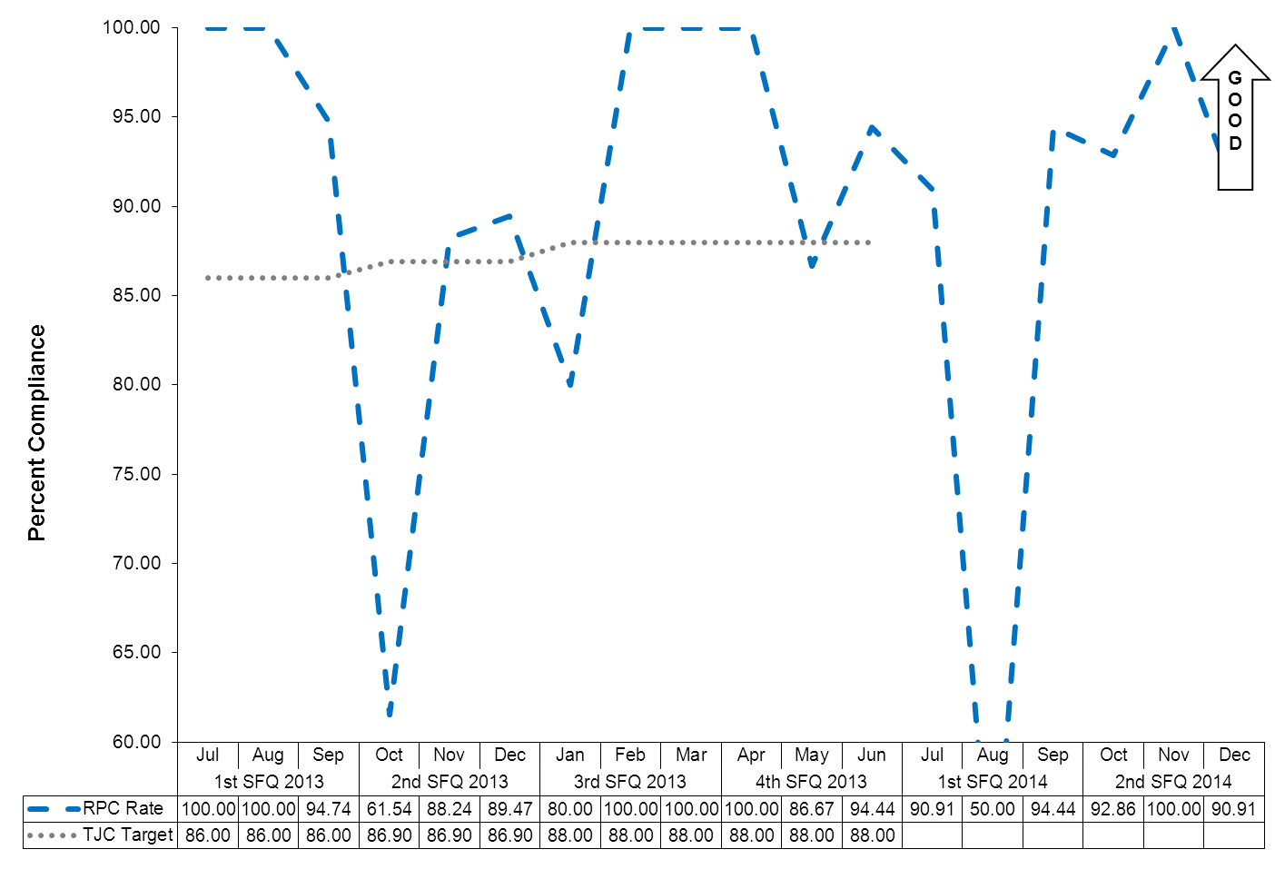

(Glossary of Terms, Acronyms & Abbreviations) (Back to Table of Contents)
JOINT COMMISSION

Capital Community Clinic
Adverse Reactions to Sedation or Anesthesia

TJC PI.01.01.01 EP6: The hospital collects data on the following: adverse events related to using moderate or deep sedation or anesthesia. (See also LD.04.04.01, EP 2)

Dental Clinic Timeout/Identification of Client

Indicators | 3Q2013 | 4Q2013 | 1Q2014 | 2Q2014
National Patent Safety Goals  Goal 1: Improve the accuracy of Client  Identification.  Capital Community Dental Clinic assures accurate client identification by: asking the client to state his/her name and date of birth.  A time out will be taken before the procedure to verify location and numbered tooth. The time out section is in the progress notes of the patient chart. This page will be signed by the Dentist as well as the dental assistant. | January  100%  7/7  February  100%  3/3  March  100%  9/9  Total  100%  19/19 | April  100%  2/2  May  100%  7/7  June  100%  7/7  Total  100%  16/16 | July  100%  6/6  August  100%  2/2  September  100%  4/4  Total  100%  12/12 | October  100%  3/3  November  100%  1/1  December  100%  2/2  Total  100%  6/6

Dental Clinic Post Extraction Prevention of Complications and Follow-up

Indicators | 3Q2013 | 4Q2013 | 1Q2014 | 2Q2014
- All clients with tooth extractions, will be assessed and have teaching post procedure, on the following topics, as provided by the Dentist or Dental Assistant  - Bleeding  - Swelling  - Pain  - Muscle soreness  - Mouth care  - Diet  - Signs/symptoms of infection  - The client, post procedure tooth extraction, will verbalize understanding of the above by repeating instructions given by Dental Assistant/Hygienist.  - Post dental extractions, the clients will receive a follow-up phone call from the clinic within 24hrs of procedure to assess for post procedure complications | January  100%  7/7  February  100%  3/3  March  100%  9/9  Total  100%  19/19l | April  100%  2/2  May  100%  7/7  June  100%  7/7  Total  100%  16/16 | July  100%  6/6  August  100%  2/2  September  100%  4/4  Total  100%  12/12 | October  100%  3/3  November  100%  1/1  December  100%  2/2  Total  100%  6/6

(Glossary of Terms, Acronyms & Abbreviations) (Back to Table of Contents)
JOINT COMMISSION

Healthcare Acquired Infections Monitoring and Management

NPSG.07.03.01 Implement evidence-based practices to prevent health care–associated infections due to multidrug-resistant organisms in acute care hospitals.
72 Bed Hospital

Indicators | 2Q14  Findings | 2Q14  Compliance | Threshold Percentile
Total number of infections for the first quarter of the fiscal year, per 1000 patient days | 12/2.3 | 100% | 1 SD within the mean
Hospital Acquired (healthcare associated) infection rate, infections per 1000 patient days | 4/2.2 | 100% | 1 SD within the mean

Data:
Pneumonitis
Cellulitis Right Leg
Conjunctivitis-HAI
Compound Infection (bacterial & fungal) of second right digit-HAI
Pneumonia-HAI
Right Thumb Paronychia
Empriical Treatment/probable early impetigo
Dental
Prophylactic measure-blister left foot > could progress to cellulitis
Chronic sinusitis following URI-HAI
Prophylactic treatment ingrown toeanil
Hemorrhoidal fissure
Hospital Associated Infections (HAI): 4
Community Acquired Infections (CAI): 7
Ideosyncratic Infections: 1

Summary: Distribution of infections is scattered throughout the hospital. No trending. There was one incident of pneumonia in a young worman with chronic underlying medical problems. She was hospitalized at MaineGeneral Medical Center (MGMC).

Plan: Continue total house surveillance.

(Glossary of Terms, Acronyms & Abbreviations) (Back to Table of Contents)
JOINT COMMISSION

Healthcare Acquired Infections Monitoring and Management

NPSG.07.03.01 Implement evidence-based practices to prevent health care–associated infections due to multidrug-resistant organisms in acute care hospitals.
Lower Saco Decertified Unit

Indicators | 2Q14  Findings | 2Q14  Compliance | Threshold Percentile
Total number of infections for the first quarter of the fiscal year, per 1000 patient days | 10/7.7 | 100% | 1 SD within the mean
Hospital Acquired (healthcare associated) infection rate, infections per 1000 patient days | 2/1.3 | 100% | 1 SD within the mean

Data:
Candida Intertrigo left breast
Impetiginous rosaecea with pustiles & exudate
Cellulitis right ear secondery to rosaesea & folliculitis
2 Dental Abscess
Tinea pedis – HAI
URI-HAI
UTI
Laceration of forearm.-prophylactic treatment
Prophylactic treatment of urinary incontinence

Hospital Associated Infections (HAI): 2
Community Acquired Infections (CAI): 7
Idiosyncatic Infections: 1
Total Infections: 10

Summary: No trending. No unusual infections.One isolated case of Tinea Pedis.
Plan: Continue total house surveillance.
(Glossary of Terms, Acronyms & Abbreviations) (Back to Table of Contents)
JOINT COMMISSION

Medication Management
Medication Errors and Adverse Reactions

TJC PI.01.01.01 EP14: The hospital collects data on the following: Significant medication errors. (See also LD.04.04.01, EP 2; MM.08.01.01, EP 1)

TJC PI.01.01.01 EP15: The hospital collects data on the following: Significant adverse drug reactions. (See also LD.04.04.01, EP 2; MM.08.01.01, EP 1)
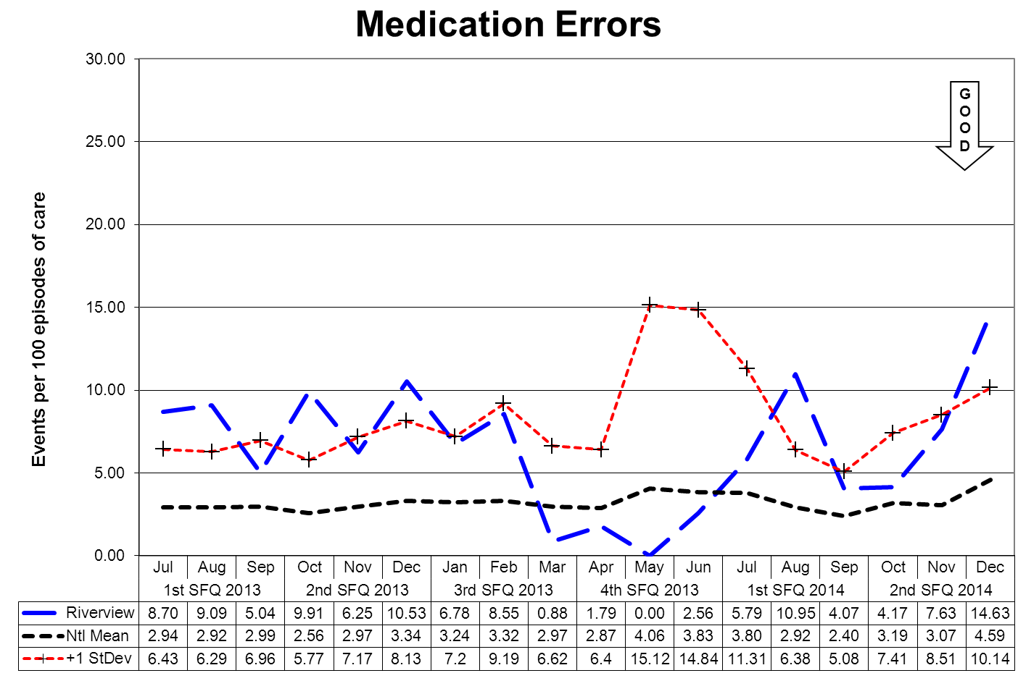

This graph depicts the number of medication error events that occurred for every 100 episodes of care (duplicated client count). For example, a rate of 1.6 means that 2 medication error events occurred for each 125 episodes of care.
(Glossary of Terms, Acronyms & Abbreviations) (Back to Table of Contents)
JOINT COMMISSION

Medication variances are classified according to four major areas related to the area of service delivery. The error must have resulted in some form of variance in the desired treatment or outcome of care. A variance in treatment may involve one incident but multiple medications; each medication variance is counted separately irrespective of whether it involves one error event or many. Medication error classifications include:
Prescribing
An error of prescribing occurs when there is an incorrect selection of drug, drug dose, dosage form, quantity, route, concentration, rate of administration, or instructions for use of a drug product ordered or authorized by physician or other legitimate prescriber. Errors may occur due to improper evaluation of indications, contraindications, known allergies, existing drug therapy and other factors. Illegible prescriptions or medication orders that lead to client level errors are also defined as errors of prescribing. in identifying and ordering the appropriate medication to be used in the care of the client.
Dispensing
An error of dispensing occurs when the incorrect drug, drug dose or concentration, dosage form, or quantity is formulated and delivered for use to the point of intended use.
Administration
An error of administration occurs when there is an incorrect selection and administration of drug, drug dose, dosage form, quantity, route, concentration, rate of administration, or instructions for use of a drug product ordered or authorized by physician or other legitimate prescriber.
Complex
An error which resulted from two or more distinct errors of different types is classified as a complex error.
Review, Reporting and Follow-up Process

The Medication Variances Process Review Team (PRT) meets weekly to evaluate the causation factors related to the medication variances reported on the units and in the pharmacy and makes recommendations, through its multi-disciplinary membership, for changes to workflow, environmental factor, and client care practices. The team consists of the Medical Director (or designee), the Director of Nursing (or designee), the Director of Pharmacy (or designee), and the Clinical Risk Manager or the Performance Improvement Manager.

The activities and recommendations of the Medication Variances PRT are reported monthly to the Integrated Performance Excellence Committee.

(Glossary of Terms, Acronyms & Abbreviations) (Back to Table of Contents)
JOINT COMMISSION

Medication Management - Administration Process
Medication Errors Related to Staffing Effectiveness

Date | OMIT | Co-mission | Float | New | O/T | Unit  Acuity |  | Staff Mix
9/2/2013 | N | Wrong time Motrin | N | N | N | US |  | 1 RN 1 LPN 4 MHW
9/22/2013 | Y | Itraconazole x2 doses | N | N | N | US |  | 2 RN, 0 LPN, 4 MHW
10/15/2013 | Y | Insulin | N | N | N | LK |  | 3 RN, 1 LPN, 7 MHW
10/16/2013 | N | Wrong time | N | N | N | LS |  | 4 RN, 0 LPN, 7 MHW
10/16/2013 | N | Wrong dose Loxapine | N | N | N | LK |  | 3 RN, 1 LPN, 7 MHW
10/16/2013 | N | No valid order | N | N | N | LK |  | 3 RN, 1 LPN 7 MHW
10/18/2013 | N | Wrong dose | N | Y | N | US |  | 3 RN, 0 LPN, 4 MHW
10/19/2013 | N | No valid order x5 | N | N | N | LS |  | 3 RN, 7 MHW
10/20/2013 | Y | Magnesium | Y | N | N | LS |  | 3 RN 1 LPN, 8 MHW
10/22/2013 | Y | Omission x1 | N | N | N | LS |  | 3 RN, 0 LPN, 7 MHW
11/3/2013 | N | No valid order | N | N | Y | US |  | 2 RN, 0 LPN, 4 MHW
11/4/2013 | N | Wrong time | N | N | N | UK |  | 2 RN, 0 LPN, 4 MHW
11/14/2013 | N | Wrong time | N | N | N | LS |  | 4 RN, 0 LPN, 7 MHW
11/16/2013 | Y | Haldol | N | N | N | LK |  | 3 RN, 0 LPN, 7 MHW
11/17/2013 | N | Wrong dose | N | N | Y | LS |  | 3 RN, 1 LPN, 8 MHW
11/18/2013 | N | Expired drug - insulin | N | N | N | LK |  | 3 RN,1 LPN 5 MHW
11/19/2013 | N | Wrong dose | N | N | N | UK |  | 2 RN, 2 LPN, 4 MHW
11/21/2013 | Y | Without valid order | N | Y | N | US |  | 3 RN, 5 MHW
11/26/2013 | Y | Insulin | N | N | N | LS |  | 4 RN, 0 LPN, 7 MHW
11/27/2013 | Y | Omission x 3 | N | Y | N | UK |  | 1 RN, 0 LPN, 3 MHW
12/3/2013 | N | Wrong dose x2 | N | Y | N | LS |  | 3 RN, 0 LPN, 7 MHW
12/4/2013 | N | Wrong time | N | Y | N | UK |  | 3 RN, 4 MHW
12/4/2013 | N | Wrong dose | N | Y | N | US |  | 3 RN, 0 LPN, 4 MHW
12/4/2013 | Y | Levothyroxine x2 | N | N | N | LS |  | 3 RN, 1 LPN, 8 MHW
12/8/2013 | N | Med without valid order | Y | N | N | LS |  | 3 RN, 0 LPN, 8 MHW
12/13/2013 | N | Wrong time | N | Y | N | LK |  | 4 RN, 0 LPN, 7 MHW
12/16/2013 | Y | Synthroid x 4 | N | Y | N | UK |  | 1RN, 0 LPN, 3 MHW
12/21/2013 | Y | Omission x5 | Y | N | N | LS |  | 4 RN 0 LPN 7 MHW
12/22/2013 | Y | Omission x1 ** | Y | Y | N | US |  | 2 RN, 0 LPN, 4 MHW
12/22/2013 | Y | Omission x1 ** | Y | Y | N | US |  | 2 RN, 0 LPN, 4 MHW
12/22/2013 | Y | Omission x1 ** | Y | Y | N | US |  | 2 RN 0 LPN 4 MHW
12/22/2013 | Y | Omission x1 ** | Y | Y | N | US |  | 2 RN 0 LPN 4 MHW
Totals | 19 |  | 11 | 8 | 2 | LS: 11 | US: 14 |  | LK: 6 | UK: 5
Percent | 53% |  | 31% | 22% | 6% | 31% | 39% |  | 17% | 14%

*Each dose of medication is documented as an individual variance (error)
(Glossary of Terms, Acronyms & Abbreviations) (Back to Table of Contents)
JOINT COMMISSION

Summary
There were a total of 44 medication errors this quarter (38 last quarter and 28 the quarter before). 18 of the medication errors were omissions. Of the 18 omissions, 9 came from a single event in which the medication station (Pyxis draw failure) failed to open during an off shift and the night cabinet did not have the needed medications. 9 medication errors were dose related. 7 medication errors were related to wrong time. 9 medication errors were medications given without a valid order. One error involved an expired medication being given. (insulin) The insulin was labelled incorrectly by staff when opened. (labelled for 30 days rather than 28) Eleven of the medication errors were committed by staff floating to another unit or by staff who have been designated as “floats.” This is misleading in a way however as it was a float who experienced the draw failure that resulted in 9 omissions, through no fault of her own, and she did an excellent job with notifying the right people and completing all the related paperwork. 17 of the 44 errors were by new staff here at RPC. Again, although 17 may appear high for new staff committing medications errors, 9 of those are because it was a new nurse, who was hired as a float experience the draw failure that resulted in 9 omissions, and as stated previously, she did an excellent job notifying, completing paperwork and administering medications to the clients who did not have medications affected by the draw failure.

Actions
All nursing related medication errors were noted to have appropriate staffing levels. One of the actions to consider may be to return to a designated medication nurse for each unit. Nurse Pharmacy Committee meets monthly and is working towards identifying issues with medication management and identifying solutions to issues identified. Medication errors are reviewed weekly by Pharmacist, Medical Director, Risk Manager and Executive Nurse after the RN IV on the unit reviews the error with the staff person responsible for individual teaching and issue / process identification. Pharmacy is looking into different programs that can be added to Pyxis to help reduce the possibility of medications errors.
(Glossary of Terms, Acronyms & Abbreviations) (Back to Table of Contents)
JOINT COMMISSION

Medication Management - Dispensing Process

Joint Commission Measures of Success
Medication Management | Unit | Baseline  2013 | Q1 Target | Q2 Target | Q3 Target | Q4 Target | Goal | Comments
Controlled Substance Loss Data | All |  | 0% | 0% | 0% | 0% | 0% | Goal of “0” discrepancies between Pyxis and CII Safe transactions
Daily Pyxis-CII Safe Compare Report
Quarterly Results |  |  | 0.3% | 0%
Monthly CII Safe Vendor Receipt | Rx | 0 | 0 | 0 | 0 | 0 | 0 | No discrepancies between CII Safe and vendor transactions for Q1 and Q2
Quarterly Results |  |  | 0 | 0
Monthly Pyxis Controlled Drug discrepancies | All | 11 | 0 | 0 | 0 | 0 | 0 | Goal of “0” discrepancies involving controlled drugs dispended from Pyxis
Quarterly Results |  |  | 23 | 39
Medication Management Monitoring | Rx | 8/year | 0 | 0 | 0 | 0 |  | 2 ADR’s reported in Q2
Measures of drug reactions, adverse drug events and other management data
Quarterly Results |  |  | 1 | 2
Resource Documentation Reports of Clinical Interventions | Rx | 185 reports |  |  |  |  |  | 100% of all clinical interventions are documented
Quarterly Results |  |  | 79 | 86

(Glossary of Terms, Acronyms & Abbreviations) (Back to Table of Contents)
STRATEGIC PERFORMANCE EXCELLENCE

Pharmacy Services

Department: | Pharmacy | Responsible Party: | Garry Miller, R.Ph.

CMS Plan of Correction Tag #A-494 and Tag #A-506 – Lower Saco
Medication Management | Unit | Baseline  Oct 2013 | Q1 Target | Q2 Target | Q3 Target | Q4 Target | Goal | Comments
Controlled Substance Loss Data | Lower Saco | 100% | 100% | 100% |  |  | 100% | Goal of 100% compliance in tracking CII safe transactions
Monthly CII Safe Transactions Report Generated and Reviewed
Quarterly Results |  |  | 100%  (Oct) | 100%  (Nov & Dec)
Monthly CII Safe Transactions Report Separately Maintained | Rx | 100% | 100% | 100% |  |  |  | Transaction Reports separately maintained for Lower Saco
Quarterly Results |  |  | 100%  (Oct) | 100%  (Nov & Dec)
After-Hours Drug Access Monitoring | Rx | 100% | 100% | 100% |  |  |  | Monitor daily after hours drug distribution reports to ensure compliance with policy
Monitor daily after-hours drug distribution reports
Quarterly Results |  |  | 100%  (Oct) | 100%  (Nov & Dec) |  |  |  | No after-hours drugs needed for Lower Saco during October

The key indicators in Medication Management are focused on preventing Controlled Substances loss and monitoring/trending of adverse drug reactions and clinical interventions. Controlled Substances Loss reviews two key reports generated by the Pyxis CII Safe which compare controlled drug transactions between the pharmacy’s CII Safe and the various Pyxis Medstations; and, the purchasing data from our drug wholesaler and the corresponding CII Safe transactions. In both instances, we are looking for zero variation. Medication Management Monitoring is comprised of the reporting, review and monitoring of adverse drug reactions (ADR’s) and Clinical Interventions as documented in the Resource Documentation tool to generate historical and graphical analysis which is reported to the P&T Committee regularly. TJC requires ongoing reporting and surveillance of adverse drug reactions, medication errors and medication related issues to the hospital wide performance improvement program with the goal of strategies to minimize their occurrence.
(Glossary of Terms, Acronyms & Abbreviations) (Back to Table of Contents)
JOINT COMMISSION

Inpatient Consumer Survey

TJC PI.01.01.01 EP16: The hospital collects data on the following: Patient perception of the safety and quality of care, treatment, and services.

The Inpatient Consumer Survey (ICS) is a standardized national survey of customer satisfaction. The National Association of State Mental Health Program Directors Research Institute (NRI) collects data from state psychiatric hospitals throughout the country in an effort to compare the results of client satisfaction in five areas or domains of focus. These domains include Outcomes, Dignity, Rights, Participation, and Environment.
Inpatient Consumer Survey (ICS) has been recently endorsed by NQF, under the Patient Outcomes Phase 3: Child Health and Mental Health Project, as an outcome measure to assess the results, and thereby improve care provided to people with mental illness. The endorsement supports the ICS as a scientifically sound and meaningful measure to help standardize performance measures and assures quality of care.
Rate of Response for the Inpatient Consumer Survey

Due to the operational and safety need to refrain from complete openness regarding plans for discharge and dates of discharge for forensic clients, the process of administering the inpatient survey is difficult to administer. Whenever possible the peer support staff work to gather information from clients on their perception of the care provided to then while at Riverview Psychiatric Center.
The Peer Support group has identified a need to improve the overall response rate for the survey. This process improvement project is defined and described in the section on Client Satisfaction Survey Return Rate of this report.
There is currently no aggregated date on a forensic stratification of responses to the survey.
(Glossary of Terms, Acronyms & Abbreviations) (Back to Table of Contents)
JOINT COMMISSION

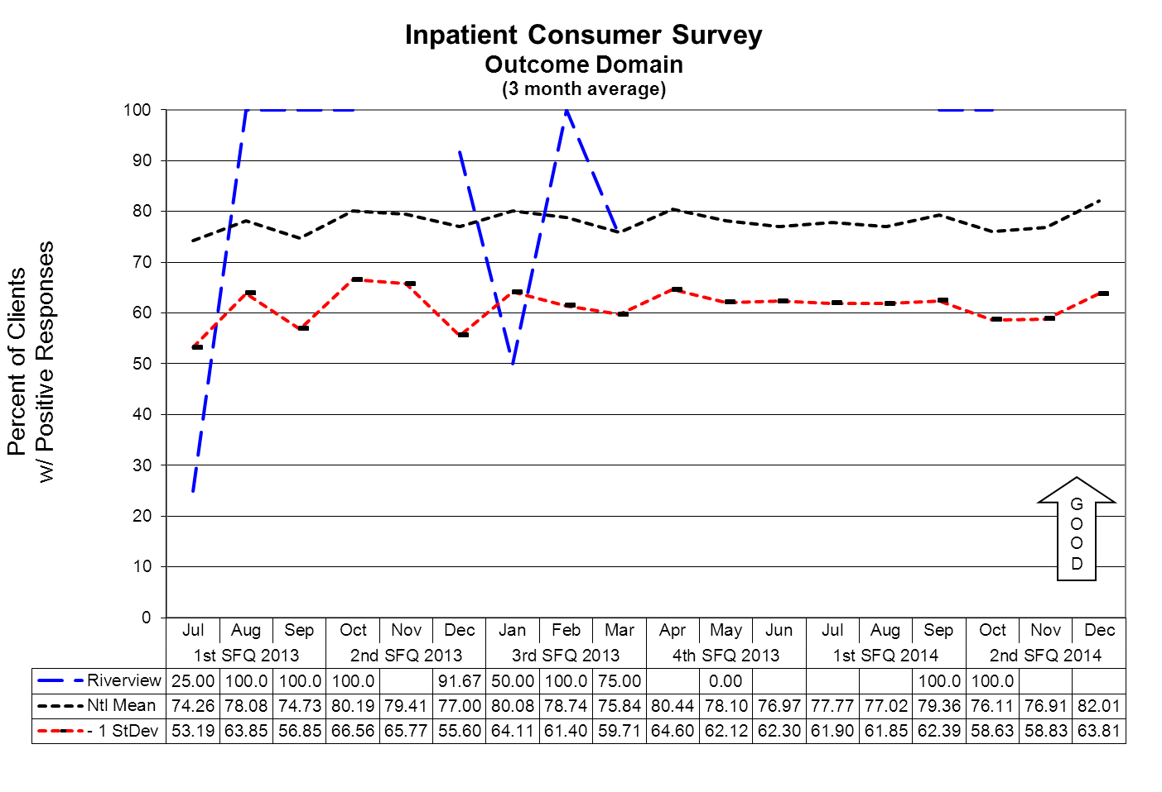

Outcome Domain Questions
- I am better able to deal with crisis.
- My symptoms are not bothering me as much.
- I do better in social situations.
- I deal more effectively with daily problems.
(Glossary of Terms, Acronyms & Abbreviations) (Back to Table of Contents)
JOINT COMMISSION
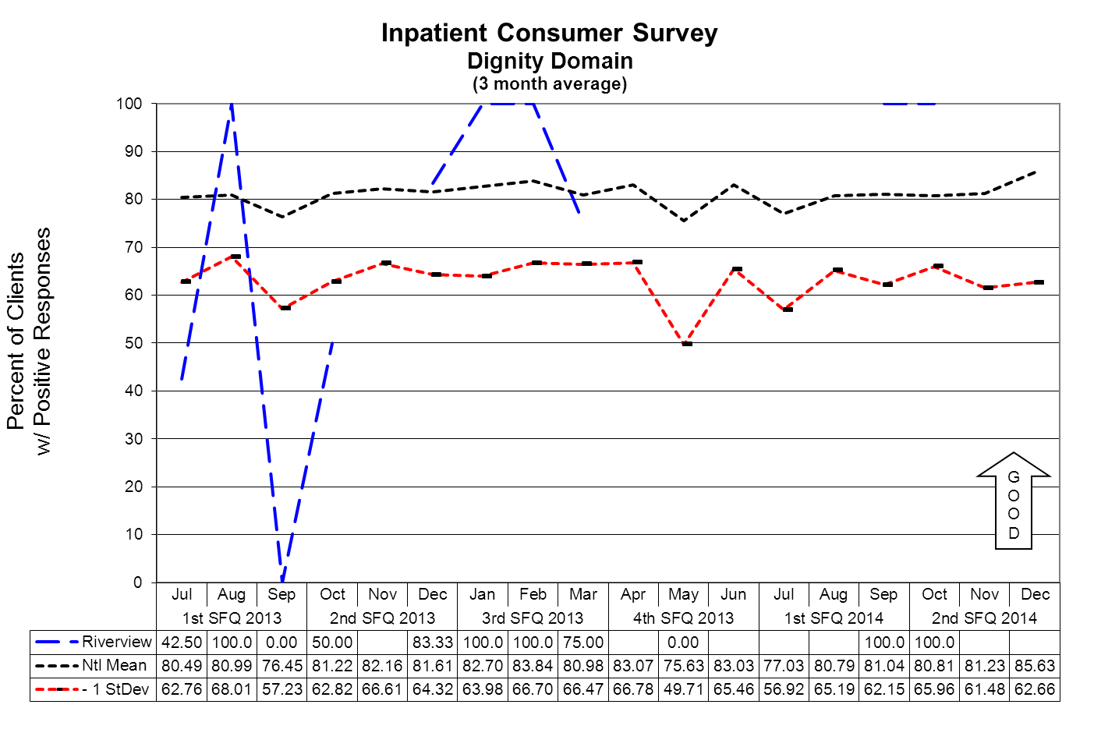

Dignity Domain Questions
- I was treated with dignity and respect.
- Staff here believed that I could grow, change and recover.
- I felt comfortable asking questions about my treatment and medications.
- I was encouraged to use self-help/support groups.

(Glossary of Terms, Acronyms & Abbreviations) (Back to Table of Contents)
JOINT COMMISSION

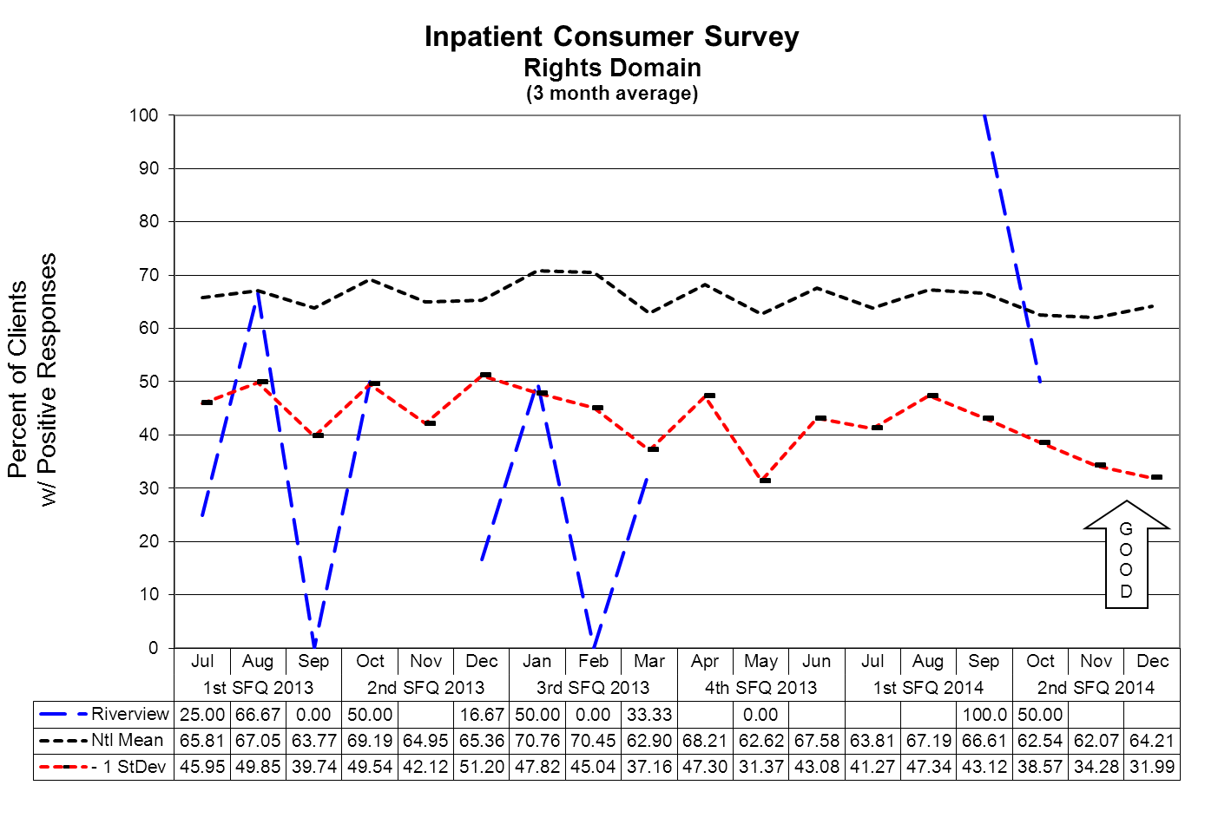

Rights Domain Questions
- I felt free to complain without fear of retaliation.
- I felt safe to refuse medication or treatment during my hospital stay.
- My complaints and grievances were addressed.

(Glossary of Terms, Acronyms & Abbreviations) (Back to Table of Contents)
JOINT COMMISSION

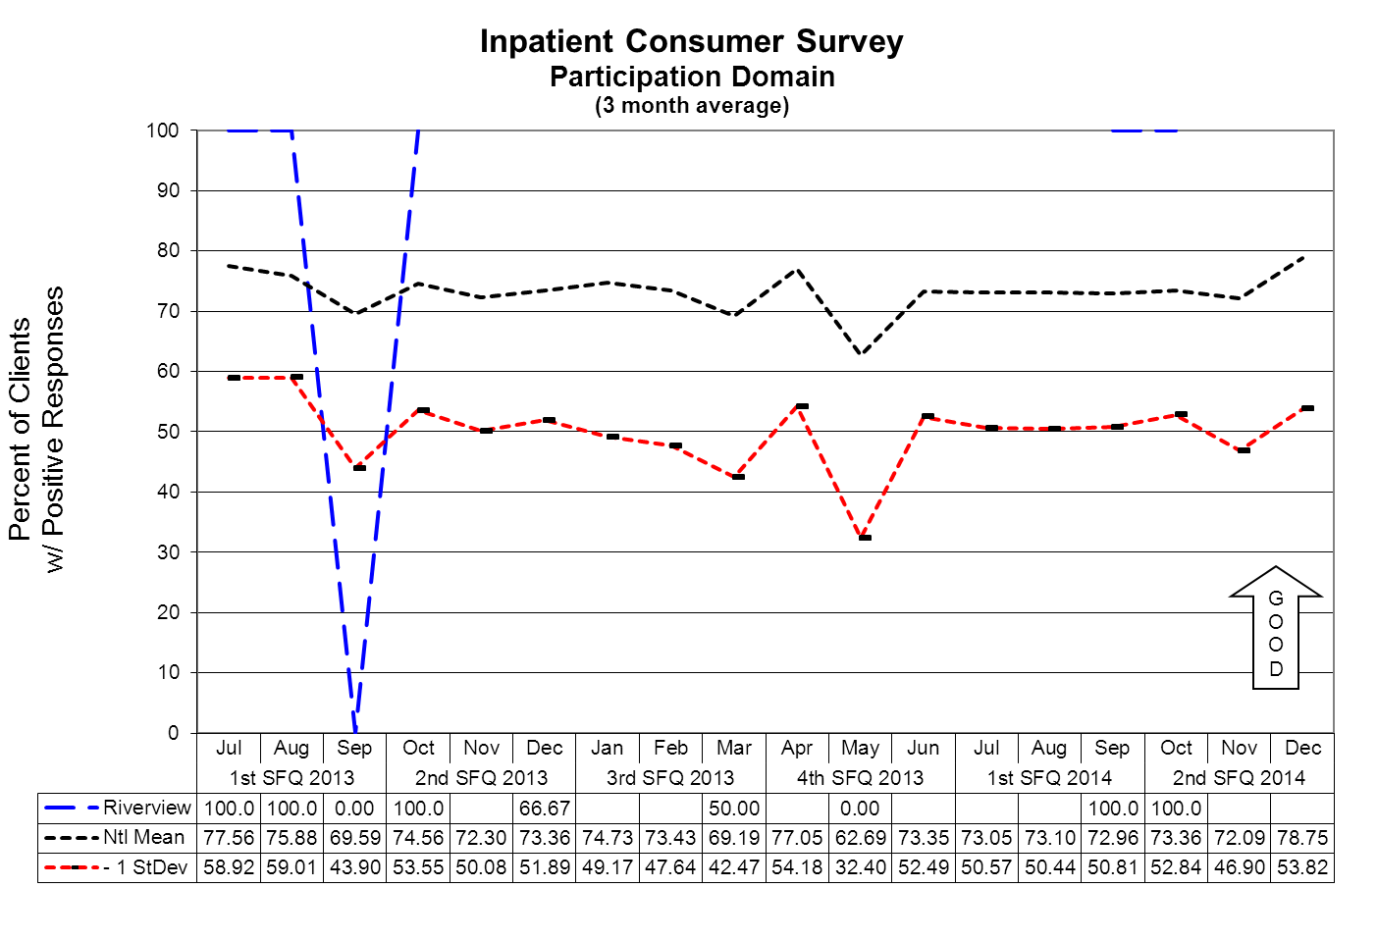

Participation Domain Questions
- I participated in planning my discharge.
- Both I and my doctor or therapist from the community were actively involved in my hospital treatment plan.
- I had an opportunity to talk with my doctor or therapist from the community prior to discharge.

(Glossary of Terms, Acronyms & Abbreviations) (Back to Table of Contents)
JOINT COMMISSION

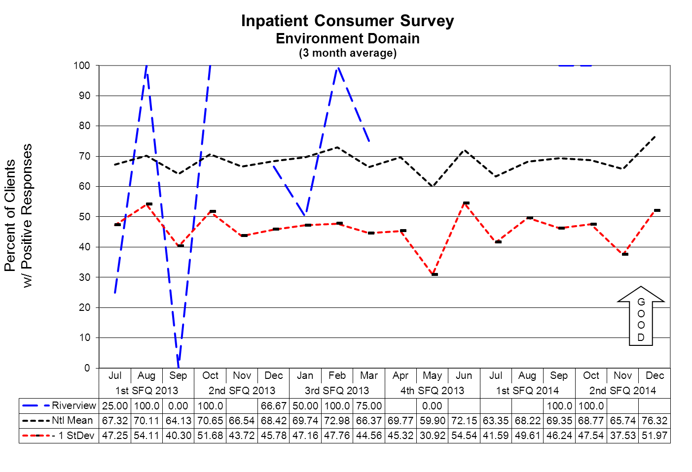

Environment Domain
- The surroundings and atmosphere at the hospital helped me get better
- I felt I had enough privacy in the hospital.
- I felt safe while I was in the hospital.
- The hospital environment was clean and comfortable.

Data aggregation on this domain began in October 2011. A trend analysis pattern related to this data is only now becoming apparent.
(Glossary of Terms, Acronyms & Abbreviations) (Back to Table of Contents)
JOINT COMMISSION

Pain Management

TJC PC.01.02.07: The hospital assesses and manages the patient's pain.

Indicator | 3Q2013 | 4Q2013 | 1Q2014 | 2Q2014
Pre-administration | 91% | 68% | 70% | 74%  2774 of 3749
Post-administration | 81% | 59% | 60% | 63%  2362 of 3749

SUMMARY

Both “Pre” and “Post” assessments continue to be up slightly from previous quarter but still lower than previous quarters. The number of pain medications given this quarter continues to be higher than the previous quarter (3749 PRN meds for pain this quarter compared to 2516 PRN pain meds last quarter) There were only 1011 pain meds given in second quarter of FY 2013.

ACTIONS

Will meet with the clinical managers to let them know that nursing needs to be more vigilant about assessing pre and post administration pain assessment. Will recommend having the oncoming shift check with the off going shift for any pain meds given that may need an assessment. Pharmacy is looking at future possibilities with Pyxis to see if a program can be installed that will alert nurses that an assessment is due/ needed.
(Glossary of Terms, Acronyms & Abbreviations) (Back to Table of Contents)
JOINT COMMISSION

Fall Reduction Strategies

TJC PI.01.01.01 EP38: The hospital evaluates the effectiveness of all fall reduction activities including assessment, interventions, and education.

TJC PC.01.02.08 The hospital assesses and manages the patient's risks for falls.
EP01: The hospital assesses the patient’s risk for falls based on the patient population and setting.
EP02: The hospital implements interventions to reduce falls based on the patient’s assessed risk.
Falls Risk Management Team has been created to be facilitated by a member of the team with data supplied by the Risk Manager. The role of this team is to conduct root cause analyses on each of the falls incidents and to identify trends and common contributing factors and to make recommendations for changes in the environment and process of care for those clients identified as having a high potential for falls.

Type of Fall by Client and Month

Fall Type | Client | OCT | NOV | DEC | 2Q2014
Un-witnessed | MR00006963* | 4 |  |  | 4
Un-witnessed | MR00000091* |  | 1 |  | 1
Un-witnessed | MR00000016* |  |  | 1 | 1
Un-witnessed | MR00004891 |  |  | 1 | 1

Witnessed | MR00000016* | 2 |  |  | 2
Witnessed | MR00000091* | 1 |  |  | 1
Witnessed | MR00006309 | 1 |  |  | 1
Witnessed | MR00006145 | 1 |  |  | 1
Witnessed | MR00006963* | 4 | 2 | 4 | 10
Witnessed | MR00004814 |  |  | 1 | 1
Witnessed | MR00006695 |  |  | 2 | 2
*
* Clients have experienced both witnessed and un-witnessed falls during the reporting quarter.

Review, Reporting and Follow-up Process

The Falls Assessment and Prevention Process Review Team (PRT) meets monthly to evaluate the causation factors related to the falls reported on the units and makes recommendations, through its multi-disciplinary membership, for changes to workflow, environmental factor, and client care practices.

The activities and recommendations of the Falls PRT are reported monthly to the Integrated Performance Excellence Committee.

(Glossary of Terms, Acronyms & Abbreviations) (Back to Table of Contents)
STRATEGIC PERFORMANCE EXCELLENCE

Priority Focus Areas
for Strategic Performance Excellence

In an effort to ensure that quality management methods used within the Maine Psychiatric Hospitals System are consistent with modern approaches of systems engineering, culture transformation, and process focused improvement strategies and in response to the evolution of Joint Commission methods to a more modern systems-based approach instead of compliance-based approach
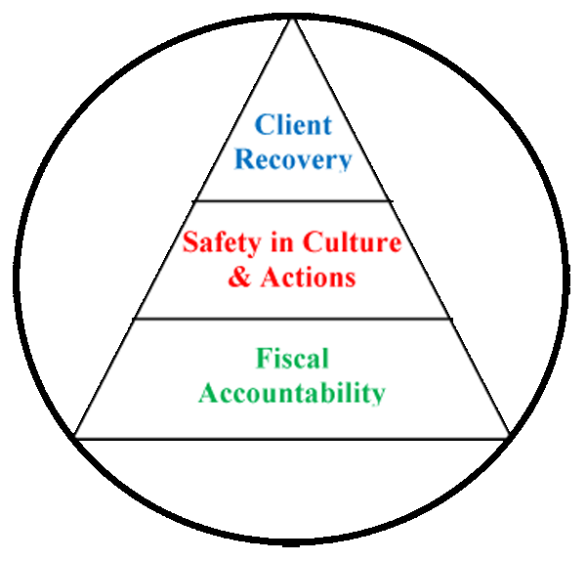
Building a framework for client recovery by
ensuring fiscal accountability
and a culture of organizational safety
through the promotion of…

- The conviction that staffs are concerned with doing the right thing in support of client rights and recovery;
- A philosophy that promotes an understanding that errors most often occur as a result of deficiencies in system design or deployment;
- Systems and processes that strive to evaluate and mitigate risks and identify the root cause of operational deficits or deficiencies without erroneously assigning blame to system stakeholders;
- The practice of engaging staffs and clients in the planning and implementing of organizational policy and protocol as a critical step in the development of a system that fulfills ethical and regulatory requirements while maintaining a practicable workflow;
- A cycle of improvement that aligns organizational performance objectives with key success factors determined by stakeholder defined strategic imperatives.
- Enhanced communications and collaborative relationships within and between cross-functional work teams to support organizational change and effective process improvement;
- Transitions of care practices where knowledge is freely shared to improve the safety of clients before, during, and after care;
- A just culture that supports the emotional and physical needs of staffs, clients, and family members that are impacted by serious, acute, and cumulative events.
(Glossary of Terms, Acronyms & Abbreviations) (Back to Table of Contents)
STRATEGIC PERFORMANCE EXCELLENCE

Strategic Performance Excellence Model Reporting Process

Department of Health and Human Services Goals
Protect and enhance the health and well-being of Maine people
Promote independence and self sufficiency
Protect and care for those who are unable to care for themselves
Provide effective stewardship for the resources entrusted to the department

Dorothea Dix and Riverview Psychiatric Centers
Priority Focus Areas
Ensure and Promote Fiscal Accountability by…
Identifying and employing efficiency in operations and clinical practice
Promoting vigilance and accountability in fiscal decision-making.

Promote a Safety Culture by…
Improving Communication
Improving Staffing Capacity and Capability
Evaluating and Mitigating Errors and Risk Factors
Promoting Critical Thinking
Supporting the Engagement and Empowerment of Staffs

Enhance Client Recovery by…
Develop Active Treatment Programs and Options for Clients
Supporting clients in their discovery of personal coping and improvement activities.

Each Department Determines Unique Opportunities and Methods
to Address the Hospital Goals
The Quarterly Report Consists of the Following

Define

Opportunities for Improvement (OFIs)

Performance Objectives

Measure

Current Performance

Analyze

Current Performance
Gaps

Current Work Flow Process

Identify Root Causes of Performance Gaps

Improve

Work Process Plans and Procedures

Implement the Planned Changes

Establish Incremental Goals & Measures

Control

Validate Improvements Achieved

Develop Systems to Sustain Improvements

(Glossary of Terms, Acronyms & Abbreviations) (Back to Table of Contents)
STRATEGIC PERFORMANCE EXCELLENCE

Admissions Process Improvement Activities
2Q2014
- The Office of Admissions has improved data collection and reporting; monthly data is no longer delineated by receiving unit rather by client legal status. This allows for more meaningful data analysis.

- Several county jails reported difficulty utilizing our discharge paperwork; we are no longer using the SBAR as the only means of discharge communication.

- The Office of Admissions continues to work with Maine State Prison and LD1515 to develop and coordinate RPC’s role as gatekeeper for the new mental health unit. We have toured the new mental health wing and are excited about this project.

- The Office of Admissions continues to provide nursing education to new hires and existing employees who would like to review the admissions process.
(Glossary of Terms, Acronyms & Abbreviations) (Back to Table of Contents)
STRATEGIC PERFORMANCE EXCELLENCE

Dietary Services
Responsible Party: Kristen Piela DSM

Strategic Objective: Safety in Culture and Actions
Hand Hygiene Compliance: In an effort to monitor, sustain and improve hand hygiene compliance, the Dietary department measures its results through observations of Dietary staff when returning from a scheduled break.
 | 1st Quarter 2014 |  |  | 2nd Quarter 2014 |  |  | 3rd Quarter 2014 |  |  | 4th Quarter 2014 |  |  | Goal
Baseline | Target – Baseline | Findings | Compliance | Target – Q1 + 12% | Findings | Compliance | Target – Q2 + 12% | Findings | Compliance | Target – Q3 + 12% | Findings | Compliance | Goal
85% | 85% | 16/30 | 53% | 65% | 33/57 | 58% | 70% |  |  |  |  |  | 80-90%

Data

33 compliant observations / 57 hand hygiene observations = 58% hand hygiene compliance rate

Summary

- Hand hygiene compliance has increased by 5%.
- Hand hygiene observations have increased; 30 observations last quarter to 57 observations this first quarter.
- Reformatting the Hand Hygiene Tool simplified the observation process and aided with the increase of observations for this quarter.

Action Plan

- Continue use of the improved Hand Hygiene Tool.
- Encourage employees to adhere to hand hygiene via verbal interaction/reminders.
- The Food Service Manager will provide employee education every quarter to include, Interactive Hand Hygiene education.
- The Food Service Manager will present this quarterly report at the departmental staff meeting.
- Update hand hygiene signage and place in different locations.

(Glossary of Terms, Acronyms & Abbreviations) (Back to Table of Contents)
STRATEGIC PERFORMANCE EXCELLENCE

Dietary Services
Responsible Party: Kristen Piela DSM

72 Bed Psychiatric Hospital

Strategic Objective: Safety in Culture and Actions
Nutrition Screen Completion: In an effort to monitor, improve and sustain timely completion of the nutrition screen for all admissions to RPC; a 72 bed Psychiatric Hospital, the Registered Dietitian will review each Nutrition Screen within the Initial Nursing Admission Data. This screen will be completed by Nursing within 24 hours of admission.
 | 1st Quarter 2014 |  |  | 2nd Quarter 2014 |  |  | 3rd Quarter 2014 |  |  | 4th Quarter 2014 |  |  | Goal
Baseline | Target – Baseline | Findings | Compliance | Target – Q1 + 1% | Findings | Compliance | Target – Q2 + 1% | Findings | Compliance | Target – Q3 + 0% | Findings | Compliance | Goal
93.5% | 93.5% | 29/31 | 93.5% | 94% | 30/31 | 97% | 98% |  |  |  |  |  | 90-95%

Data:
30 Nutrition screens completed w/in 24 hours of admission
31 Total Admissions
= 97% of nutrition screens completed within 24 hours of admission

Summary:
- The Registered Dietitian reviewed the nutrition screens of the 31 client admissions for this quarter.
- Upon review, the RD discovered 3 nutrition screens incomplete.
- RD spoke with the admitting nurse and requested completion of the screen resulting in two of the three being complete within 24 hours of admission.

Action Plan:
- RD will continue correspondence with nursing staff regarding the discovery of an incomplete nutrition screen.
- Present quarterly report at departmental staff meeting and IPEC meeting.

(Glossary of Terms, Acronyms & Abbreviations) (Back to Table of Contents)
STRATEGIC PERFORMANCE EXCELLENCE

Dietary Services
Responsible Party: Kristen Piela DSM

Lower Saco Decertified Unit

Strategic Objective: Safety in Culture and Actions
Nutrition Screen Completion: In an effort to monitor, improve and sustain timely completion of the nutrition screen for all admissions to RPC; decertified unit. The Registered Dietitian will review each Nutrition Screen within the Initial Nursing Admission Data. This screen will be completed by Nursing within 24 hours of admission.
 | 1st Quarter 2014 |  |  | 2nd Quarter 2014 |  |  | 3rd Quarter 2014 |  |  | 4th Quarter 2014 |  |  | Goal
Baseline | Target | Findings | Compliance | Established Basline | Findings | Compliance | Target – Q2 + 1% | Findings | Compliance | Target – Q3 + 0% | Findings | Compliance | Goal
95-100%  26/26 |  |  |  | 95-100% | 26/26 | 100% |  |  |  |  |  |  | 95-100%

Data:
26 Nutrition screens completed w/in 24 hours of admission
26 Total Admissions
= 100% of nutrition screens completed within 24 hours of admission

Summary:
- The Registered Dietitian reviewed the nutrition screens of the 26 client admissions for this quarter.
- Upon review, the RD discovered 1 nutrition screen incomplete.
- RD spoke with the admitting nurse and requested completion of the screen resulting in 100% completion within 24 hours of admission.

Action Plan:
- RD will continue correspondence with nursing staff regarding the discovery of an incomplete nutrition screen.
- Present quarterly report at departmental staff meeting and IPEC meeting.
(Glossary of Terms, Acronyms & Abbreviations) (Back to Table of Contents)
STRATEGIC PERFORMANCE EXCELLENCE

Environment of Care

INDICATOR
GROUNDS SAFETY/SECURITY INCIDENTS
DEFINITION
Safety/Security incidents occurring on the grounds at Riverview. Grounds being defined as “outside the building footprint of the facility, being the secured yards, parking lots, pathways surrounding the footprint, unsecured exterior doors, and lawns. Incidents being defined as, “Acts of thefts, vandalism, injuries, mischief, contraband found, and safety / security breaches. These incidents shall also include “near misses, being of which if they had gone unnoticed, could have resulted in injury, an accident, or unwanted event”.
OBJECTIVE
Through inspection, observation, and aggressive incident management, an effective management process would limit or eliminate the likelihood that a safety/security incident would occur. This process would ultimately create and foster a safe environment for all staff, clients, and visitors.
THOSE RESPONSIBLE FOR MONITORING
Monitoring would be performed by Safety Officer, Security Site-Manager, Security Officers, Operations Supervisor, Operations staff, Director of Support Services, Director of Environmental Services, Environmental Services staff, Supervisors, and frontline staff.
METHODS OF MONITORING
Monitoring would be performed by;
- Direct observation
- Cameras
- Patrol media such as “Vision System”
- Assigned foot patrol
METHODS OF REPORTING: Reporting would occur by one or all of the following methods;
- Daily Activity Reports (DAR’s)
- Incident Reporting System (IR’s)
- Web-based media such as the Vision System
UNIT
Hospital grounds as defined above
BASELINE
To be determined after compilation of data during the months from July 2013 to June 2014.
2014 Q1-Q4 TARGETS
Baseline – 5% each Q
(Glossary of Terms, Acronyms & Abbreviations) (Back to Table of Contents)
STRATEGIC PERFORMANCE EXCELLENCE

Environment of Care
Department: | Safety & Security |  | Responsible Party: |  |  |  | Bob Patnaude  Safety Officer
Strategic Objectives
Safety in Culture and Actions |  | Unit |  | Baseline | Q1  Target  Actual | Q2  Target  Actual |  |  | Q3 Target  Actual | Q4 Target  Actual | Goal | Comments
Grounds Safety & Security Incidents |  | # of Incidents |  | * Baseline of 10 | (16)  -5%  (24) | (24)  -5%  (7) |  |  | (7)  -5% |  | Baseline  -5%
Safety/Security incidents occurring on the grounds at Riverview, which include “Acts of thefts, vandalism, injuries, mischief, contraband found, and safety / security breaches

SUMMARY OF EVENTS

The Q2 Target was (24)-5%. Our actual number was (7); a significant decrease this quarter. We are pleased that in all the cases, our Security staff or clinical staff have discovered items before those items get into the hands of anyone who would have an ill intent with the items. We feel that the reporting, which follows below, continues to provide a very clear picture of Safety and Security events, how they are handled, and that the use of surveillance equipment plays an integral part in combating safety and security threats to people and property. Our aggressive rounds by Security continues to prove its’ worth with regard to Security’s presence and patrol techniques.

EVENT | DATE | TIME | LOCATION |  | DISPOSTION | COMMENTS
1. Safety Threat  (Small pen attachment found outside) | 10/2/13 | 1730 | Kennebec Yard | Given to Charge Nurse |  | 1. MHW found on picnic table.  2. RN and NOD immediately notified  3. Safety notified  4. IR # 6097 completed
2. Safety Concern  (Tobacco product on and outside staff vehicle) | 10/13/13 | 1640 | Staff Parking Lot | Owner called to vehicle to secure |  | 1. Security found during checks  2. Owner contacted and secured  3. NOD notified  4. IR # 562 SEC completed/Safety notified
3. Safety Concern  (Construction debris left by contracted construction crew) | 10/27/13 | 0700 | Outside Front Lobby | Safety and Maintenance Dir. Asked Security to keep there and maintain vigilance |  | 1. Security found during checks  2. Safety, NOD, and Maintenance notified  3. Security to patrol and monitor  4. IR # 566 SEC completed, removed next day
4. Safety Concern  (Construction debris left by contracted construction crew) | 10/27/13 | 0940 | Outside by Sebago Room exit door | Security properly disposed of item (2 ft. piece of wire) |  | 1. Security found during checks  2. NOD notified  3. Security disposed of item  4. IR # 567 SEC completed/Safety notified
(Glossary of Terms, Acronyms & Abbreviations) (Back to Table of Contents)
STRATEGIC PERFORMANCE EXCELLENCE

Environment of Care
EVENT | DATE | TIME | LOCATION |  | DISPOSTION | COMMENTS
5. Security Threat  (Metal can top in open bed of pick-up) | 11/12/13 | 1040 | Staff Parking Lot | Owner called and secured. Security reminded owner of threat. |  | 1. Security discovered during rounds  2. Operations sent out email to identify owner  3. Owner responded and secured  4. NOD notified  5. IR # 573 SEC completed/Safety notified
6. Safety & Security Threat  (Vehicle operator displaying road rage after following State vehicle into lot) | 11/12/13 | 2015 | State Vehicle Parking Area | Security responded outside. Capitol Police and APD called. PD investigated. |  | 1. Security responded outside to assist staff  2. Security called Capitol and Augusta PD  3. Police investigated  4. IR # 162- US completed/Safety notified and assisted Security and both police departments.
7. Safety Concern  (Metal object found on ground; may have come off roof) | 11/24/13 | 2010 | Saco Yard | Secured by Security |  | 1. Security found during rounds  2. NOD notified  3. IR # 521 completed/Safety notified

(Glossary of Terms, Acronyms & Abbreviations) (Back to Table of Contents)
STRATEGIC PERFORMANCE EXCELLENCE

Harbor Treatment Mall

Objectives | 3Q2013 | 4Q2013 | 1Q2014 | 2Q2014
1. Hand-off communication sheet was received at the Harbor Mall within the designated time frame. | 67%  28 of 42 | 60%  25/42 | 71%  30/41 | 69%  29/42
2. SBAR information completed from the units to the Harbor Mall. | 76%  32 of 42 | 88%  37/42 | 86%  36/42 | 88%  37/42

DEFINE
To provide the exchange of client-specific information between the client care units and the Harbor Mall for the purpose of ensuring continuity of care and safety within designated time frames.
MEASURE
Indicator number one has decreased from 71% last quarter to 69% for this quarter. Indicator number two has increased from 86% last quarter to 88% this quarter.
ANALYZE
Overall compliance has maintained at 79% for last quarter and this quarter. For indicator number one the designated time for the sheets to be received is not in compliance. The amount of time the sheets are late has decreased. Continue to concentrate on both indicators to improve current performance gaps.
IMPROVE
I met with the Nurse IV on US to review November’s data since they had the most HOC sheets that were not received on time or not received at all.
CONTROL
The plan is to continue to monitor the data and follow up with any unit(s) who may be having difficulties in developing a consistent system that works for them to meet the objectives. I will review the results of this quarterly report at Nursing Leadership.
(Glossary of Terms, Acronyms & Abbreviations) (Back to Table of Contents)
STRATEGIC PERFORMANCE EXCELLENCE

Health Information Technology (Medical Records)
Documentation and Timeliness

Indicators | 2Q14  Findings | 2Q14  Compliance | Threshold Percentile
Records will be completed within Joint Commission standards, state requirements and Medical Staff bylaws timeframes. | There were 52 discharges in quarter 2 2014. Of those, 51 were completed by 30 days. | 98 % | 80%
Discharge summaries will be completed within 15 days of discharge. | 52 out of 52 discharge summaries were completed within 15 days of discharge during quarter 2 2014. | 100 % | 100%
All forms/revisions to be placed in the medical record will be approved by the Medical Records Committee. | 12 forms were approved/ revised in quarter 2 2014 (see minutes). | 100% | 100%
Medical transcription will be timely and accurate. | Out of 714 dictated reports, 714 were completed within 24 hours. | 100% | 90%

Summary: The indicators are based on the review of all discharged records. There was 98% compliance with record completion. Weekly “charts needing attention” lists are distributed to medical staff, including the Medical Director, along with the Superintendent, Risk Manager and the Quality Improvement Manager. There was 100% compliance with timely & accurate medical transcription services.

Actions: Continue to monitor.

(Glossary of Terms, Acronyms & Abbreviations) (Back to Table of Contents)
STRATEGIC PERFORMANCE EXCELLENCE

Health Information Technology (Medical Records)
Confidentiality

Indicators | 2Q14  Findings | 2Q14  Compliance | Threshold Percentile
All client information released from the Health Information department will meet all Joint Commission, State, Federal & HIPAA standards. | 5467 requests for information (139 requests for client information and 5328 police checks) were released for quarter 2 2014. | 100% | 100%
All new employees/contract staff will attend confidentiality/HIPAA training. | 29 new employees/contract staff in quarter 2 2014. | 100% | 100%
Confidentiality/Privacy issues tracked through incident reports. | 0 privacy-related incident report during quarter 2 2014. | 100% | 100%

Summary: The indicators are based on the review of all requests for information, orientation for all new employees/contract staff and confidentiality/privacy-related incident reports.

No problems were found in quarter 2 related to release of information from the Health Information department and training of new employees/contract staff, however compliance with current law and HIPAA regulations need to be strictly adhered to requiring training, education and policy development at all levels.

Actions: The above indicators will continue to be monitored.
(Glossary of Terms, Acronyms & Abbreviations) (Back to Table of Contents)
STRATEGIC PERFORMANCE EXCELLENCE

Health Information Technology (Medical Records)
Release of Information for Concealed Carry Permits

Define
The process of conducting background checks on applicants for concealed carry permits is the responsibility of the two State psychiatric hospitals. Clients admitted to private psychiatric hospitals, voluntarily or by court order, are not subject to this review. Delays in the processing of background checks has become problematic due to an increasing volume of applications and complaints received regarding delays in the processing of these requests
Analyze
Data collected for the 2nd quarter 2014 showed that we received 5328 applications. This is a decrease from last quarter (1st quarter 2014) when we received 6189 applications.
Improve
The process has been streamlined as we have been working with the state police by eliminating the mailing of the applications from them to RPC and DDPC. RPC has reactivated the medical records email to receive lists of the applicants from the state police that include the DOB and any alias they may have had. This has cut down on paper as well as time taken sorting all the applications. Due to the change in how we process the applications, we no longer have data on the Max and Avg Receipt Delay and Processing Time.

NOTE: At the end of the reporting period, there were 0 police checks outstanding for Riverview Psychiatric Center.

FY 2013/2014 | Jan` | Feb | Mar | Apr | May | Jun | July | Aug | Sep | Oct | Nov | Dec
# Applications Received | 1529 | 1657 | 2623 | 1993 | 2239 | 1336 | 1497 | 2096 | 2596 | 1944 | 1732 | 1652
Avg Receipt Delay | -- | -- | 35 | 26 | 42 | 66 | 82 | 76 | 30 | - | - | -
Max Receipt Delay | -- | -- | 381 | 451 | 504 | 1694 | 1568 | 258 | 508 | - | - | -
Avg Processing Time | -- | -- | 11 | 8 | 13 | 15 | 13 | 11 | 3 | - | - | -
Max Processing Time | -- | -- | 13 | 11 | 20 | 19 | 45 | 15 | 7 | - | - | -

(Glossary of Terms, Acronyms & Abbreviations) (Back to Table of Contents)
STRATEGIC PERFORMANCE EXCELLENCE

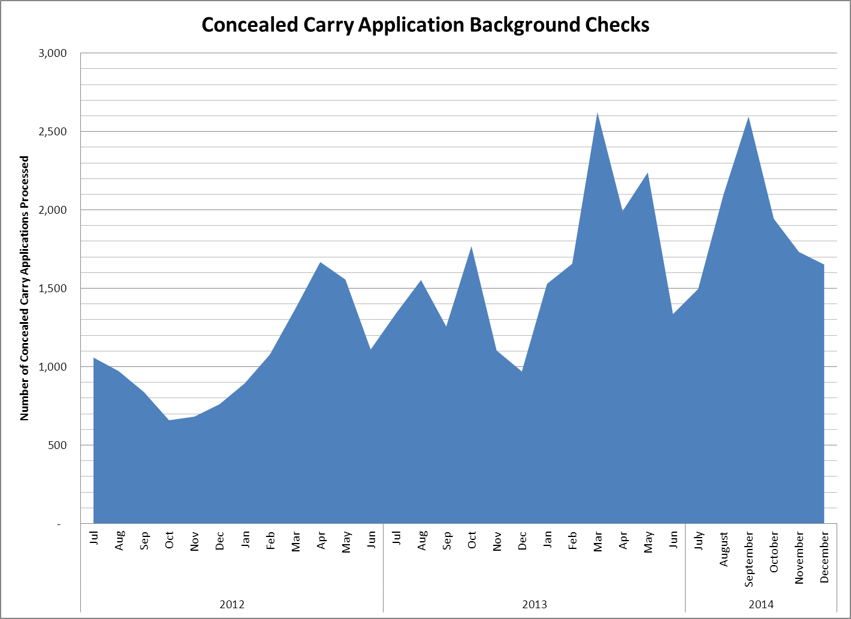

Over the past two years the number of applications for concealed carry permits has increased significantly. While there is a seasonal drop in applications during the winter months the overall trend has been upward with March 2013 showing the highest volume of applications to date.
(Glossary of Terms, Acronyms & Abbreviations) (Back to Table of Contents)
STRATEGIC PERFORMANCE EXCELLENCE

Human Resources

Define
Completion of performance evaluations according to scheduled due dates continues to be problematic.
Measure
Current results are consistently below the 85% average quarterly performance goal.
Analyze
A thorough analysis of the root causes for lack of compliance with this performance standard is indicated.
Improve
In the interim, the Personnel Director has begun the process of reporting to hospital leadership the status of performance evaluation completion at least monthly so follow-up with responsible parties can be accomplished.
Control
Plans to modify hospital performance evaluation goals for supervisory personnel will include the completion of subordinate performance evaluations in a timely manner as a critical supervisory function.
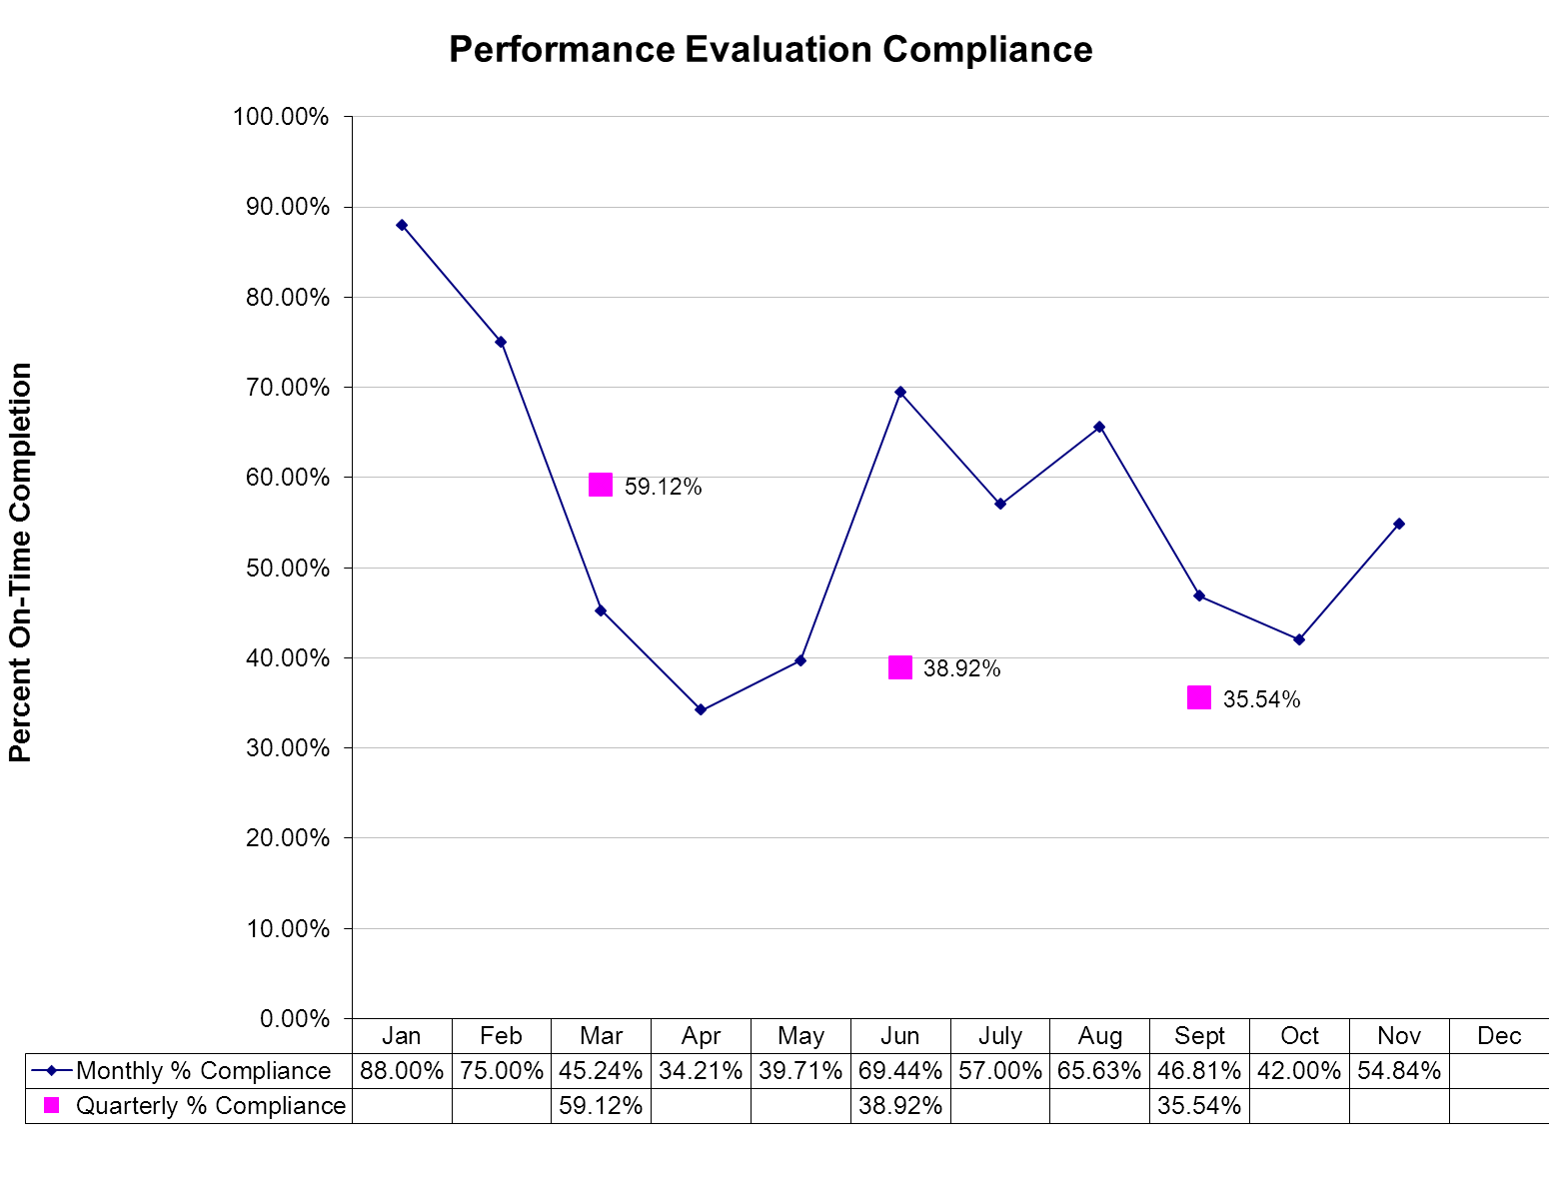
(Glossary of Terms, Acronyms & Abbreviations) (Back to Table of Contents)
STRATEGIC PERFORMANCE EXCELLENCE

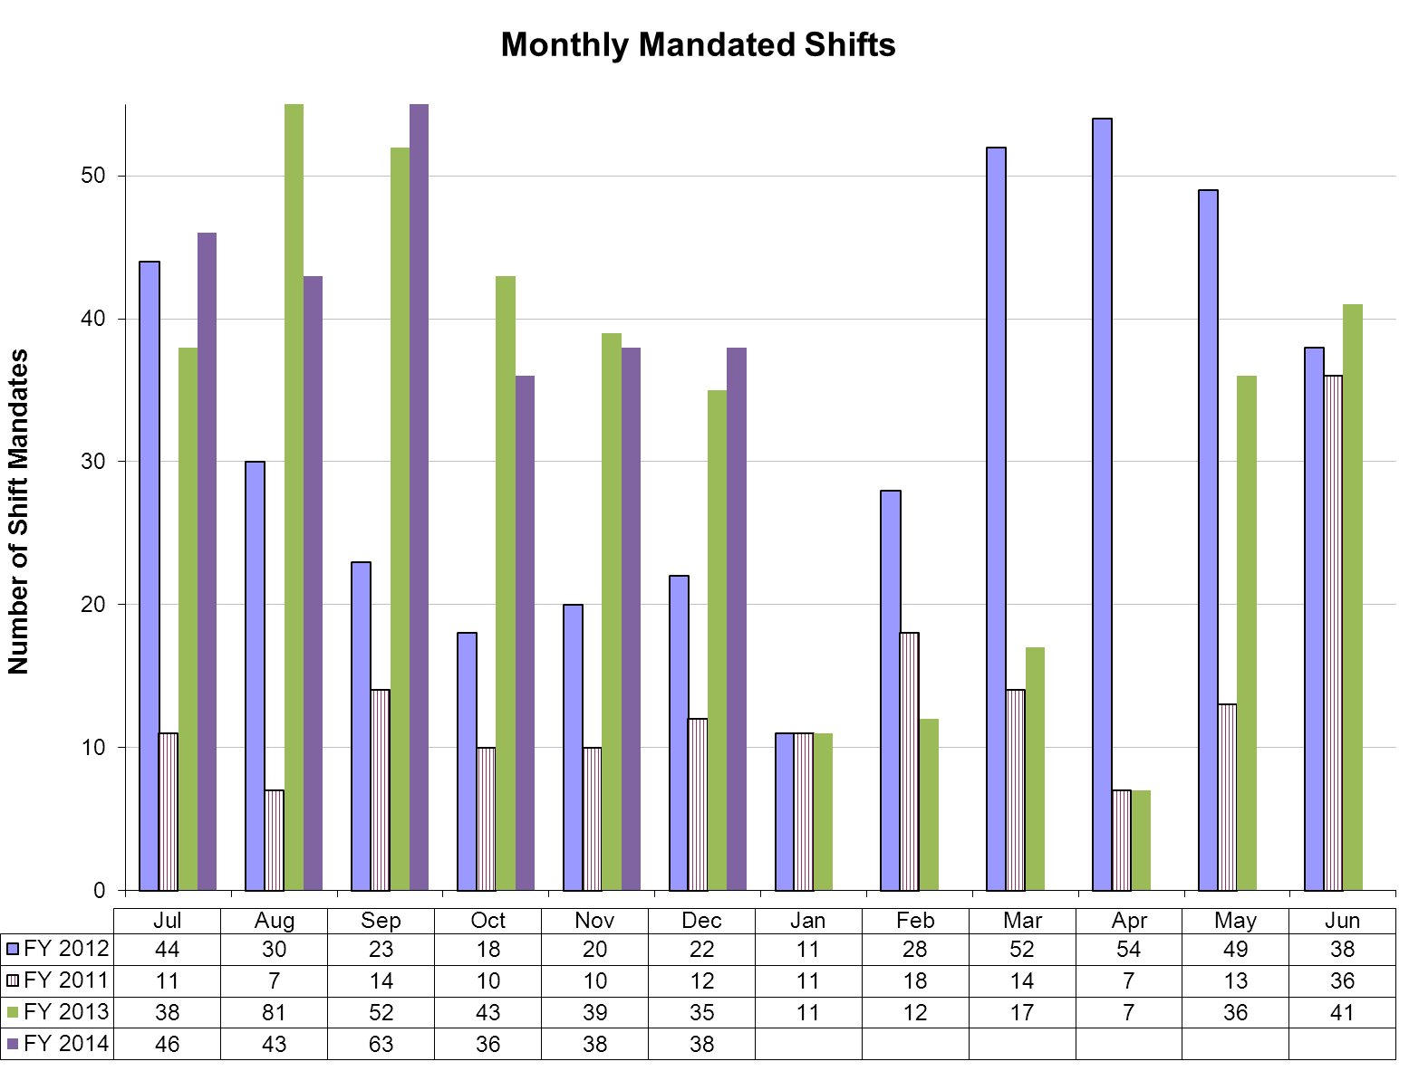
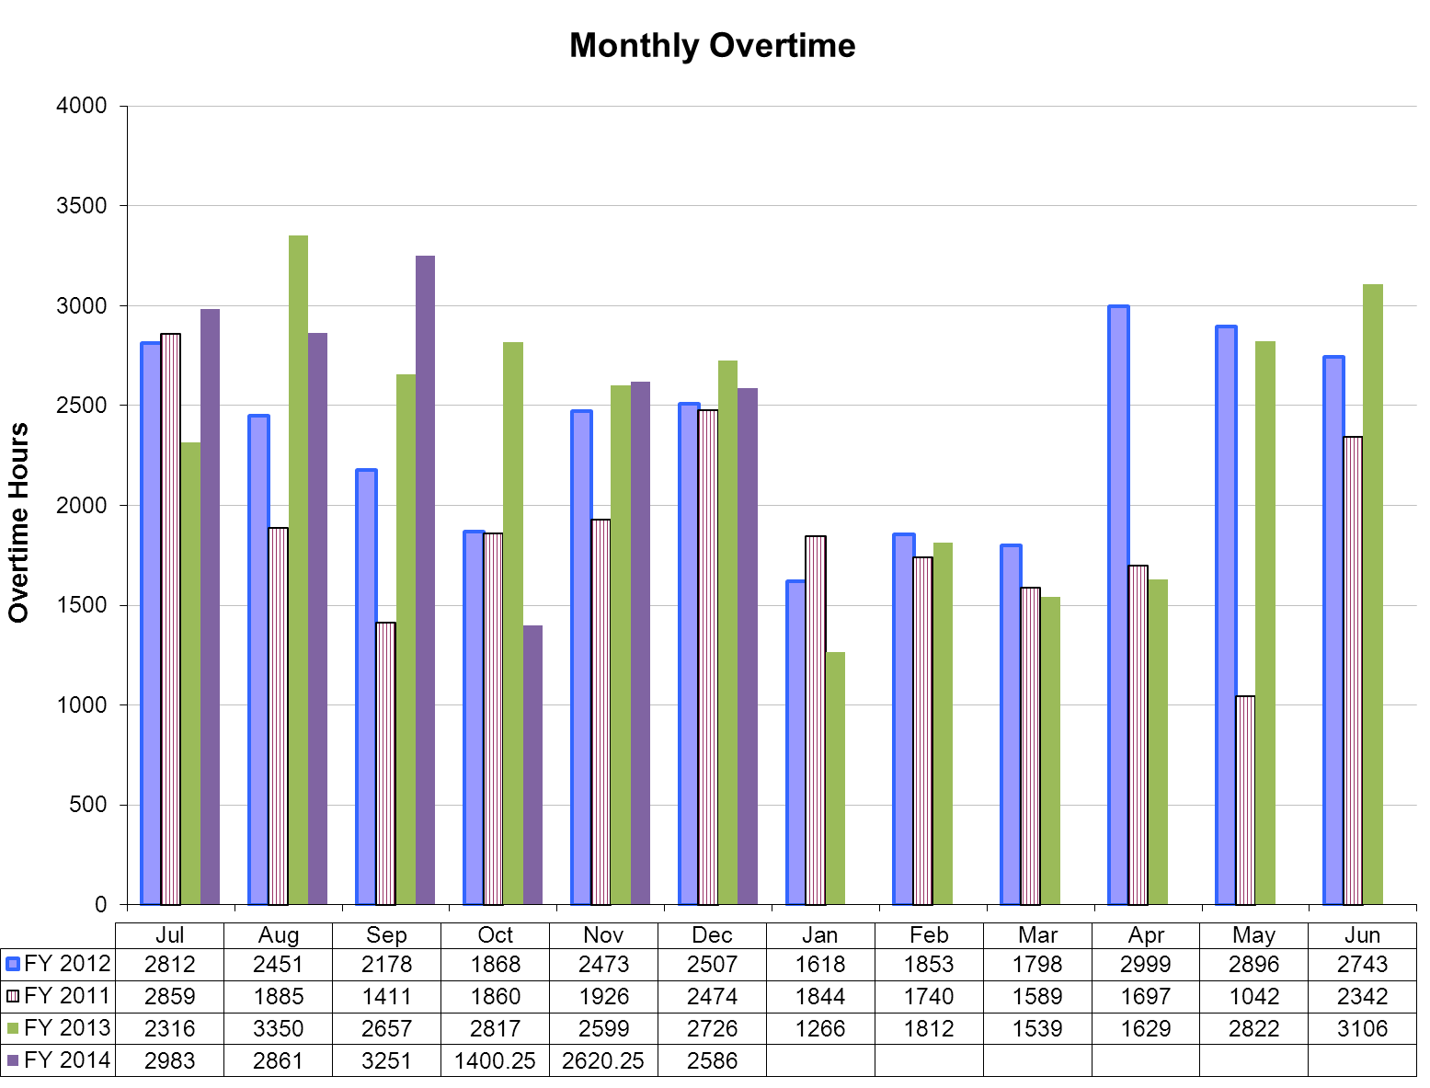
(Glossary of Terms, Acronyms & Abbreviations) (Back to Table of Contents)
STRATEGIC PERFORMANCE EXCELLENCE

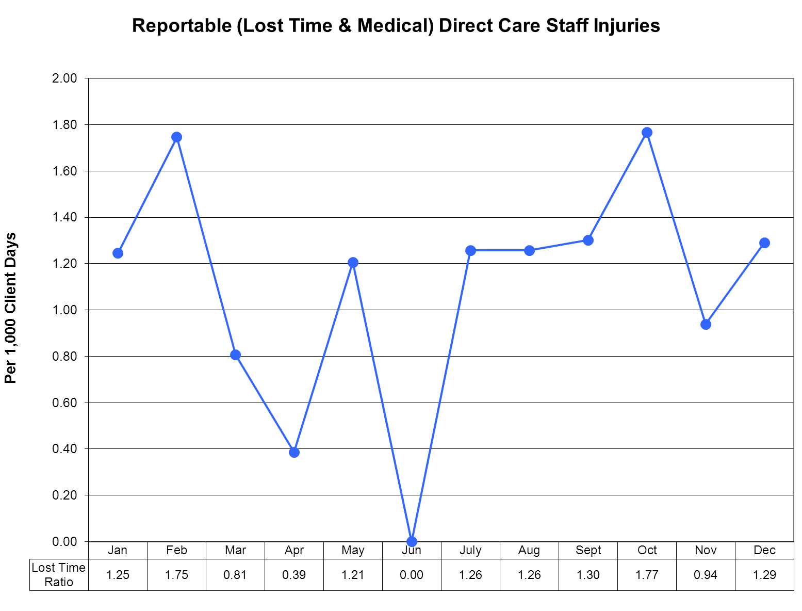

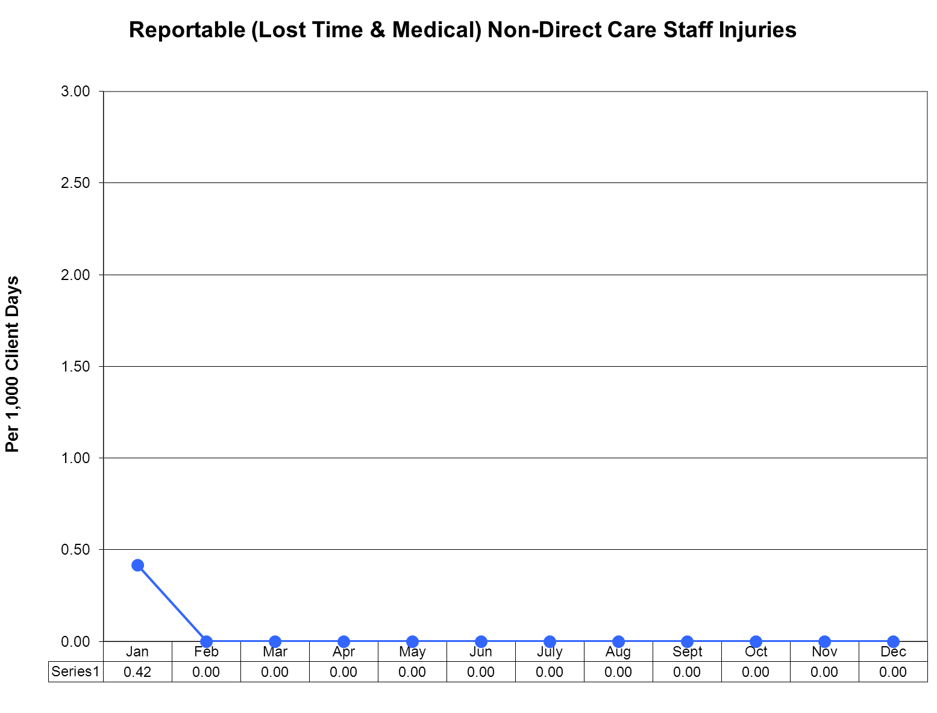
(Glossary of Terms, Acronyms & Abbreviations) (Back to Table of Contents)
STRATEGIC PERFORMANCE EXCELLENCE

Medical Staff
Timeliness of Psychological Testing

Data Collection: All requests for psychological testing or evaluation were reviewed during the time period of October, November and December 2013. The date of the request, the medical staff member requesting the information, the date of initiation of testing and date of completion of testing were determined for comparison to target norms.

Findings: During the period in question, there were a total of three requests for psychological testing, two for general psychological assessment and one for neuropsychological testing. The requests for psychological assessment were completed in 10 and 3 days respectively, well within the hoped for time frame. A single request, however, for neuropsychological testing was completed in a total of 51 days, which is outside the hoped for target of 30 days.

Analysis: It is noted that during the previous quarter requests for psychological testing had markedly decreased. This remained the case through this quarter and it is felt that it also relates to a temporary reduction in the number of psychologists available within the hospital. Overall, the timeliness of testing was below the threshold of 90%, on this occasion 66.7%; however, the marked difference between the request for neuropsychological testing and standard psychological testing is noted.

Plan: A Director of the psychology department has now been appointed and has commenced work. It is expected that reorganization of the psychology department will result not only in the department being able to reach its threshold of 90% but that, in addition, there will be an increase in availability of psychological testing and thereafter an increase in utilization of psychological testing within the hospital once again.

(Glossary of Terms, Acronyms & Abbreviations) (Back to Table of Contents)
STRATEGIC PERFORMANCE EXCELLENCE

Medical Staff
Polyantipsychotic Medication Monitoring

 | October | November | December
Census | 70 | 71 | 72
Antipsychotic Orders for Clients
No Antipsychotics | 12 (17%) | 13 (18%) | 14 (19%)
Mono-antipsychotic therapy | 38 (54%) | 35 (49%) | 36 (50%)
Two Antipsychotics | 15 (21%) | 17 (24%) | 18 (25%)
Three Antipsychotics | 5 (7%) | 6 (8%) | 3 (4%)
Four Antipsychotics | 0 (0%) | 0 (0%) | 1 (2%)
At least 1 antipsychotic | 58 (83%) | 58 (82%) | 58 (81%)
Total on Poly-antipsychotic therapy | 20 (29%) | 23 (32%) | 22 (31%)
Percentage of poly-antipsychotic therapy amongst those with orders for antipsychotics | 34% | 40% | 38%
More than 2 antipsychotics | 5 (7%) | 6 (8%) | 4 (6%)
Poly-Antipsychotic therapy breakdown
SGA + FGA | 7 (47%) | 10 (59%) | 12 (67%)
2 SGAs (“Pine” + “Done”) | 3 (20%) | 5 (29%) | 3 (16.5%)
Other (2 antipsychotic regimens) | 5 (33%) | 2 (12%) | 3 (16.5%)
Other 2 Antipsychotic Regimen Details | 1) loxapine scheduled & prn + chlorpromazine injection prn  2) clozapine scheduled + olanzapine ODT scheduled  3) paliperidone palmitate (long acting injection) + aripiprazole scheduled & prn  4) chlorpromazine scheduled + fluphenazine scheduled  5) aripiprazole scheduled + quetiapine prn | 1) loxapine prn + chlorpromazine prn  2) clozapine scheduled + quetiapine prn | 2 SGA combinations:  1) aripiprazole scheduled + olanzapine prn  2) clozapine scheduled + quetiapine prn  3) paliperidone palmitate (long acting injection) + risperidone scheduled
3+ Antipsychotic Regimens | 1) haloperidol scheduled & prn, olanzapine scheduled, quetiapine scheduled & prn  2) haloperidol scheduled & prn, olanzapine ODT prn, ziprasidone injection prn  3) olanzapine ODT | 1) haloperidol scheduled & prn, olanzapine scheduled, quetiapine scheduled & prn  2) haloperidol scheduled & prn, olanzapine ODT prn, ziprasidone injection prn  3) paliperidone palmitate | 1) olanzapine scheduled & prn, risperidone scheduled & prn, chlorpromazine prn  2) aripiprazole scheduled, haloperidol scheduled, ziprasidone scheduled  3) haloperidol scheduled
(Glossary of Terms, Acronyms & Abbreviations) (Back to Table of Contents)
STRATEGIC PERFORMANCE EXCELLENCE

 | scheduled & prn, paliperidone palmitate (long acting injection), risperidone prn  4) clozapine scheduled, haloperidol prn, quetiapine prn  5) aripiprazole scheduled, haloperidol scheduled, ziprasidone scheduled | (long acting injection), risperidone solution scheduled, aripiprazole prn  4) paliperidone palmitate (long acting injection), quetiapine scheduled, risperidone prn  5) aripiprazole scheduled, haloperidol scheduled, ziprasidone scheduled  6) aripiprazole scheduled, olanzapine prn, quetiapine prn | & prn, olanzapine scheduled, quetiapine scheduled & prn  4) clozapine scheduled, haloperidol scheduled, olanzapine ODT prn, ziprasidone Injection prn)
*Justifiable Poly-Antipsychotic Therapy | 16/20 (80%) [below goal of 90%] | 19/23 (83%) [below goal of 90%] | 20/22 (91%) [above goal of 90%]

SGA = Second Generation Antipsychotic; FGA = First Generation Antipsychotic; “Pines” = clozapine, olanzapine, quetiapine, asenapine; “Dones” = risperidone, paliperidone, ziprasidone, lurasidone, iloperidone; prn = as needed

*This portion was added based on an evaluation of the poly pharmacy regimens. One flaw with this is that we cannot tell if there is the intent to cross taper and discontinue a particular antipsychotic

Data Collection
All medication profiles in the hospital were reviewed on three occasions this quarter in October, November and December. We were particularly interested in the proportion of clients who were receiving more than one antipsychotic medication, since practice guidelines by the American Psychiatric Association clearly discourage this practice. When a case of poly-pharmacy was encountered we further required the prescriber to justify the practice based on pre-agreed upon clinical elements required to make the justification.

Findings
Over the quarter we found that about 82% of clients were receiving at least one antipsychotic medication. Of these clients, about 37% were receiving more than one such agent, and by definition was a case of poly-pharmacy. Within this overall percentage we noted that in October the percentage was 34, in November it was 40, and in December it was 38. This is an increase in poly-antipsychotic therapy from the previous quarter (32.2% total, 37.3% July, 33.3% August, and 26.6% September).

Analysis
We were below our target of 90% justified for the quarter at 84.6%. The trend line showed improvement over the quarter and was above threshold in December at 91%. The overall percentage of clients receiving poly-antipsychotic therapy increased from last quarter but remained relatively constant within quarter. There were no clients receiving ultrahigh numbers of medications (greater than 3 antipsychotics) in October or November and only one client with four antipsychotic orders in December.

Plan
We will continue this monitor for another quarter since appropriate antipsychotic prescribing is both a common task in the hospital as well as one fraught with many potential negative sequellae. We will continue to give feedback to medical staff and to look closely at all cases where it has been difficult to wean the client off high doses of multiple drugs. A full review of all cases of antipsychotic treatment will be undertaken in January.
(Glossary of Terms, Acronyms & Abbreviations) (Back to Table of Contents)
STRATEGIC PERFORMANCE EXCELLENCE

Medical Staff
Antibiotic Use Monitoring

Data Collection
During the quarter the antibiotic monitoring form consisting of a special doctor’s order sheet with details of the antibiotic indication, drug, and strength, and giving agreed upon prescribing guidelines was fully implemented. Adherence to utilization of the form and the clinical appropriateness of indications for the antibiotic orders are gathered at the end of each month and the summary is provided at the following months’ Pharmacy and Therapeutics (P&T) Committee. The Peer Review Team has been identified.

Findings

During the monitoring period there were 26 orders for antibiotics. In two instances the antibiotic order form was not utilized, both in the month of December. This a 92% adherence rate for the quarter. The orders for October were presented at the November P&T Committee meeting where 100% adherence rate of form utilization was reported. Review of the indications by pharmacy showed that all antibiotic orders were for appropriate indications. November and December adherence rates to the utilization of the antibiotic order form 100% and 67%, respectively. The indications are due to be reviewed by a peer review team prior to the January P&T Committee meeting.

Analysis

Though concerning that the 100% scores through October/November dropped off in December, the low number of cases involved suggests a readily rectifiable situation, as noted below in the plan. This material will be presented and discussed at the January peer review meeting of medical staff. Based on first quarter analysis of this monitor, it is expected to be able to integrate use of the antibiotic prescribing sheet into hospital culture quite successfully, and it is hoped that termination of this monitor may even occur during the course of 2014.

Plan
The Peer Review team will evaluate the appropriateness of each antibiotic order. The team will also, on an ongoing basis, review the clinical guidelines and make recommendations for changes. Other trends identified by the team will be reported as necessary. A summary will be presented at each P&T Committee Meeting. Our threshold for this monitor is that 90% of all antibiotic orders will meet clinical guidelines as developed by the Medical Executive Committee.

(Glossary of Terms, Acronyms & Abbreviations) (Back to Table of Contents)
STRATEGIC PERFORMANCE EXCELLENCE

Medical Staff
Metabolic Monitoring of Atypical Antipsychotics

Data Collection
The pharmacy completed data collection of metabolic monitoring parameters for all clients in the hospital who were receiving atypical antipsychotics during the quarter. Data elements collected on all clients included BMI (Body Mass Index) and BP (blood pressure) plus lab results including HDL cholesterol, triglycerides, fasting blood sugar, and hemoglobin A1c. Also collected were the dates of the last tests and the names of the atypical drugs each client was receiving. This information is posted on the physician’s shared drive and presented monthly at the Pharmacy and Therapeutics (P&T) Committee Meeting

Findings
During the monitoring period there were 67 clients receiving at least one atypical antipsychotic agent. Data was completely recorded for all desired data elements for 47 of 67 (or 70%) clients. We found that about 23.9% of clients taking an atypical antipsychotic met the criteria for Metabolic Syndrome. Twenty-two percent of clients were missing enough data elements that their metabolic status was unable to be determined. Missing data elements were primarily related to lab studies, mostly due to refusal of clients to obtain blood work. About 47% of clients with values for each data element did not have these obtained within the last quarter, suggesting the need to evaluate each client’s metabolic monitoring frequency.

Analysis
At 70% we were below our target of 95% of clients on atypical antipsychotics having a complete metabolic profile available to the pharmacist and to the medical staff. This was primarily due to missing laboratory values in the data base due to refusals. However, by the end of the quarter metabolic syndrome status could not be determined for only 7 (16.3%) clients. Thus data was complete for 83.7% of clients on second generation antipsychotics, indicating some improvement on this indicator.

Plan
Going forward, our plan will be to review the recommended metabolic monitoring frequency for each client to optimize the monitoring and prevent unnecessary lab work. We will continue to monitor the data elements of metabolic monitoring for each client prescribed a second generation antipsychotic. We will also continue to refine and improve our data entry. We will explore the concept of a metabolic clinic to better assess, identify, monitor, educate and treat clients at risk for metabolic syndrome.
(Glossary of Terms, Acronyms & Abbreviations) (Back to Table of Contents)
STRATEGIC PERFORMANCE EXCELLENCE

Nursing

INDICATOR
Mandate Occurrences
DEFINITION
When no volunteers are found to cover a required staffing need, an employee is mandated to cover the staffing need according to policy. This creates difficulty for the employee who is required to unexpectedly stay at work up to 16 hours. It also creates a safety risk.
OBJECTIVE
Through collaboration among direct care staff and management, solutions will be identified to improve the staffing process in order to reduce and eventually eliminate mandate occurrences. This process will foster safety in culture and actions by improving communication, improving staffing capacity, mitigating risk factors, supporting the engagement and empowerment of staff. It will also enhance fiscal accountability by promoting accountability and employing efficiency in operations.
THOSE RESPONSIBLE FOR MONITORING
Monitoring will be performed by members of the Staffing Improvement Task Force which includes representation of Nurses and Mental Health Workers on all units, Staffing Office and Nursing Leadership.
METHODS OF MONITORING
Monitoring would be performed by;
- Staffing Office Database Tracking System
METHODS OF REPORTING
Reporting would occur by one or all of the following methods;
- Staffing Improvement Task Force
- Nursing Leadership
- Riverview Nursing Staff Communication
UNIT
Mandate shift occurrences
BASELINE
August 2012: Nurse Mandates 24 shifts, Mental Health Worker Mandates 53 shifts
MONTHLY TARGETS
Baseline –10% each month
(Glossary of Terms, Acronyms & Abbreviations) (Back to Table of Contents)
STRATEGIC PERFORMANCE EXCELLENCE

Nursing Department Mandates
Staffing Improvement Task Force

Safety in Culture and Actions | Unit | 7/2013 | 8/2013 | 9/2013 | 10/2013 | 11/2013 | 12/2013 | Goal
Mandate Occurrences - Nurses | # of shifts | 5 | 3 plus | 20 | 4 | 8 | 9 | 16  (10% reduction monthly x4 from baseline)
When no volunteers are found to cover a required staffing need, an employee is mandated to cover the staffing need according to policy.
Mandate Occurrences – Mental Health Workers | # of shifts | 51 | 30 plus | 98 | 32 | 30 | 29 | 35  (10% reduction monthly from baseline)
When no volunteers are found to cover a required staffing need, an employee is mandated to cover the staffing need according to policy.

Comments

Nursing mandates were down this quarter from 28 in the previous quarter to 21
MHW mandates down this quarter from 179 to 91
(Glossary of Terms, Acronyms & Abbreviations) (Back to Table of Contents)
STRATEGIC PERFORMANCE EXCELLENCE

Peer Support

INDICATOR
Client Satisfaction Survey Return Rate
DEFINITION
There is a low number of satisfaction surveys completed and returned once offered to clients due to a number of factors.
OBJECTIVE
To increase the number of surveys offered to clients, as well as increase the return rate.
THOSE RESPONSIBLE FOR MONITORING
Peer Services Director and Peer Support Team Leader will be responsible for developing tracking tools to monitor survey due dates and surveys that are offered, refused, and completed. Full-time peer support staff will be responsible for offering surveys to clients and tracking them until the responsibility can be assigned to one person.
METHODS OF MONITORING
- Biweekly supervision check-ins
- Monthly tracking sheets/reports submitted for review
METHODS OF REPORTING
- Client Satisfaction Survey Tracking Sheet
- Completed surveys entered into spreadsheet/database
UNIT
All client care/residential units
BASELINE
Determined from previous year’s data.
QUARTERLY TARGETS
Quarterly targets vary based on unit baseline with the end target being 50%.
(Glossary of Terms, Acronyms & Abbreviations) (Back to Table of Contents)
STRATEGIC PERFORMANCE EXCELLENCE

Peer Support
Inpatient Client Survey – Improving the Rate of Return

Department: |  | Peer Support |  |  |  |  | Responsible Party: |  |  | Chris Monahan
Strategic Objectives
Client Recovery |  |  | Unit | Baseline | FY14Q1 | FY14 Q2 |  | FY14  Q3 | FY14  Q4 |  | Goal | Comments
CSS Return Rate |  |  | LK  LS  UK  US | 15%  5%  45%  30% | 5%  4%  39%  100% | 18%  8%  47%  33% |  |  |  |  | 50%  50%  50%  50% | Percentages are calculated based on number of people eligible to receive a survey vs. the number of people who completed the surveys.
The client satisfaction survey is the primary tool for collecting data on how clients feel about the services they are provided at the hospital. Data collection has been low on all units and the way in which the surveys are administered has challenges based on the unit operations and performance of the peer support worker.

(Glossary of Terms, Acronyms & Abbreviations) (Back to Table of Contents)
STRATEGIC PERFORMANCE EXCELLENCE

Summary of Inpatient Client Survey Results

# | Indicators | 1Q2014  Findings | 2Q2014  Findings
1 | I am better able to deal with crisis. | 70% | 69%
2 | My symptoms are not bothering me as much. | 78% | 71%
3 | The medications I am taking help me control symptoms that used to bother me. | 65% | 75%
4 | I do better in social situations. | 69% | 73%
5 | I deal more effectively with daily problems. | 70% | 69%
6 | I was treated with dignity and respect. | 70% | 75%
7 | Staff here believed that I could grow, change and recover. | 73% | 69%
8 | I felt comfortable asking questions about my treatment and medications. | 63% | 69%
9 | I was encouraged to use self-help/support groups. | 65% | 77%
10 | I was given information about how to manage my medication side effects. | 65% | 63%
11 | My other medical conditions were treated. | 63% | 71%
12 | I felt this hospital stay was necessary. | 63% | 63%
13 | I felt free to complain without fear of retaliation. | 60% | 53%
14 | I felt safe to refuse medication or treatment during my hospital stay. | 39% | 63%
15 | My complaints and grievances were addressed. | 58% | 65%
16 | I participated in planning my discharge. | 67% | 73%
17 | Both I and my doctor or therapist from the community were actively involved in my hospital treatment plan. | 58% | 73%
18 | I had an opportunity to talk with my doctor or therapist from the community prior to discharge. | 72% | 71%
19 | The surroundings and atmosphere at the hospital helped me get better. | 68% | 69%
20 | I felt I had enough privacy in the hospital. | 68% | 71%
21 | I felt safe while I was in the hospital. | 65% | 75%
22 | The hospital environment was clean and comfortable. | 73% | 75%
23 | Staff were sensitive to my cultural background. | 63% | 83%
24 | My family and/or friends were able to visit me. | 78% | 77%
25 | I had a choice of treatment options. | 58% | 73%
26 | My contact with my doctor was helpful. | 70% | 77%
27 | My contact with nurses and therapists was helpful. | 60% | 79%
28 | If I had a choice of hospitals, I would still choose this one. | 58% | 69%
29 | Did anyone tell you about your rights? | 58% | 71%
30 | Are you told ahead of time of changes in your privileges, appointments, or daily routine? | 60% | 67%
31 | Do you know someone who can help you get what you want or stand up for your rights? | 58% | 71%
32 | My pain was managed. | 64% | 65%
 | Overall Score | 64% | 71%

(Glossary of Terms, Acronyms & Abbreviations) (Back to Table of Contents)
STRATEGIC PERFORMANCE EXCELLENCE

Pharmacy Services

The IPEC reporting reflects three major areas of focus for performance improvement that have pharmacy specific indicators: Safety in Culture and Actions, Fiscal Accountability and Medication Management (see Medication Management – Dispensing Process). The pharmacy specific indicators for each of the priority focus areas utilizes measurable and objective data that is trended and analyzed to support performance improvement efforts and medication safety, as well as, ensure regulatory compliance and best practice in key areas.
Safety in Culture and Actions
RPC’s primary medication distribution system uses the Pyxis Medstations to provide an electronic “closed loop” system to dispense medications for patients. Within the Pyxis system, key data elements are reported, trended and analyzed to ensure medication safety and regulatory compliance are maintained. Pyxis Discrepancies created by nursing staff are monitored daily and analyzed by Pharmacy with follow up to Nursing as needed for resolution. A monthly summary is provided to the Nursing-Pharmacy Committee for further review and discussion of trends and ideas to minimize the occurrence of discrepancies by Nursing. Pyxis Overrides of Controlled Drugs by nursing staff is another indicator that is closely monitored and trended with follow up for resolution as needed. A monthly summary is also reviewed by the Nursing-Pharmacy Committee for action steps. The goal with each of these indicators is to minimize the occurrence of either discrepancies or overrides by action steps to address performance issues via education or system changes which help satisfy TJC requirements for monitoring the effectiveness of the Medication Management system. Veriform Medication Room Audits are performed on each medication room to determine compliance with established medication storage procedures and requirements. The results of the audits are shared with the nursing managers for their respective corrective actions or staff education.
Fiscal Accountability
The Discharge Prescriptions indicator tracks the cost and number of prescription drugs dispensed to patients at discharge. This baseline data will be used to determine the best approach to implement steps to decrease this expense. The lack of a resource to perform insurance verification and research prior authorizations needed so clinicians’ can make timely and informed prescribing decisions is believed to be inherent in the discharge process. Without this resource, RPC is obliged to provide discharge medications to prevent a gap in medication coverage as the patient is being transitioned to another facility. The plan of correction is to explore options and propose a resolution to RPC’s Medical Director.

(Glossary of Terms, Acronyms & Abbreviations) (Back to Table of Contents)
STRATEGIC PERFORMANCE EXCELLENCE

Pharmacy Services

Department: | Pharmacy |  |  |  |  |  |  |  | Responsible Party: |  |  | Garry Miller, R.Ph.
Strategic Objectives
Safety in Culture & Actions |  | Unit |  |  |  | Baseline  2013 |  | Q1 Target |  | Q2 Target | Q3 Target | Q4 Target | Goal | Comments
Pyxis CII Safe Comparison |  |  |  | Rx |  |  |  | 0% |  | 0% | 0% | 0% |  | Goal of no discrepancies between Pyxis and CII safe transactions.
Daily and monthly comparison of Pyxis vs CII Safe transactions
Quarterly Results |  |  |  |  |  |  |  | 0.3% |  | 0%
Veriform Medication Room Audits |  |  |  | All |  | 97% |  | 100% |  | 100% | 100% | 100% | 90% | Overall compliance is 98% for Q1 and Q2
Monthly comprehensive audits of criteria
Quarterly Results |  |  |  |  |  |  |  | 98% |  | 98%
Pyxis Discrepancies |  |  |  | All |  | 63/mo |  | 50 |  | 50 | 50 | 50 | 50/mo | Trending of monthly data was significantly increased for Q2 vs Q1
Monthly monitoring and trending of Pxyis discrepancies.
Quarterly Results |  |  |  |  |  |  |  | 226  (75/mo) |  | 403  (134/mo)
Pyxis Overrides – Controlled Drugs |  |  |  | All |  | 15/mo |  | 10 |  | 10 | 10 | 10 | 10 | Target goal is 10/month
Monthly monitoring and trending of Pyxis overrides for Controlled Drugs
Quarterly Results |  |  |  |  |  |  |  | 65 |  | 53
Fiscal Accountability |  |  | Unit |  |  |  | Baseline  2013 | Q1 Target |  | Q2 Target | Q3 Target | Q4 Target | Goal | Comments
Discharge Prescriptions |  |  |  |  | Rx |  | $8440  334  Drugs | $5262  418  Drugs |  | $4184  252  Drugs |  |  |  | Significant costs are incurred in providing discharge drugs
Monitoring and Tracking of dispensed Discharge Prescriptions

(Glossary of Terms, Acronyms & Abbreviations) (Back to Table of Contents)
STRATEGIC PERFORMANCE EXCELLENCE

Program Services

Define
Client participation in on-unit groups and utilization of resources to relieve distress is variable but should be promoted to encourage activities that support recovery and the development of skills necessary for successful community integration.
Measure
The program services team will measure the current status of program participation and resource utilization to identify a baseline for each of the four units.
Analyze
Analysis of the barriers to utilization will be conducted in an attempt to determine causation factors for limited participation.
Improve
Strategies for encouraging increased participation in on-unit groups and the utilization of resources to relieve distress will be identified in a collaborative manner with client and staff participation.
Control
Ongoing review of utilization of programs and resources will be conducted to determine whether unit practice has changed and improvements are sustainable.
INDICATOR | Baseline | Quarterly  Improvement  Target | Improvement Objective
1. How many on unit groups were offered each week  Day shift →  Evenings → |  |  | 14
2. Number of clients attending day groups on unit
or facilitated by day staff
(# of clients in all of day groups divided by # of
day groups provided)
3. Number of clients attending evening groups on
unit or facilitated by evening staff
(# of clients in all of evenings groups divided by
# of evening groups provided)
4. Of the 10 charts reviewed, how many  treatment plans reflected the on unit groups  attended. |  |  | 100%
5. The client can identify distress tolerance tools  on the unit |  |  | 100%
6. The client is able to can identify his or her primary  staff. |  |  | 100%
(Glossary of Terms, Acronyms & Abbreviations) (Back to Table of Contents)
STRATEGIC PERFORMANCE EXCELLENCE

Program Services Lower Kennebec

INDICATOR | FINDINGS | % | THRESHOLD
1. How many on unit groups were offered each week  Day shift →  Evenings → | 7  7 | 100% | 14 weekly
2. Number of clients attending day groups on unit  or facilitated by day staff  (# of clients in all of day groups divided by # of  day groups provided) | 2.5 | 50% | 5/group
3. Number of clients attending evening groups on  unit or facilitated by evening staff  (# of clients in all of evenings groups divided by  # of evening groups provided) | 2.5 | 50% | 5/group
4. Of the 10 charts reviewed, how many  treatment plans reflected the on unit groups  attended | 10/10 | 50% | 100%
5. The client can identify distress tolerance tools  on the unit | 5/10 | 50% | 100%
6. The client is able to state who his primary  staff is | 9/10 | 90% | 100%

EVALUATION OF EFFECTIVENESS
There continues to be unit groups seven days a week on Lower Kennebec, one on the day shift and one on the evening shift. The groups are posted to the left of the nursing station. The treatment plans now include groups.

ISSUES
Attendance in unit groups has decreased on both the day and evening shift from 57% to 50%. The decrease in attendance cannot be attributed to a single factor and is most likely influenced by client movement due to admissions and transfers.

ACTIONS
Nurses will conduct unit groups on the day and evening shift Monday through Friday. MHWs will conduct the groups on weekends. Participation will be monitored and trends will be explored and identified. The acting PSD has been reassigned to the Upper Kennebec unit. The former PSD has been reassigned to the Lower Kennebec unit.
(Glossary of Terms, Acronyms & Abbreviations) (Back to Table of Contents)
STRATEGIC PERFORMANCE EXCELLENCE

Program Services Upper Kennebec

INDICATOR | FINDINGS | % | THRESHOLD
1. How many on unit groups were offered each week  Day shift →  Evenings → | 7/7 | 100% | 14 weekly
2. Number of clients attending day groups on unit  or facilitated by day staff  (# of clients in all of day groups divided by # of  day groups provided) | 2 | 10% | 5/group
3. Number of clients attending evening groups on  unit or facilitated by evening staff  (# of clients in all of evenings groups divided by  # of evening groups provided) | 4/7 | 57% | 5/group
4. Of the 10 charts reviewed, how many  treatment plans reflected the on unit groups  attended | 10 | 100% | 100%
5. The client can identify distress tolerance tools  on the unit (re named coping tools) | 8/10 | 80% | 100%
6. The client is able to state who his primary  staff is | 8/10 | 100% | 100%

EVALUATION OF EFFECTIVENESS
On unit groups are posted and occur daily on the day and evening shifts. Participation is low between 1 and 3. Staff has identified 5 clients that do not attend groups at the mall or groups on the unit. This issue has been incorporated in the treatment plans of those clients. Isolation is an issue with two of those clients. On unit groups have been incorporated in all of the treatment plans. Distress tolerance tools have been renamed coping tools to be more consistent with recovery-based language. Primary staff names and assignments are listed each shift on a dry erase board by the day room.

ISSUES
Since on unit groups are part of the care plans, deviation from the posted groups and structure needs to be avoided. The staff needs to understand the importance of maintaining the structure and maintain compliance with the groups as posted. Unofficial substitutions of groups cannot occur.

ACTIONS
Encourage ideas from clients and staff for topics for on unit groups. Collaborate with other units for what groups have a high interest and attendance rate. Explore low attendance rates and consider time changes for the groups. Educate staff and state a clear expectation on the importance of initial introductions to their primary clients. Identify clients that do not attend on unit groups or treatment mall groups. Review interventions for these specific clients and this specific issue for effectiveness and review and revise the treatment plans.
(Glossary of Terms, Acronyms & Abbreviations) (Back to Table of Contents)
STRATEGIC PERFORMANCE EXCELLENCE

Program Services Lower Saco

INDICATOR | FINDINGS | % | THRESHOLD
1. How many on unit groups were offered each week  Day shift →  Evenings → | Main/SCU  36 / 12  27 / 10 | 100%  100% | 7 / 7 = 14  7 / 7 = 14
2. Number of clients attending day groups on unit  or facilitated by day staff  (# of clients in all of day groups divided by # of  day groups provided) | 4.5 / 1.5 |  | N/A
3. Number of clients attending evening groups on  unit or facilitated by evening staff  (# of clients in all of evenings groups divided by  # of evening groups provided) | 3.5/ 1 |  | N/A
4. Of the 10 charts reviewed, how many  treatment plans reflected the on unit groups  attended | 10 | 100% | 100%
5. The client can identify distress tolerance tools  on the unit | 27/30 | 90% | 100%
6. The client is able to state who his primary  staff is | 30/30 | 100% | 100%
INDICATOR | FINDINGS | % | THRESHOLD

EVALUATION OF EFFECTIVENESS
ISSUES
The Lower Saco unit improved significantly with on-unit groups by MHWS and professional staff. Documentation in the Meditech has improved. This treatment effort is being reflected in the treatment plans. The on-unit groups have been a regular part of each client’s daily activity and are incorporated in their Rx plans. A high level of acuity on any given day can negatively impact levels of attendance and interest. Recreational Therapy staff members are more consistent in documenting participation and nursing staff have improved documentation over the past quarter. Only an occasional new client may need to be reminded about available tools/activities to help relieve distress.

ACTIONS
RT staff members are very important in providing diversion and therapy groups to Lower Saco clients, which needs to be maintained. The unit is offering many more groups weekly than the threshold; we need to be working to improve quality and variety with the groups provided. We are adding some new staff acuity specialist positions, which once in place should help address acuity situations and further improve overall quality of groups.
.

(Glossary of Terms, Acronyms & Abbreviations) (Back to Table of Contents)
STRATEGIC PERFORMANCE EXCELLENCE

Program Services Upper Saco

INDICATOR | FINDINGS | % | THRESHOLD
1. How many on unit groups were offered each week  Day shift →  Evenings → | 19  12 | 100%  100% | Days/ Even.  7 / 7 = 14
2. Number of clients attending day groups on unit  or facilitated by day staff  (# of clients in all of day groups divided by # of  day groups provided) | 2.5avg./19grps |  | N/A
3. Number of clients attending evening groups on  unit or facilitated by evening staff  (# of clients in all of evenings groups divided by  # of evening groups provided) | 4avg./12grps |  | N/A
4. Of the 10 charts reviewed, how many  treatment plans reflected the on unit groups  attended | 3 | 30% | 100%
5. The client can identify distress tolerance tools  on the unit | 30/30 | 100% | 100%
6. The client is able to state who his primary  staff is | 30/30 | 100% | 100%

EVALUATION OF EFFECTIVENESS
ISSUES
The Upper Saco unit has increased offering on-unit groups. The documentation in the Meditech is improving. There continues to be a need to better reflect this on-unit treatment effort in the treatment plans. Nearly all of the clients on Upper Saco attend the hospital treatment mall with a high level of participation and attendance with this off-unit treatment. Off unit groups are reflected in the treatment plans and are a regular part of physician orders. There needs to be increased effort at reflecting on-unit groups in the treatment plans, especially for weekends and for clients not regularly attending the hospital treatment mall.

ACTIONS
Nearly all clients’ length of stays on Upper Saco are for longer stays than most clients on other units, and as such they quickly become familiar with distress tolerance tools ( MP3 players ,cards ,exercise machines, etc.) and how to access them. They also know their assigned primary staff. The team coordinator has been incorporating off- unit groups in client treatment plans, but additional efforts need to be made to get all on-unit offered groups in individual treatment plans. Continued efforts are being made to offer groups to those clients that have less activity at the hospital treatment mall. The unit RN 4 is addressing with nursing staff the need to further improve this area.
(Glossary of Terms, Acronyms & Abbreviations) (Back to Table of Contents)
STRATEGIC PERFORMANCE EXCELLENCE

Rehabilitation Services
Department: |  | Rehabilitation Services |  |  | Responsible Party: |  |  |  | Janet Barrett
Strategic Objectives
Client Recovery |  |  | Baseline | Q1 Target |  | Q2 Target | Q3 Target | Q4 Target |  | Goal | Comments
 | Vocational Incentive Program Treatment Plans |  | 55% | 92% |  | 95% | 98% | 100% |  | The treatment plans will be reviewed more regularly and updated at each client 30 day treatment team meeting. | All charts reviewed had current plans but 2 of the charts reviewed did not have weekly progress notes. They had been done biweekly on this client working in the community with minimal vocational supervision.
 | The objective of this improvement project is to ensure vocational treatment plans are initiated on all clients within 5 days of beginning work and will be reviewed and updated if necessary every 30 days. Documentation on interventions in the treatment plans will reflect progress towards interventions and will be documented on weekly.
 | Quarterly Results |  |  | 95% |  | 88%

Client Recovery |  | Baseline | Q1 Target | Q2 Target | Q3 Target | Q4 Target | Goal | Comments
 | Recreational Therapy Assessments & Treatment Plans | 75% | 85% | 90% | 95% | 100% | The treatment plans will be reviewed more regularly and updated at each client treatment team meeting or if there is any change in client status | All assessments reviewed were done within allotted time frame and all treatment plans reviewed were current but in 3 of the 36 charts reviewed had missing progress note documentation for 2 weeks.
 | The objective of this improvement project is to ensure that Recreational Therapy assessments are completed within 7 days of admission and that a treatment plan is initiated after the assessment and will be reviewed and updated if necessary every 30 days. Documentation on interventions in the treatment plans will reflect progress towards interventions and will be documented on weekly.
 | Quarterly Results |  | 85% | 91%

(Glossary of Terms, Acronyms & Abbreviations) (Back to Table of Contents)

STRATEGIC PERFORMANCE EXCELLENCE

Rehabilitation Services
Department: | Rehabilitation Services |  |  | Responsible Party: |  |  |  | Janet Barrett
Strategic Objectives
Client Recovery & Safety in Culture and Actions |  | Baseline | Q1 Target |  | Q2 Target | Q3 Target | Q4 Target |  | Goal | Comments
Occupational Therapy referrals and doctors orders. |  | 33% | 50%  39 of 43 |  | 75%  13 of 16 | 100% | 100% |  | To increase the percentage of referrals and doctor’s orders by 25 % each quarter until we attain 100% compliance. | There were 3 clients who had services initiated prior to receiving the MD order. The order had been written but there was confusion on who to send the hard copy of the order to. Nursing staff educated in the OT referral process.
The objective of this improvement project is to ensure each client receiving Occupational Therapy Services from RPC OT staff has a doctor’s order as well as a referral form completed prior to the initiation of services.

Quarterly Results |  |  | 91% |  | 81%

